**1. INTRODUCTION**

**EduMart** is a dynamic web-based platform designed to connect individuals seeking educational services with skilled professionals who offer them. The platform enables clients to discover, book, and procure a diverse range of services such as subject tutorials, graphic designing, application development, and more. At the same time, it empowers service providers to showcase their expertise, manage their service listings, communicate with clients, and handle bookings efficiently.

The project focuses on creating a user-friendly, secure, and scalable web application that facilitates smooth interactions between service providers and clients. **EduMart** incorporates modern features including real-time chat, booking and payment integration, and a review and rating system, ensuring a seamless service experience. The platform uses Django for the backend, HTML/CSS/JS for the frontend, and SQLite as the database.

By offering capabilities like advanced search filters, role-based user access, profile management, and automated booking status tracking, **EduMart** simplifies the process of both providing and accessing educational services. It serves as a reliable and centralized hub for educational needs in today’s digital age.

**Project Title:** ‘**EduMart’** (Marketplace for Educational Services)

**Category:** Web Development

**1.1. PROBLEM DEFINITION**

In the current scenario, individuals seeking educational or skill-based services face challenges in finding reliable and credible service providers. Traditional methods such as advertisements or word-of-mouth referrals prove to be time-consuming and often lack transparency regarding service quality. Likewise, skilled professionals struggle to effectively reach their target audience and showcase their expertise.

Most existing platforms fail to offer a specialized focus on educational services, leading to a cluttered user experience with irrelevant or non-academic offerings. Additionally, the absence of features like streamlined booking processes, secure online payments, and real-time communication creates inefficiencies and reduces trust between clients and service providers.

Clients often find it difficult to compare service providers based on important factors such as skill set, experience, pricing, and user feedback. On the other hand, service providers lack tools to highlight their unique strengths, manage bookings efficiently, and receive meaningful client reviews.

**EduMart** addresses these challenges by offering a dedicated, user-friendly, and transparent platform that caters exclusively to educational services. It simplifies the process of discovering, booking, and availing services, while empowering providers to showcase their offerings, manage client interactions, and build their reputation in a secure digital environment.

**1.2. MOTIVATION**

**EduMart** is driven by the need to bridge the gap between clients seeking educational or skill-based services and the professionals offering them. In the current digital landscape, individuals still struggle to find reliable, high-quality educational service providers. The process remains inefficient and scattered, especially on platforms that are not tailored for education-specific needs. These platforms often lack proper categorization, user-friendly interfaces, and the tools necessary for evaluating provider credibility.

Service providers, particularly educators, developers, and designers, also face challenges in showcasing their expertise, managing their bookings, and connecting with potential clients. Traditional methods do not offer features such as verified reviews, real-time interaction, or a central space to highlight specialized skills.

The motivation behind **EduMart** is to create a dedicated marketplace focused exclusively on educational and skill-based services. The platform aims to provide a structured, secure, and transparent environment where users can easily discover, compare, and book services, while professionals can manage their profiles, receive feedback, and build a strong reputation.

By incorporating features such as role-based user accounts (client/provider), categorized service listings, real-time chat, secure booking and payment systems, and a review/rating system, EduMart eliminates the inefficiencies of traditional methods and replaces them with a seamless, digital-first experience.

This platform empowers users with better decision-making tools and enables professionals to grow their reach in a competitive digital space. Ultimately, **EduMart** makes educational services more accessible, organized, and trustworthy for everyone involved.

**2. OBJECTIVE**

**EduMart** aims to create a secure, efficient, and user-friendly web platform that connects clients with skilled professionals offering educational and skill-based services. The platform ensures seamless accessibility for discovering, booking, and availing services, while empowering service providers to showcase their expertise, manage listings, and handle bookings effectively. With features such as advanced search filters, real-time booking availability, secure online payments, in-app chat, and a review and rating system, **EduMart** streamlines the entire service exchange process to enhance user experience, build trust, and foster transparency in every interaction. Prioritizing data security, scalability, and system reliability, **EduMart** safeguards user information while supporting growing traffic and service volume without compromising performance. Its ultimate objective is to deliver a dedicated, customized, and robust marketplace for clients and providers in the educational services space.

**3. GOALS**

The main goals of this project are:

1. **Centralized** **Marketplace:** Build a platform connecting clients with educational and skill-based service providers.
2. **Enhanced** **User** **Experience:** Create a user-friendly interface for seamless navigation and bookings.
3. **Trust** **and** **Transparency:** Implement reviews and ratings to ensure accountability and quality services.
4. **Empower** **Providers:** Enable professionals to showcase expertise and manage bookings efficiently.
5. **Streamlined** **Processes:** Simplify service discovery and bookings with advanced tools and real-time updates.
6. **Security:** Protect user data and payments with secure authentication and encryption.
7. **Customization:** Offer personalized profiles and tailored listings for better user relevance.
8. **Scalability:** Design the platform to handle growth without compromising performance.
9. **Real**-**Time** **Communication:** Integrate messaging for seamless client-provider interactions.
10. **Continuous** **Improvement:** Monitor feedback and update features to enhance functionality.

**4. REQUIREMENT ANALYSIS & SPECIFICATIONS**

**4.1. Functional Requirements**

* **User Registration and Authentication: EduMart** allows users to register as either clients or service providers. Secure login and registration are implemented using email and password authentication. Each user can manage their profile details.
* **Service Listings:** Service providers can create and manage listings by adding titles, descriptions, categories (like tutorials, design, or development), pricing, and availability. Listings are stored and updated dynamically in the database.
* **Advanced Search and Filters:** Clients can search for services using various filters such as category, pricing, availability, and user ratings to find the most relevant offerings.
* **Real-Time Booking:** Clients can book services based on the provider's availability. Once a booking is confirmed, both users receive notifications and the schedule is updated in real time.
* **Payment Gateway Integration:** Secure payment processing is integrated to handle transactions between clients and providers (implemented using Razorpay).
* **Review and Rating System:** After a service is completed, clients can submit reviews and rate the service provider. Ratings are visible to other users and contribute to the provider's public profile.
* **Messaging System:** A built-in real-time chat feature enables direct communication between clients and service providers to discuss service details or ask questions before confirming a booking.
* **Django Admin Panel:** The Django admin interface provides administrators with access to manage user accounts, monitor services, approve or remove listings, handle disputes, and maintain platform integrity.
* **User Profiles:** Each user has a dedicated profile. Clients can track booking history and upcoming services, while providers can manage listings, view reviews, and update portfolio content.

**4.2. Non-Functional Requirements**

* **Performance:** The platform is optimized for fast response times during browsing, searching, booking, and chatting, ensuring smooth operation even with multiple concurrent users.
* **Usability: EduMart** features a clean, intuitive interface with responsive design, making it accessible across desktops, tablets, and mobile devices.
* **Scalability:** The architecture is designed to support future expansion, enabling more users, services, and features to be added without degrading performance.
* **Security:** EduMart ensures user data is securely stored. Passwords are encrypted, sessions are managed through middleware, and unauthorized access is restricted. Payment data is handled through secure protocols (when integrated).
* **Compatibility:** The platform is tested and works across major web browsers like Chrome, Firefox, Brave, and Safari, and is compatible with Windows, macOS, and Linux.
* **Maintainability:** Clean, modular Django code and comprehensive inline documentation enable developers to easily maintain and extend the platform.
* **Backup and Data Recovery:** Regular database backups are recommended for production deployment to prevent data loss in case of system failure.
* **Accessibility:** The platform follows basic accessibility guidelines, with support for keyboard navigation and screen readers where applicable.

**4.3. Technical Requirements**

1. **Frontend Technologies**

* **HTML:** Creating Structure and markup for webpages.
* **CSS:** Styling and layout using Custom CSS.
* **JavaScript:** Client-side scripting for interactive features and game logic.
* **Bootstrap:** Framework for more prebuilt features for defining interactive UI.

1. **Backend Technologies**

* **Django:** Framework for building the backend, handling routing, and interacting with the database.
* **Database:** SQLite for storing user data, game data, and performance metrics.
* **ORM:** Django’s ORM (Object Relational Mapping) for database interactions.

**4.4. SOFTWARE & HARDWARE REQUIREMENTS**

**Hardware Required:**

**Name of Components Specifications**

Processor : Intel/AMD/Ryzen

RAM : 4GB or More

Speed : 1.00 GHz

System Type : 64-bit operating system

**Software Required:**

**Name of Components Specifications**

Operating System : Windows/Mac/Linux

Frontend : HTML, CSS, JavaScript

Framework **:** Django, Bootstrap

Database **:** SQLite

IDE **:** Visual Studio Code

Browser **:** Chrome/Mozilla/Edge/Brave

**5. SYSTEM DESIGN**

Detailed System design of **EduMart** using Data Flow Diagram (DFD):

**Level-0**

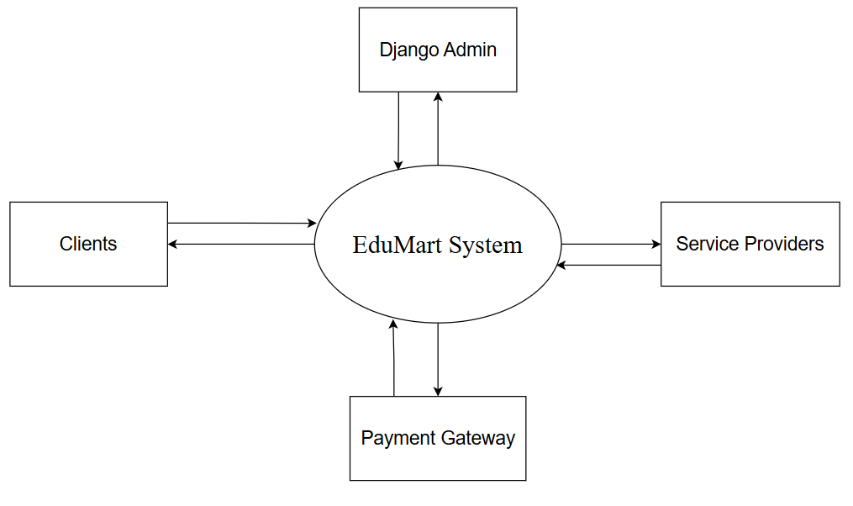

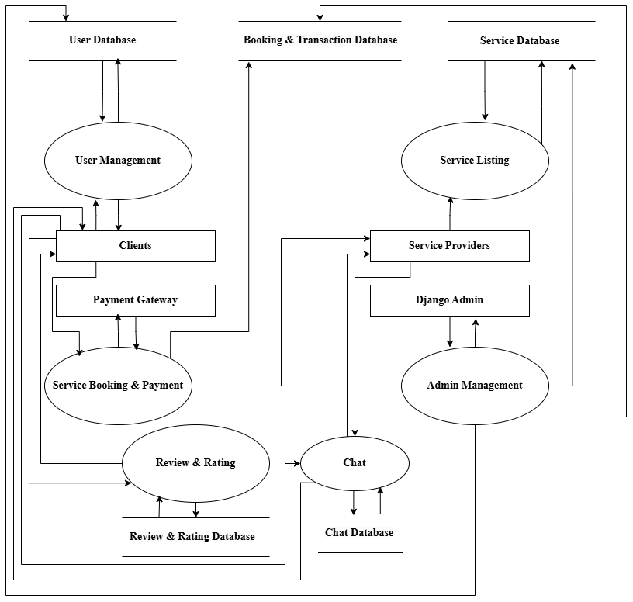**Level-1**

**Level-2**

**User Management**

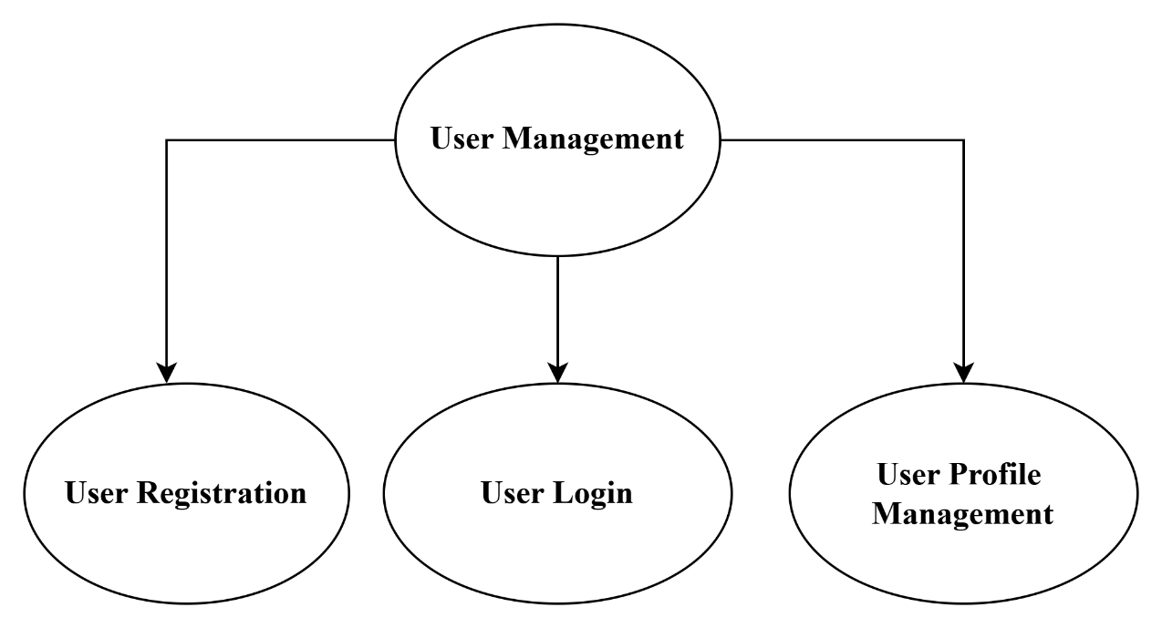

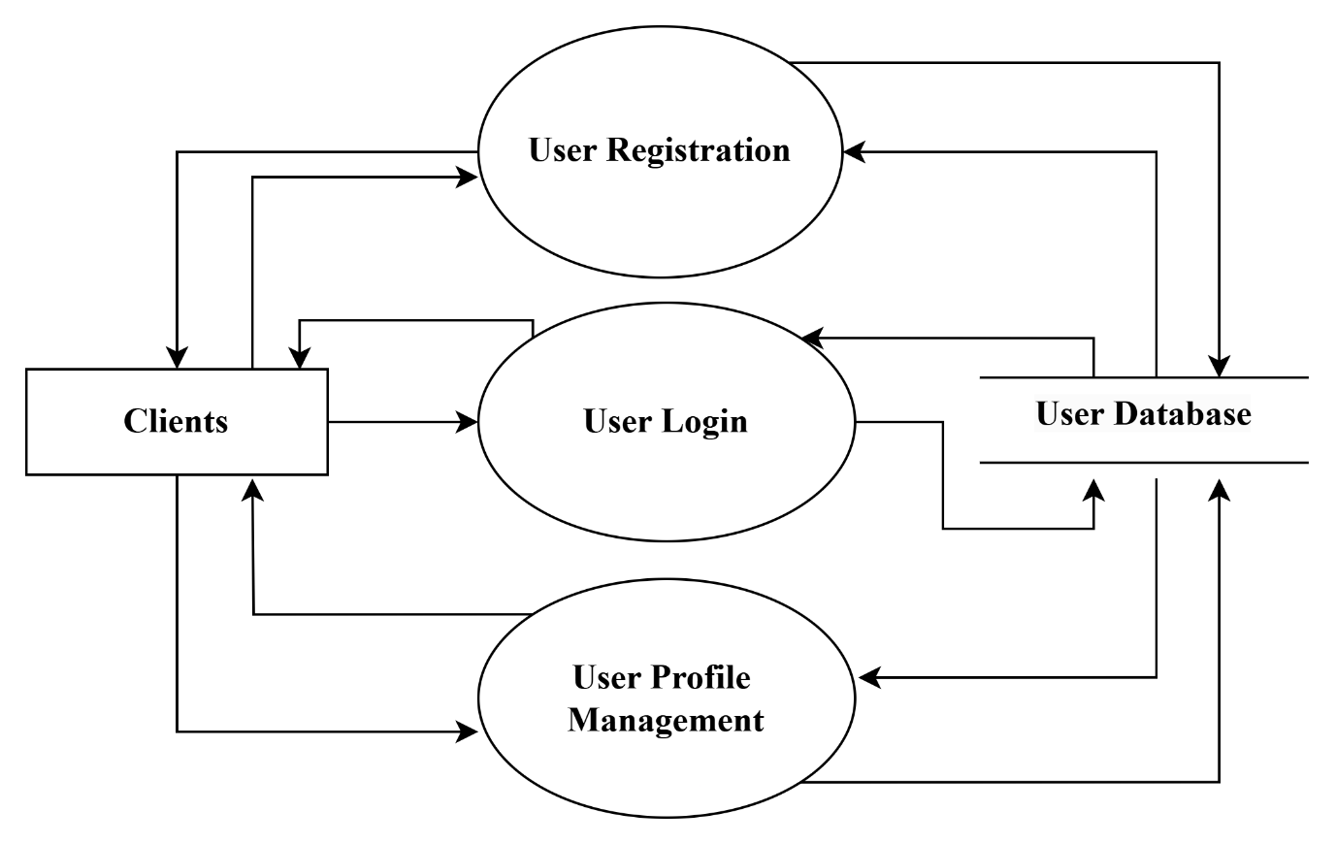

**Level-2 Continues**

**Service Listing**

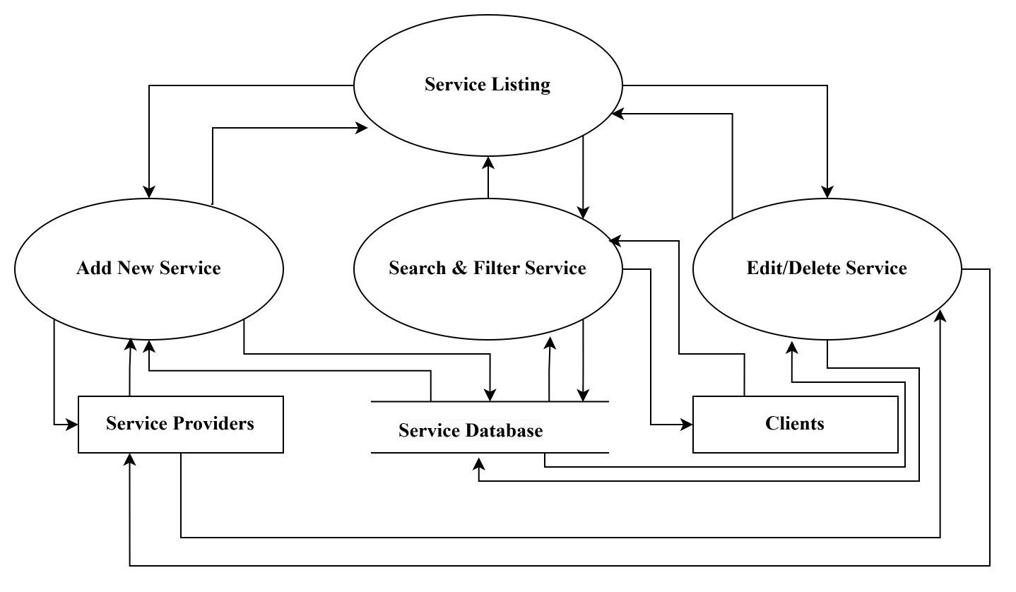

**Service Booking & Payments**

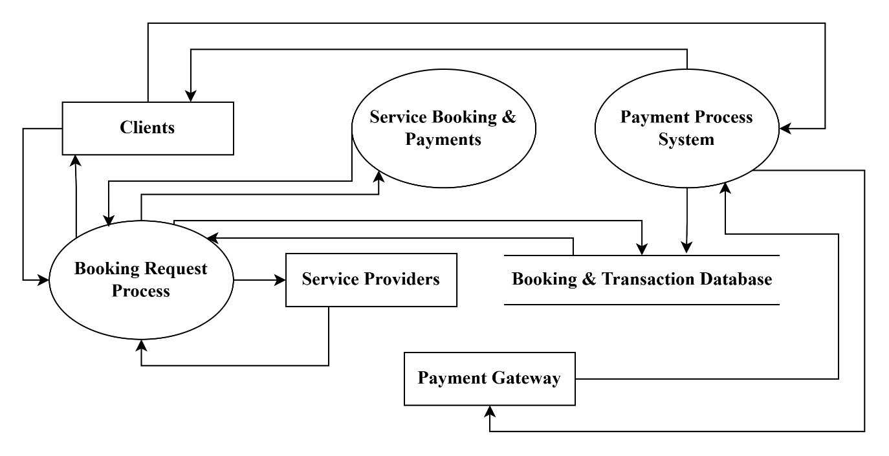

**Level-2 Continues**

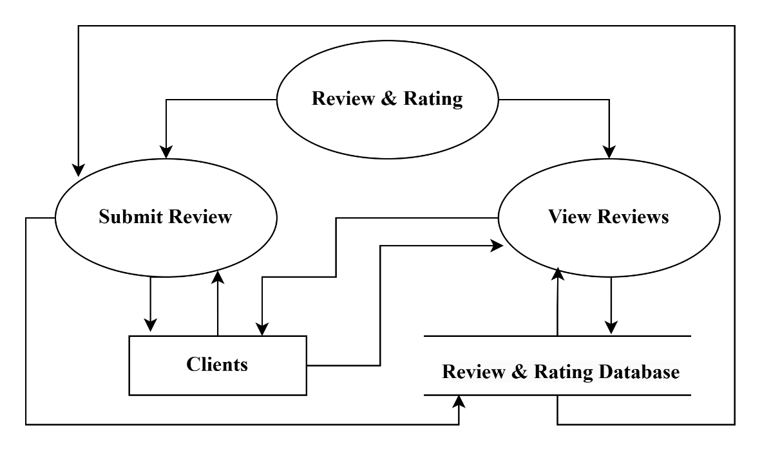**Review & Rating**

**Admin Management**

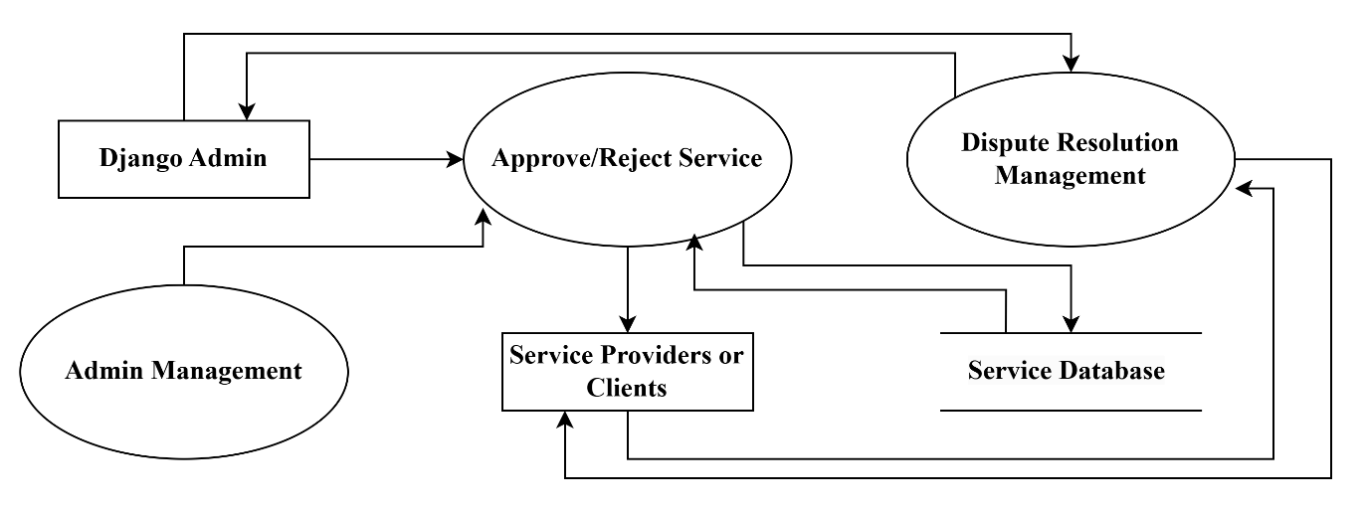

**Chat**

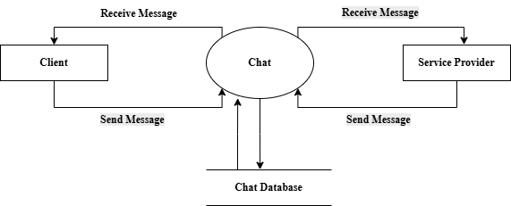

**6. DEVELOPMENT & TESTING**

The development phase will follow an agile methodology, with iterative cycles of planning, development, and testing. Key activities will include:

* **Development:** Writing and integrating code based on the specified requirements and design.
* **Testing:** Conducting unit tests, integration tests, and user acceptance tests to ensure functionality, performance, and security.
* **Deployment:** Deploying the website to a production environment and ensuring it is fully operational.
* **Maintenance:** Providing ongoing support and updates based on user feedback and emerging requirements.

**7. MODULES**

The **EduMart** project is structured into the following core modules:

1. **User Authentication Module:** This module manages secure login and registration for all users, including clients and service providers. Role-based access control ensures that users only access features relevant to their role. Passwords are securely encrypted, and session management ensures data privacy.
2. **Service Listing & Management Module:** Service providers can create, update, and manage educational service listings. Each service includes a title, detailed description, pricing, availability, and category (e.g., tutoring, design, development). Listings can be approved or moderated by the admin via the Django panel.
3. **Search & Filter Module:** Clients can search for educational services using keywords and apply filters such as category, title and service provider name. This helps users quickly discover relevant services based on their needs.
4. **Booking & Scheduling Module:** Clients can book services in real-time based on the provider’s availability. This module handles booking confirmations, status tracking, and automatic updates to service schedules, ensuring a seamless user experience.
5. **Payment Gateway Integration Module:** A secure payment gateway handles all financial transactions between clients and service providers. This module ensures payment confirmation, transaction tracking, and security compliance to protect user data.
6. **Chat & Communication Module:** Clients and service providers can communicate directly through a real-time messaging system integrated within the platform.
7. **Review & Rating Module:** After service completion, clients can submit reviews and ratings for the services they used. These ratings are publicly visible and help build trust and transparency within the platform.
8. **Admin Management Module:** Admins can manage users, review service listings, monitor bookings, resolve disputes, and moderate platform activity using the Django admin interface. This module ensures the integrity and smooth operation of the entire platform.
9. **User Profile & Dashboard Module:** Each user has access to a personalized dashboard that displays their bookings, listed services, reviews, and profile information. Service providers can manage their offerings, view client feedback, and update portfolios.

**8. TEST CASES**

1. **User Authentication**

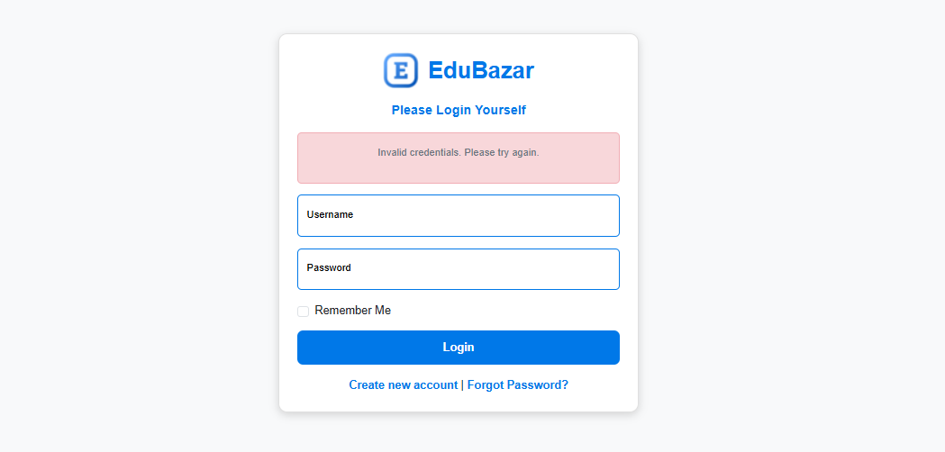 **Test Case 1.1:** User Login with Invalid Credentials

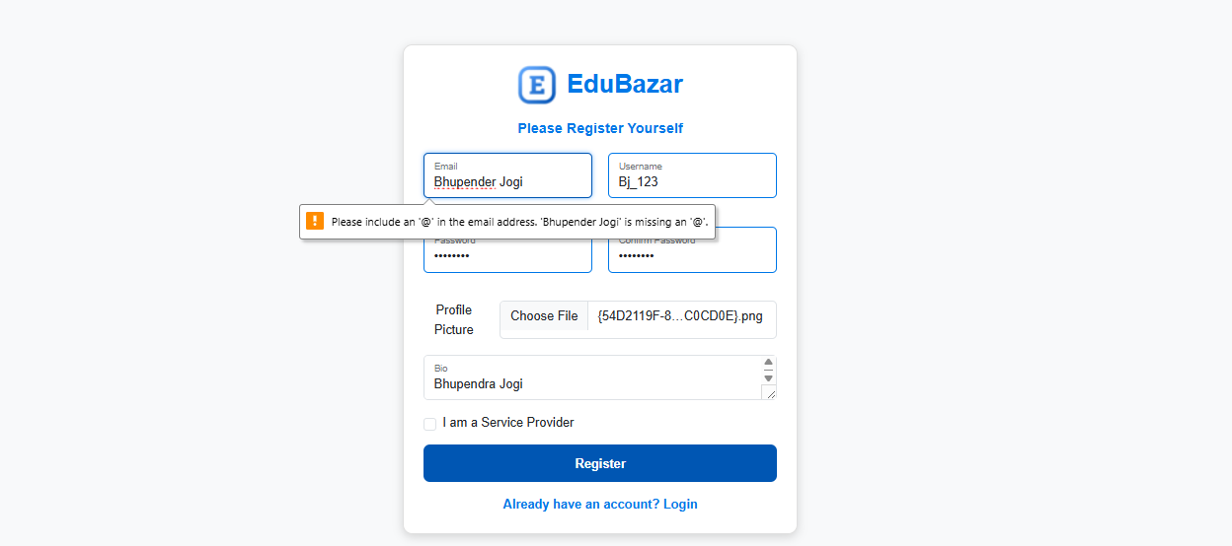**Test Case 1.2:** User Registration

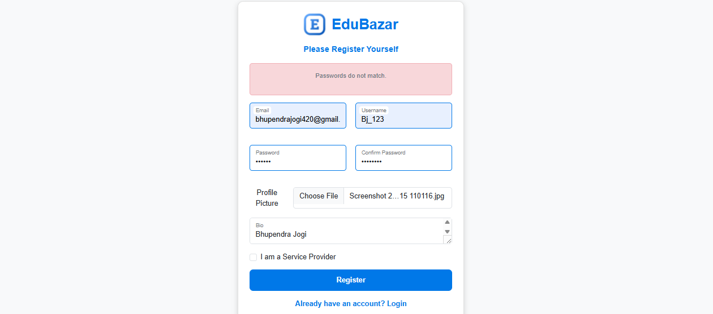

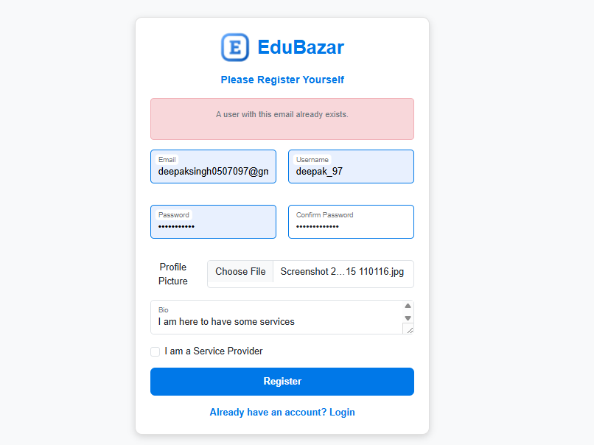

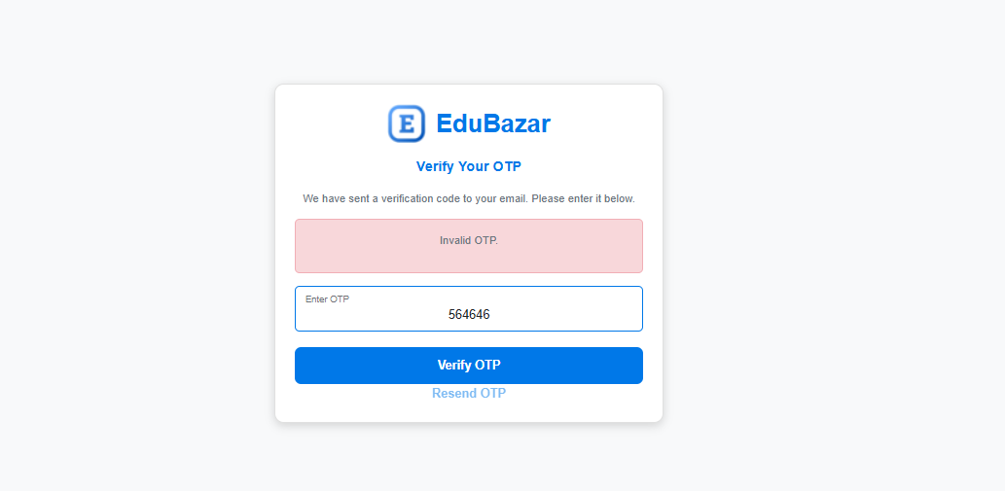**Test Case 1.3:** Invalid OTP (Forgot Password/Registration Verification)



**2. Booking System**

**Test Case 2.1:** For Ongoing Service

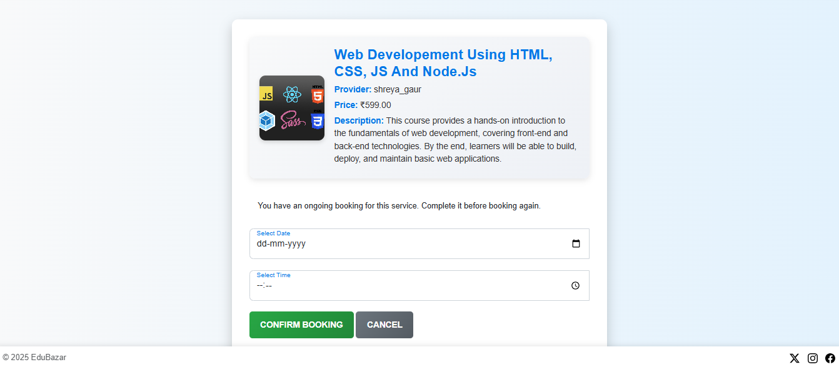



**9. PROJECT OUTPUTS**

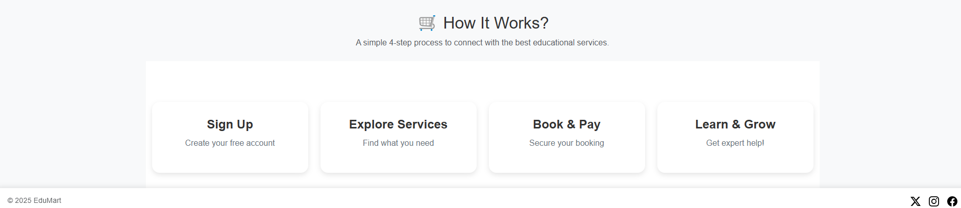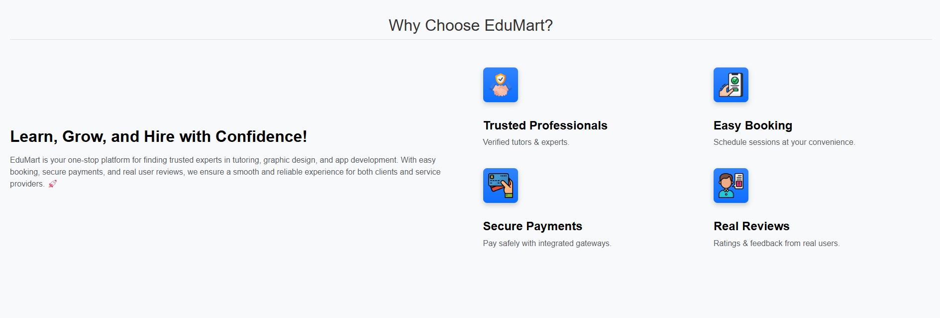**Home Page**

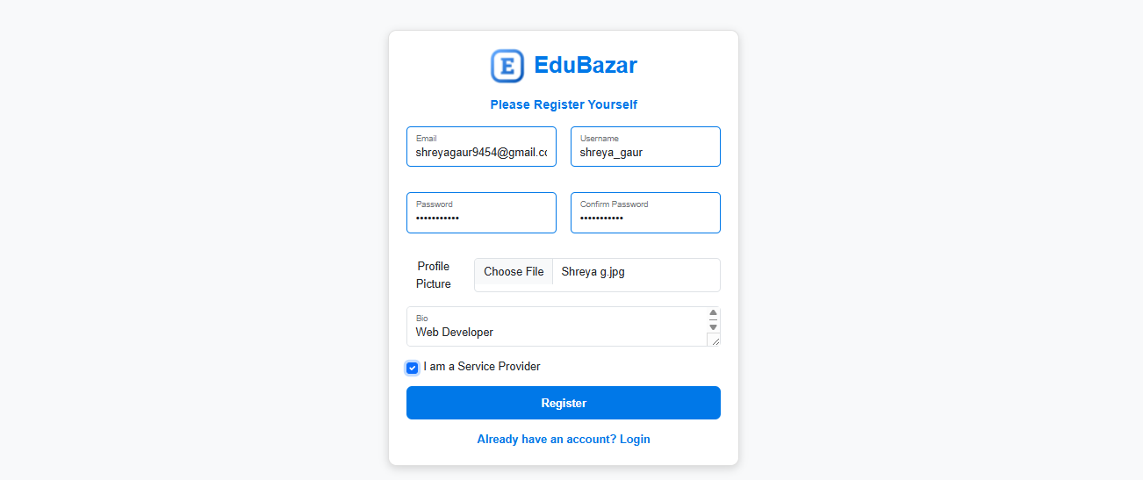**Registration**



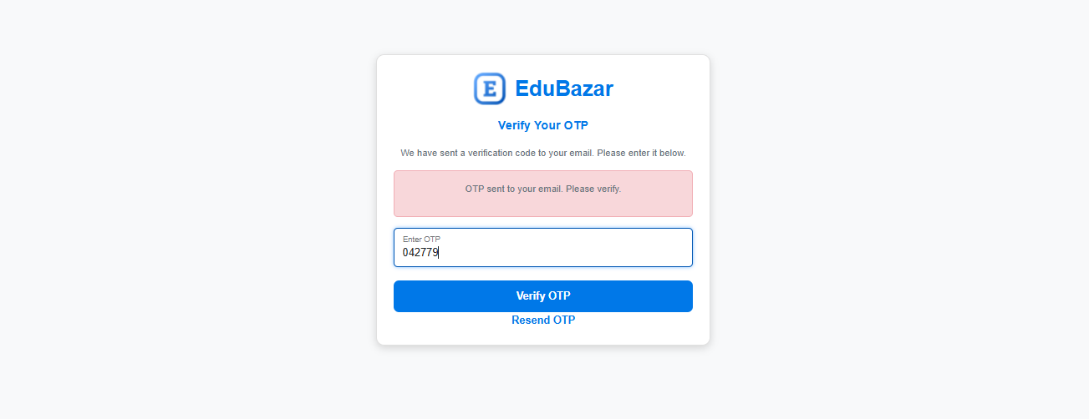

**Login**

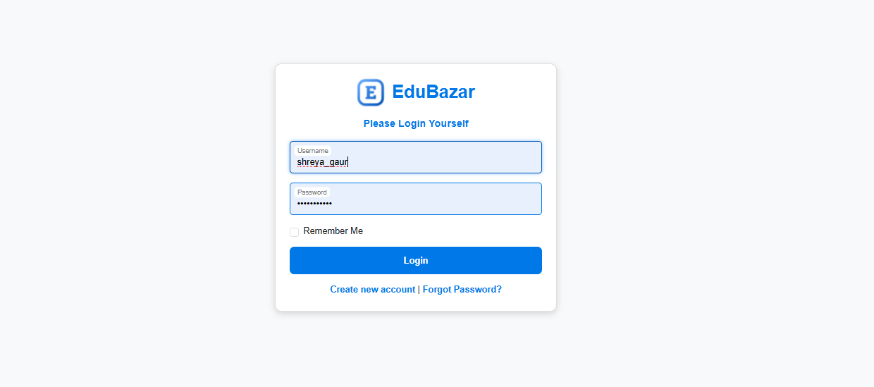



**User Profile (Login)**

**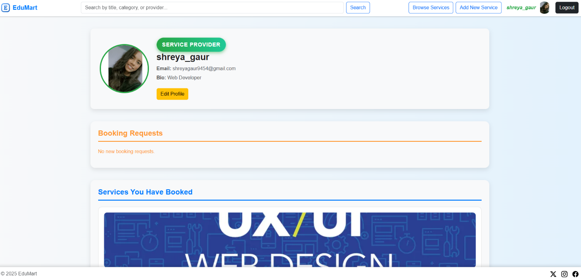****Edit Profile**

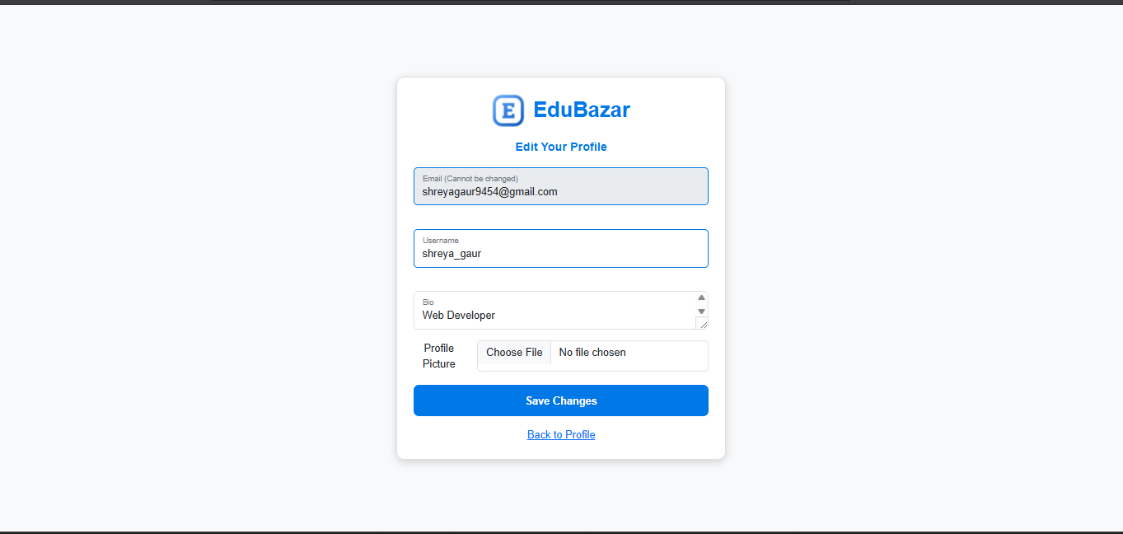

**Add Service**

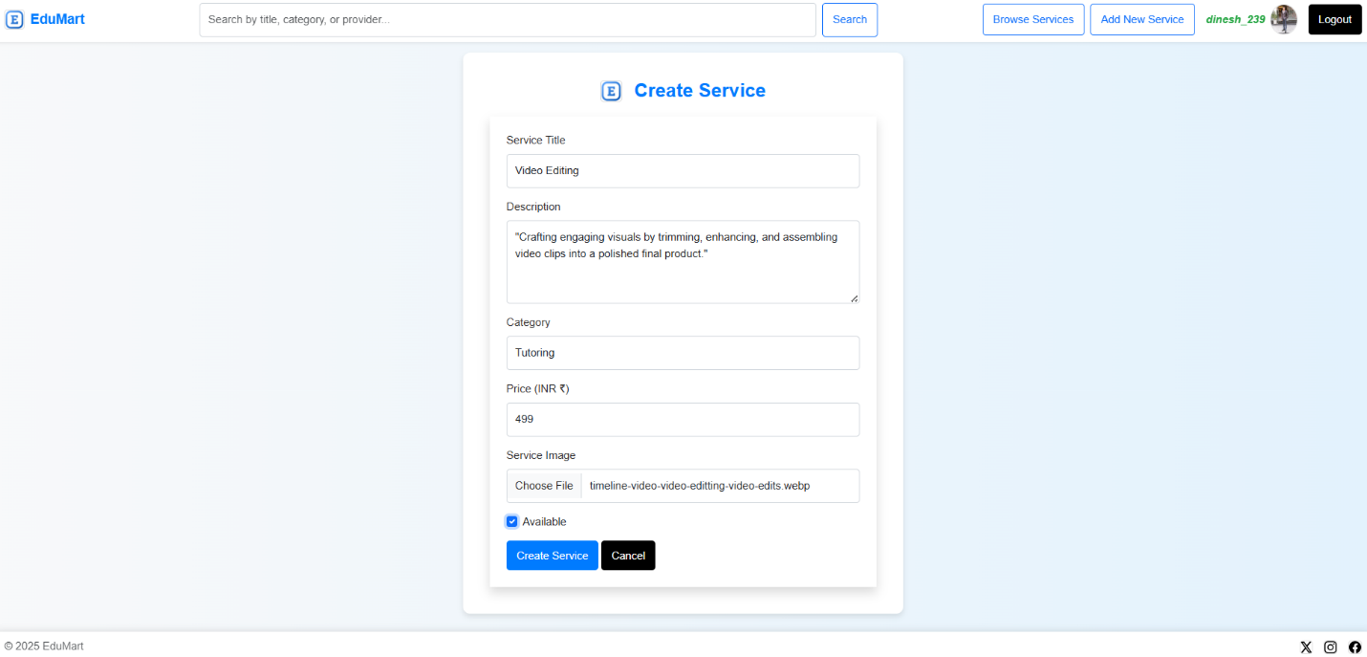

**Added Service**

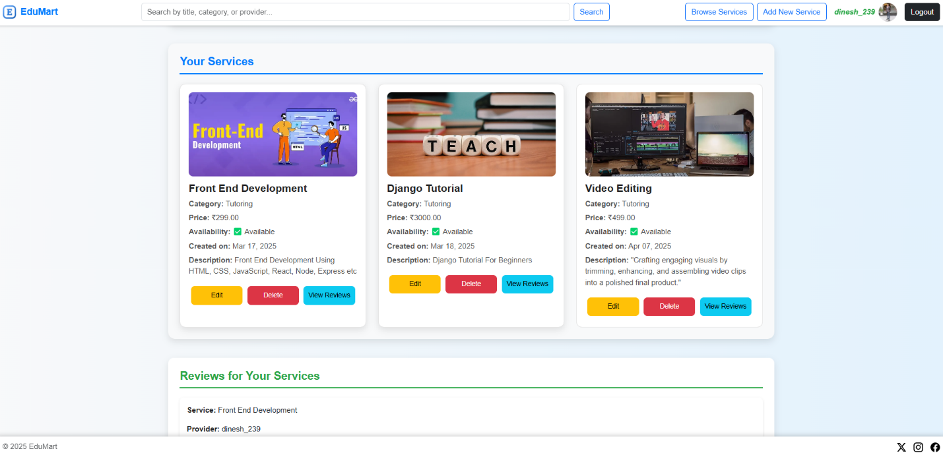

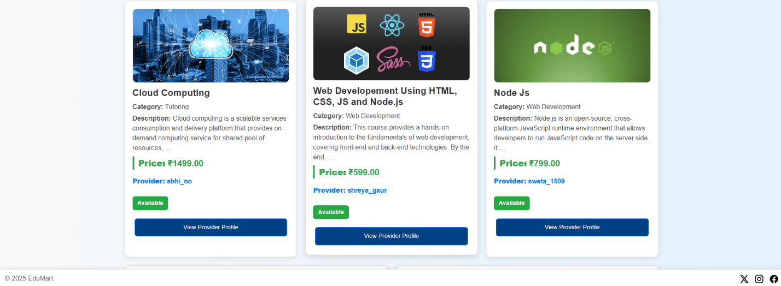**Service Listing**

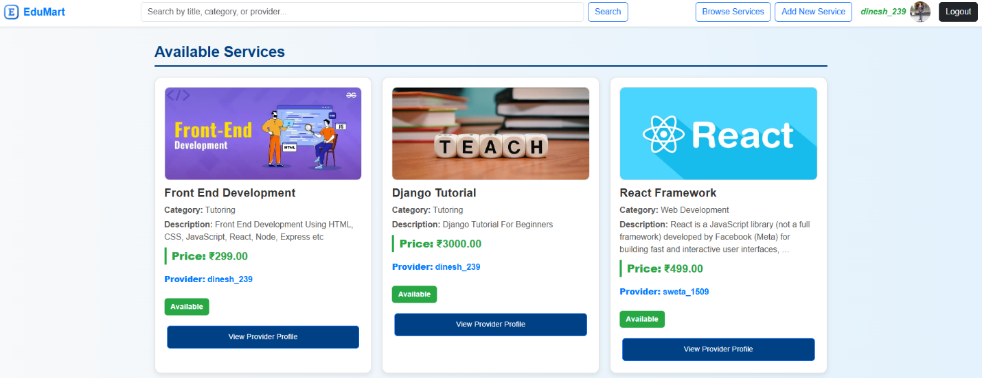

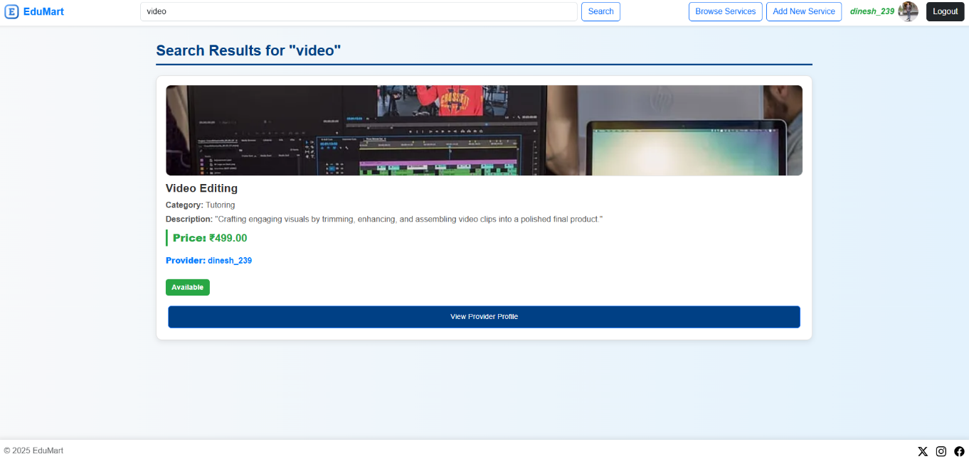**Searching**

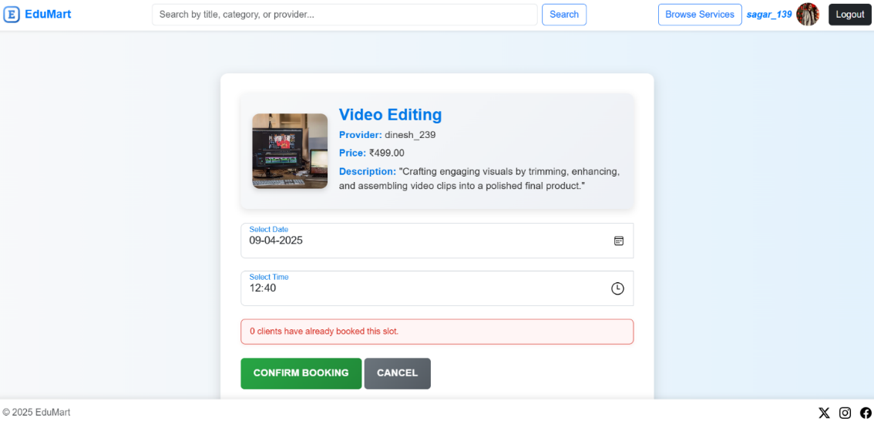**Service Booking (By Client)**

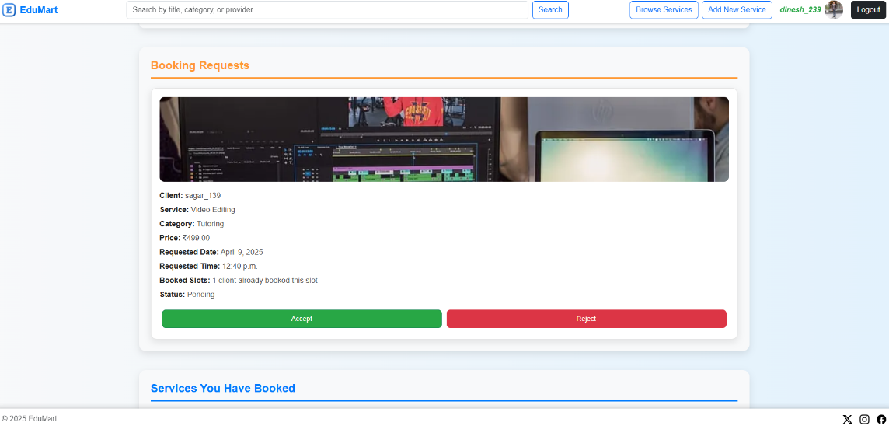**Accepting Booking Request (By Service Provider)**

**Payment (By Client)**

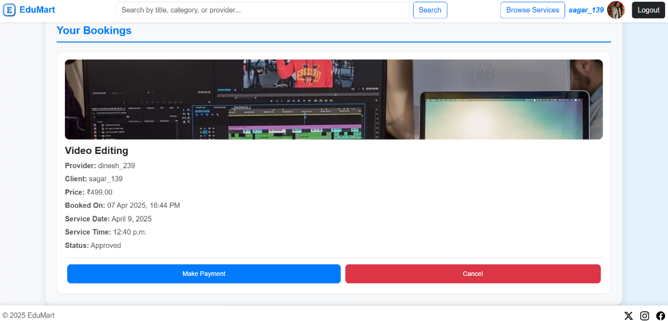

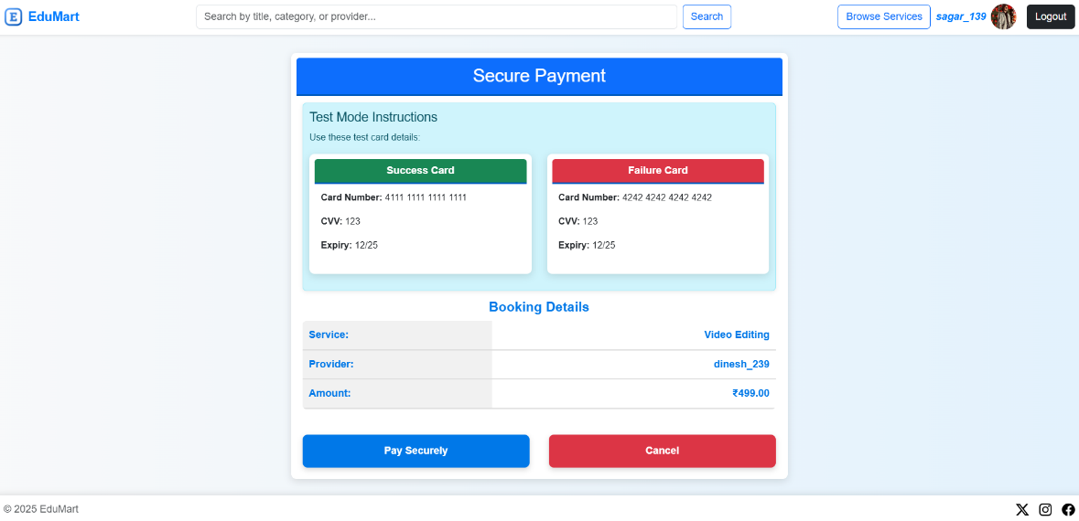

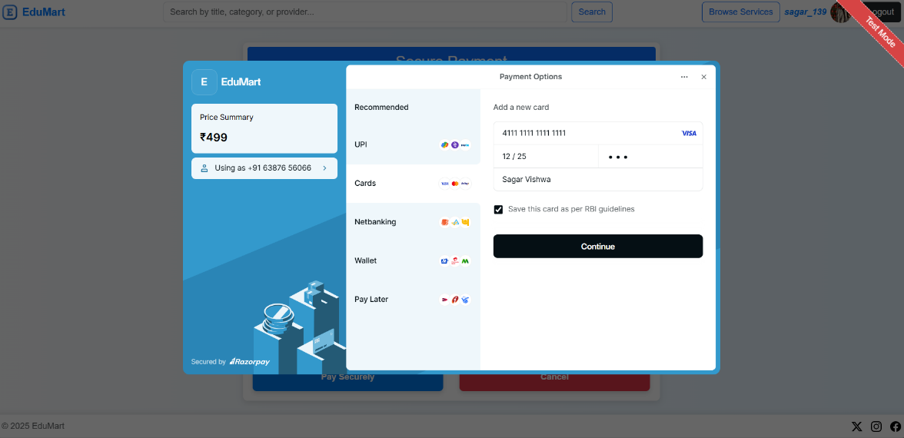

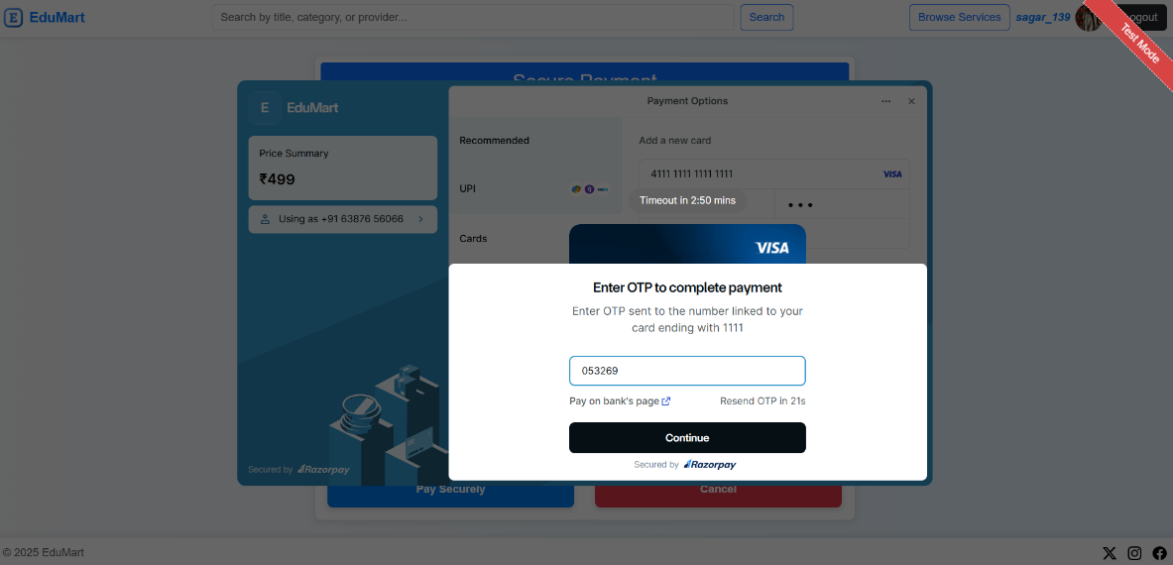

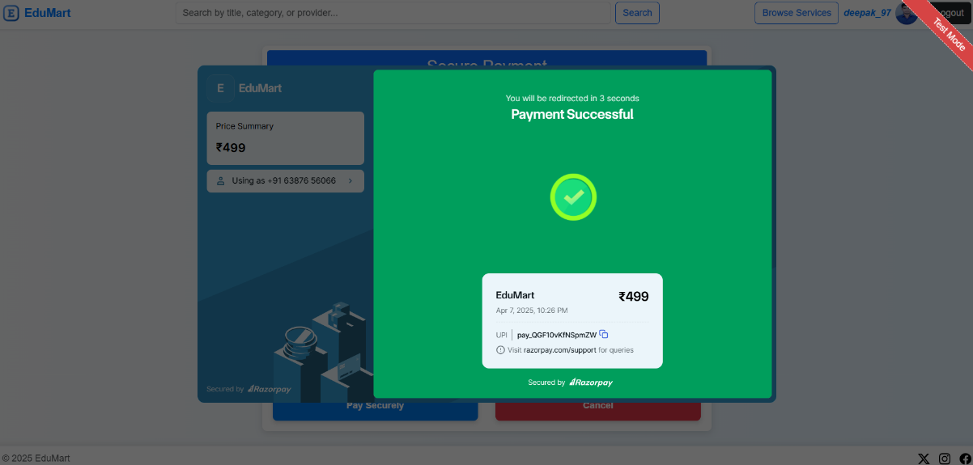**Payment Success**

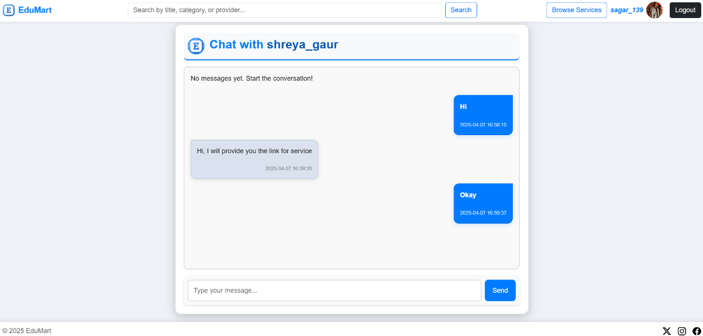**Client, Service Provider Interaction (Chat)**

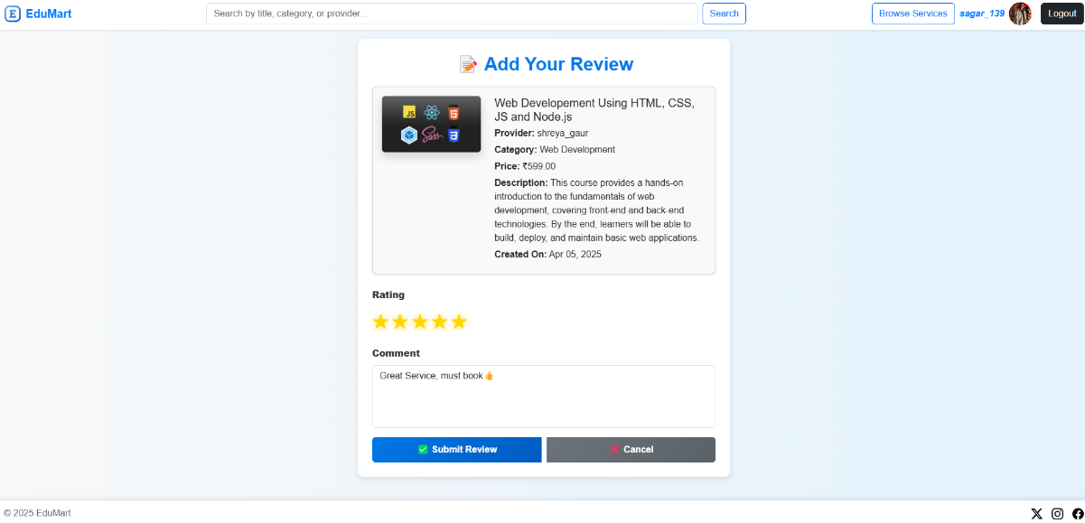**Submitting Review (By Client when Service Completes)**

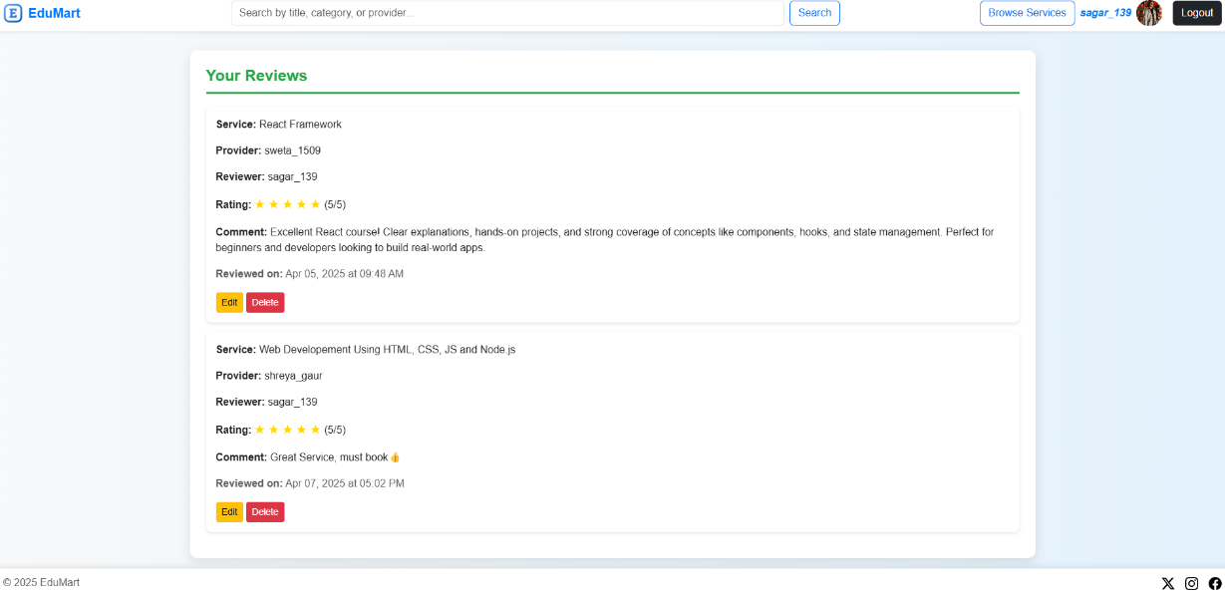**Review**

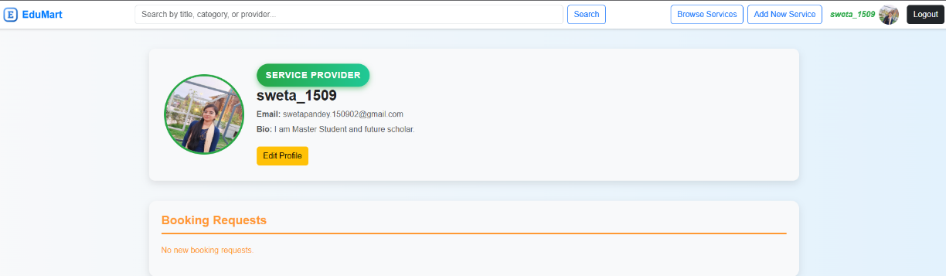**Viewing Provider Profile**

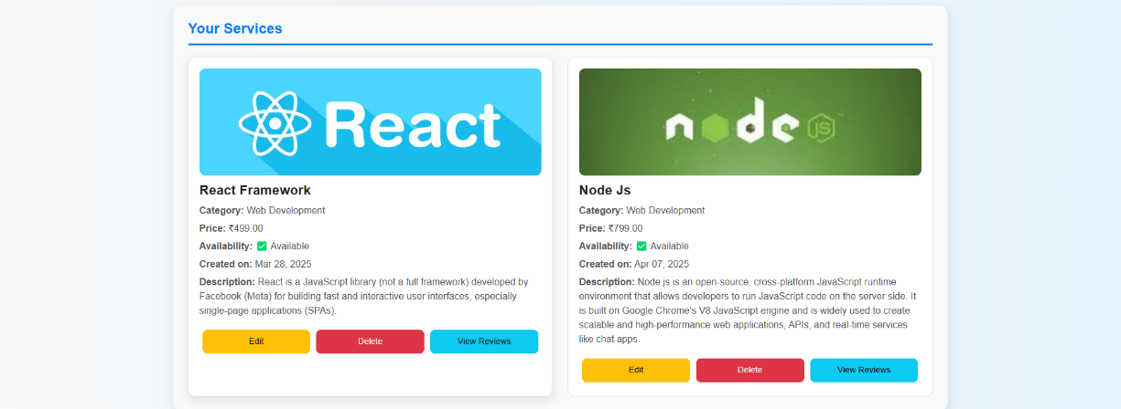

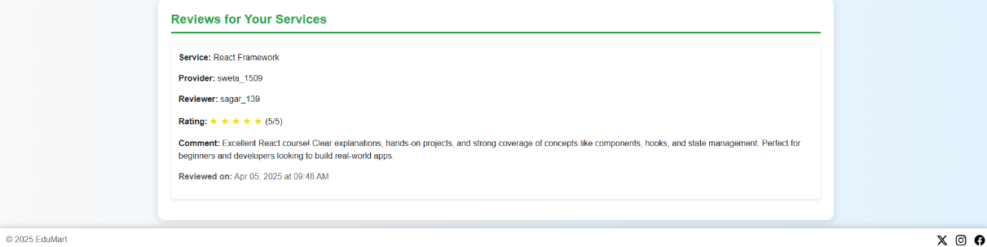

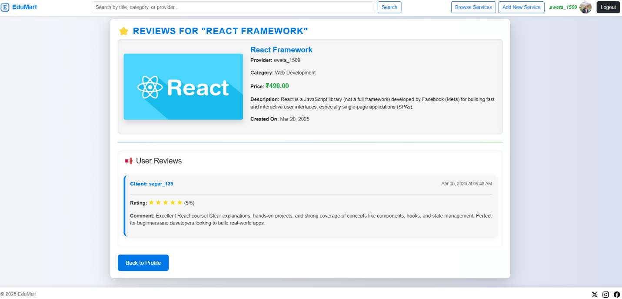**View Review**



**10. CODES**

**edumart (Project App)**

**asgi.py**import os

from django.core.asgi import get_asgi_application

from channels.routing import ProtocolTypeRouter, URLRouter

from channels.auth import AuthMiddlewareStack

from chat.routing import websocket_urlpatterns

os.environ.setdefault("DJANGO_SETTINGS_MODULE", "EduMart.settings")

application = ProtocolTypeRouter({

    "http": get_asgi_application(),

    "websocket": AuthMiddlewareStack(

        URLRouter(websocket_urlpatterns)

    ),

})

**settings.py**

import os

import random

import string

from pathlib import Path

BASE_DIR = Path(__file__).resolve().parent.parent

SECRET_KEY = 'django-insecure-zer*+d3zpq!vg^2n(i43co3rulxmb!=ldtuw)w+_fvbe&d34+h'

DEBUG = True

ALLOWED_HOSTS = []

AUTH_USER_MODEL = 'users.CustomUser'

LOGIN_URL = '/users/login/'

RAZORPAY_API_KEY = "rzp_test_A1QJ17pPhtyAce"

RAZORPAY_API_SECRET = "L5i7LWxeEmsISKFq1e5xFmiQ"

SESSION_SAVE_EVERY_REQUEST = True

SESSION_COOKIE_AGE = 86400 * 7

SESSION_COOKIE_SECURE = False

SESSION_ENGINE = "django.contrib.sessions.backends.db"

SESSION_COOKIE_NAME = "edumart_session"

SESSION_COOKIE_HTTPONLY = True

SESSION_COOKIE_SECRET = ''.join(random.choices(string.ascii_letters + string.digits, k=32))

INSTALLED_APPS = [

    'daphne',

    'django.contrib.admin',

    'django.contrib.auth',

    'django.contrib.contenttypes',

    'django.contrib.sessions',

    'django.contrib.messages',

    'django.contrib.staticfiles',

    'rest_framework',

    'channels',

    'users',

    'services',

    'bookings',

    'payments',

    'reviews',

    'chat',

]

MIDDLEWARE = [

    'django.middleware.security.SecurityMiddleware',

    'django.contrib.sessions.middleware.SessionMiddleware',

    'django.middleware.common.CommonMiddleware',

    'django.middleware.csrf.CsrfViewMiddleware',

    'django.contrib.auth.middleware.AuthenticationMiddleware',

    'django.contrib.messages.middleware.MessageMiddleware',

    'django.middleware.clickjacking.XFrameOptionsMiddleware',

    'EduMart.middleware.auth_middleware.AuthMiddleware',

    'EduMart.middleware.session_middleware.UniqueSessionMiddleware',

]

ROOT_URLCONF = 'edumart.urls'

TEMPLATES = [

    {

        'BACKEND': 'django.template.backends.django.DjangoTemplates',

        'DIRS': [BASE_DIR / "templates"],

        'APP_DIRS': True,

        'OPTIONS': {

            'context_processors': [

                'django.template.context_processors.debug',

                'django.template.context_processors.request',

                'django.contrib.auth.context_processors.auth',

                'django.contrib.messages.context_processors.messages',

            ],

        },

    },

]

ASGI_APPLICATION = "edumart.asgi.application"

CHANNEL_LAYERS = {

    "default": {

        "BACKEND": "channels.layers.InMemoryChannelLayer",

    },

}

WSGI_APPLICATION = edumart.wsgi.application'

DATABASES = {

    'default': {

        'ENGINE': 'django.db.backends.sqlite3',

        'NAME': BASE_DIR / 'db.sqlite3',

    }

}

AUTH_PASSWORD_VALIDATORS = [

    {'NAME': 'django.contrib.auth.password_validation.UserAttributeSimilarityValidator'},

    {'NAME': 'django.contrib.auth.password_validation.MinimumLengthValidator'},

    {'NAME': 'django.contrib.auth.password_validation.CommonPasswordValidator'},

    {'NAME': 'django.contrib.auth.password_validation.NumericPasswordValidator'},

]

LANGUAGE_CODE = 'en-us'

TIME_ZONE = 'UTC'

USE_I18N = True

USE_TZ = True

STATIC_URL = 'static/'

STATICFILES_DIRS = [BASE_DIR / "static"]

MEDIA_URL = '/media/'

MEDIA_ROOT = BASE_DIR / "media"

DEFAULT_AUTO_FIELD = 'django.db.models.BigAutoField'

EMAIL_BACKEND = 'django.core.mail.backends.smtp.EmailBackend'

EMAIL_HOST = 'smtp.gmail.com'

EMAIL_PORT = 587

EMAIL_USE_TLS = True

EMAIL_HOST_USER = 'davidsilvermann309@gmail.com'

EMAIL_HOST_PASSWORD = 'jemuebwmpganqgiv'

DEFAULT_FROM_EMAIL = 'davidsilvermann309@gmail.com'

**urls.py**

from django.contrib import admin

from django.urls import path,include

from django.conf import settings

from django.conf.urls.static import static

from .views import index, profile, provider_profile,manage_booking

urlpatterns = [

    path('admin/', admin.site.urls),

    path('',index,name="index"),

    path('profile',profile,name="profile"),

    path('provider_profile/<int:provider_id>/', provider_profile, name="provider_profile"),

    path('booking/<int:booking_id>/<str:action>/',manage_booking, name='manage_booking'),

    path('users/',include('users.urls')),

    path('services/', include('services.urls')),

    path('bookings/',include('bookings.urls')),

    path('payments/', include('payments.urls')),

    path('reviews/', include('reviews.urls')),

    path('chat/', include('chat.urls')),

]

if settings.DEBUG:

    urlpatterns += static(settings.MEDIA_URL, document_root=settings.MEDIA_ROOT)

**views.py**

from django.shortcuts import render, get_object_or_404, redirect

from django.contrib.auth.decorators import login_required

from users.models import CustomUser

from services.models import Service

from reviews.models import Review

from bookings.models import Booking  # Import the Booking model

from django.contrib import messages

from django.utils import timezone

def index(request):

    return render(request, 'index.html')

@login_required

def profile(request):

    delete_past_bookings()  # Delete outdated bookings

    user = request.user

    services = Service.objects.filter(provider=user, available=True) if user.is_service_provider else None

    client_bookings = Booking.objects.filter(client=user, status="Confirmed") if not user.is_service_provider else None

    bookings_client = Booking.objects.filter(client=user, status__in=["Pending", "Approved"]) if not user.is_service_provider else None

    provider_bookings = Booking.objects.filter(service__provider=user, status="Confirmed") if user.is_service_provider else None

    client_completed_services = Booking.objects.filter(client=user, status="Completed") if not user.is_service_provider else None

    provider_completed_services = Booking.objects.filter(service__provider=user, status="Completed") if user.is_service_provider else None

    notifications = Booking.objects.filter(service__provider=user, status="Pending") if user.is_service_provider else None

    client_reviews = Review.objects.filter(client=user) if not user.is_service_provider else None

provider_reviews = Review.objects.filter(service__provider=user) if user.is_service_provider else None

    return render(request, "profile.html", {

        "user": user,

        "services": services,

        "client_bookings": client_bookings,  # Confirmed bookings

        "bookings_client": bookings_client,  # Pending & Approved bookings

        "provider_bookings": provider_bookings,

        "client_completed_services": client_completed_services,

        "provider_completed_services": provider_completed_services,

        "notifications": notifications,

        "client_reviews": client_reviews,

        "provider_reviews": provider_reviews,

    })

@login_required

def manage_booking(request, booking_id, action):

    booking = get_object_or_404(Booking, id=booking_id, service__provider=request.user)

    if action == 'accept':

        booking.status = 'Confirmed'

        messages.success(request, f"Booking #{booking.id} has been confirmed!")

    elif action == 'reject':

        booking.status = 'Cancelled'

        messages.warning(request, f"Booking #{booking.id} has been rejected!")

        booking.save()

    return redirect('profile')

def provider_profile(request, provider_id):

    provider = get_object_or_404(CustomUser, id=provider_id)

    if request.user.is_authenticated and request.user == provider:

        return redirect('profile')

    services = Service.objects.filter(provider=provider, available=True)

    provider_reviews = Review.objects.filter(service__provider=provider).select_related('client', 'service')

    return render(request, 'provider_profile.html', {

        'provider': provider,

        'services': services,

        'provider_reviews': provider_reviews

    })

def delete_past_bookings():

    now = timezone.now()

    today = now.date()

    current_time = now.time()    Booking.objects.filter(date__lt=today).exclude(status__in=["Confirmed", "Completed"]).delete()

    Booking.objects.filter(date=today, time__lt=current_time).exclude(status__in=["Confirmed", "Completed"]).delete()

    Booking.objects.filter(

        date__lt=today, status="Confirmed"

    ).update(status="Completed")

    Booking.objects.filter(

        date=today, time__lt=current_time, status="Confirmed"

    ).update(status="Completed")

**wsgi.py**

import os

from django.core.wsgi import get_wsgi_application

os.environ.setdefault('DJANGO_SETTINGS_MODULE', 'EduMart.settings')

application = get_wsgi_application()

**Static**

**css/index_style.css**

body { font-family: 'Arial', sans-serif; background-color: #f8f9fa; color: #333; margin: 0; }

.navbar { background-color: #fff; padding: 10px 0; box-shadow: 0 2px 10px rgba(0, 0, 0, 0.1); transition: background-color 0.3s ease, box-shadow 0.3s ease; }

.navbar.fixed-top { position: fixed; top: 0; left: 0; right: 0; z-index: 1000; }

.navbar.navbar-scroll { background-color: rgba(255, 255, 255, 0.9); backdrop-filter: blur(10px); }

.navbar-brand { font-weight: bold; font-size: 1.5rem; color: #007bff !important; }

.navbar-brand img { margin-right: 10px; }

.navbar p { font-size: 1.1rem; color: #333; margin-bottom: 0; white-space: nowrap; font-style: italic; }

.carousel { position: relative; margin-bottom: 50px; padding-top: 70px; }

.carousel-img { width: 100%; height: 80vh; object-fit: cover; }

.fixed-overlay { position: absolute; top: 60%; left: 50%; transform: translate(-50%, -50%); text-align: center; color: #fff; z-index: 10; background-color: rgba(0, 0, 0, 0.7); padding: 40px 60px; border-radius: 15px; box-shadow: 0px 8px 30px rgba(0, 0, 0, 0.6); width: 80%; max-width: 800px; animation: fadeIn 1.5s ease-in-out; }

.fixed-overlay h1 { font-size: 3.5rem; font-weight: bold; margin-bottom: 10px; text-shadow: 2px 2px 4px rgba(0, 0, 0, 0.5); }

.fixed-overlay p { font-size: 1.5rem; font-weight: normal; margin-bottom: 20px; text-shadow: 2px 2px 4px rgba(0, 0, 0, 0.5); }

@keyframes fadeIn { from { opacity: 0; } to { opacity: 1; } }

.featured-section { padding: 80px 0; background-color: #fff; }

.featured-section h2 { font-size: 2.5rem; font-weight: bold; margin-bottom: 40px; text-align: left; padding-left: 15px; color: #28a745; }

.feature-icon-small { display: inline-flex; align-items: center; justify-content: center; width: 70px; height: 70px; border-radius: 15px; background: linear-gradient(135deg, #28a745, #218838); margin-bottom: 25px; box-shadow: 0 4px 10px rgba(0, 0, 0, 0.2); transition: transform 0.3s ease; }

.feature-icon-small:hover { transform: scale(1.1); }

.feature-icon-small img { width: 50px; height: 50px; }

.popular-services { padding: 80px 0; background-color: #f8f9fa; }

.popular-services h2 { font-size: 2.5rem; font-weight: bold; margin-bottom: 40px; text-align: left; padding-left: 15px; color: #28a745; }

.card-cover { background-size: cover; background-position: center; border: none; border-radius: 15px; transition: transform 0.3s ease, box-shadow 0.3s ease; overflow: hidden; }

.card-cover:hover { transform: translateY(-10px); box-shadow: 0 8px 20px rgba(0, 0, 0, 0.3); }

.card-cover h3 { font-size: 2rem; font-weight: bold; color: #fff; text-shadow: 2px 2px 4px rgba(0, 0, 0, 0.5); }

.card-cover p { font-size: 1.2rem; color: #fff; text-shadow: 2px 2px 4px rgba(0, 0, 0, 0.5); }

.how-it-works { padding: 80px 0; background-color: #fff; }

.how-it-works h2 { font-size: 2.5rem; font-weight: bold; margin-bottom: 40px; text-align: left; padding-left: 15px; color: #28a745; }

.step-box { text-align: center; padding: 30px; border: none; border-radius: 15px; transition: transform 0.3s ease, box-shadow 0.3s ease; background-color: #fff; box-shadow: 0 4px 10px rgba(0, 0, 0, 0.1); }

.step-box:hover { transform: translateY(-10px); box-shadow: 0 8px 20px rgba(0, 0, 0, 0.2); }

.step-box i { font-size: 2.5rem; color: #28a745; margin-bottom: 20px; transition: color 0.3s ease; }

.step-box:hover i { color: #218838; }

.step-box h5 { font-size: 1.5rem; font-weight: bold; margin-bottom: 10px; color: #333; }

.step-box p { font-size: 1rem; color: #6c757d; }

.footer { background-color: #fff; padding: 10px 0; box-shadow: 0 -2px 10px rgba(0, 0, 0, 0.1); position: fixed; bottom: 0; left: 0; right: 0; z-index: 1000; height: 50px; display: flex; align-items: center; }

.footer .container-fluid { display: flex; justify-content: space-between; align-items: center; padding: 0 20px; }

.footer span { font-size: 0.9rem; color: #6c757d; }

.footer ul { margin: 0; padding: 0; }

.footer img { filter: grayscale(100%); transition: filter 0.3s ease; height: 20px; width: 20px; }

.footer img:hover { filter: grayscale(0%); }

**css/home_base_style.css**body { background: linear-gradient(to right, #f8f9fa, #e3f2fd); font-family: 'Poppins', sans-serif; min-height: 100vh; display: flex; flex-direction: column; }

.navbar { backdrop-filter: blur(10px); box-shadow: 0px 4px 6px rgba(0, 0, 0, 0.1); }

.navbar-brand span { color: #007bff; font-weight: bold; }

.user-username { font-weight: bold; }

.service-provider-username { color: #28a745 !important; }

.customer-username { color: #007bff !important; }

.footer { background: #fff; padding: 10px 0; box-shadow: 0 -2px 10px rgba(0, 0, 0, 0.1); display: flex; justify-content: space-between; align-items: center; }

.footer img { filter: grayscale(100%); transition: filter 0.3s ease; }

.footer img:hover { filter: grayscale(0%); }

**css/profile_style.css**  
.main-content{width:100%;max-width:1500px;margin:0 auto;display:flex;flex-direction:column;gap:40px;padding-bottom:60px}

.profile-section{background:#f8f9fa;border-radius:12px;box-shadow:0 6px 15px rgba(0,0,0,0.1);padding:30px;display:flex;align-items:center;gap:25px;width:100%;transition:.3s ease-in-out}

.profile-section:hover{transform:scale(1.02);box-shadow:0 8px 20px rgba(0,0,0,0.15)}

.profile-large{width:160px;height:160px;border-radius:50%;border:4px solid #007bff;transition:.3s ease-in-out}

.service-provider .profile-large{border-color:#28a745!important}

.profile-large:hover{transform:scale(1.05);box-shadow:0 0 15px rgba(0,123,255,0.6)}

.profile-info{flex:1;text-align:left}

.profile-info h3{font-size:1.8rem;font-weight:bold;color:#222}

.profile-info p{margin:6px 0;font-size:1rem;color:#555}

.notifications-section{background:#f8f9fa;border-radius:15px;box-shadow:0 6px 15px rgba(0,0,0,0.1);padding:25px;width:100%;transition:.3s ease-in-out}

.notifications-section:hover{transform:scale(1.02)}

.notifications-section h4{font-size:1.5rem;color:#FF9933;font-weight:bold;border-bottom:3px solid #FF9933;padding-bottom:10px;margin-bottom:20px}

.notifications-section p.text-muted{color:#FF9933!important}

.notification-list{display:flex;flex-wrap:wrap;gap:25px;justify-content:center}

.notification-card{flex:1 1 calc(30% - 20px);background:#fff;border-radius:12px;box-shadow:0 5px 15px rgba(0,0,0,0.1);padding:18px;transition:.3s ease-in-out;position:relative;overflow:hidden;text-align:left;border:1px solid rgba(0,0,0,0.1)}

.notification-card img{width:100%;height:180px;object-fit:cover;border-radius:10px;margin-bottom:12px}

.notification-card p{font-size:1rem;margin:6px 0;color:#555;text-align:left}

.notification-card p strong{font-weight:bold;color:#222}

.notification-card .status,.service-status{font-size:1.2rem;font-weight:bold;margin-top:8px;display:block;text-align:left;padding:5px 0;padding-left:10px;border-left:5px solid;background:rgba(0,123,255,0.1)}

.notification-card .status::before{content:"Status: ";font-weight:normal;color:#333}

.service-status.confirmed{border-color:#28a745;background:rgba(40,167,69,0.1);color:#218838}

.service-status.completed{border-color:#007bff;background:rgba(0,123,255,0.1);color:#0056b3}

.notification-actions{display:flex;justify-content:space-between;margin-top:15px}

.notification-actions .btn{flex:1;margin:5px;border-radius:8px;font-size:.9rem;padding:8px;transition:.3s ease-in-out}

.notification-actions .btn-success{background:#28a745;color:#fff}

.notification-actions .btn-success:hover{background:#218838}

.notification-actions .btn-danger{background:#dc3545;color:#fff}

.notification-actions .btn-danger:hover{background:#bd2130}

.notification-card:hover{transform:scale(1.05);box-shadow:0 7px 20px rgba(0,0,0,0.15)}

.booked-services-title,.booked-services-title+p{color:#FF9933}

@media(max-width:1200px){.notification-card{flex:1 1 calc(45% - 20px)}}

@media(max-width:768px){.notification-card{flex:1 1 100%}.notification-actions{flex-direction:column}.notification-actions .btn{width:100%}}

.service-provider-badge{display:inline-block;background:linear-gradient(90deg,#28a745,#20c997);color:#fff;padding:10px 18px;border-radius:25px;font-size:1.1rem;font-weight:bold;box-shadow:0 4px 10px rgba(40,167,69,0.5);transition:.2s ease-in-out;text-transform:uppercase;letter-spacing:1px}

.service-provider-badge:hover{transform:scale(1.07);box-shadow:0 5px 12px rgba(40,167,69,0.6)}

.services-section{background:#f8f9fa;border-radius:15px;box-shadow:0 6px 15px rgba(0,0,0,0.1);padding:25px;width:100%;transition:.3s ease-in-out}

.services-section:hover{transform:scale(1.02)}

.services-section h4{font-size:1.5rem;color:#007bff;font-weight:bold;border-bottom:3px solid #007bff;padding-bottom:10px;margin-bottom:20px}

.service-list{display:flex;flex-wrap:wrap;gap:25px;justify-content:center}

.service-card{flex:1 1 calc(30% - 20px);background:#fff;border-radius:12px;box-shadow:0 5px 15px rgba(0,0,0,0.1);padding:18px;transition:.3s ease-in-out;position:relative;overflow:hidden;text-align:left;border:1px solid rgba(0,0,0,0.1)}

.service-card img{width:100%;height:180px;object-fit:cover;border-radius:10px}

.service-card h5{font-size:1.4rem;font-weight:bold;margin-top:12px;color:#222;text-align:left}

.service-card p{font-size:1rem;margin:6px 0;color:#555;text-align:left}

.service-price{font-size:1.5rem;font-weight:bold;color:#28a745;margin-top:8px;display:block;text-align:left;padding:5px 0;padding-left:10px;border-left:5px solid #28a745;background:rgba(40,167,69,0.1)}

.service-price::before{content:"Price: ";font-weight:normal;color:#333}

.service-availability{display:inline-block;padding:6px 12px;font-size:.9rem;font-weight:bold;border-radius:6px;color:#fff;margin-top:10px;text-align:left}

.available{background:#28a745}

.not-available{background:#dc3545}

.service-actions{display:flex;justify-content:space-between;margin-top:15px}

.service-actions .btn{flex:1;margin:5px;border-radius:8px;font-size:.9rem;padding:8px;transition:.3s ease-in-out}

.service-actions .btn-primary{background:#007bff;color:#fff}

.service-actions .btn-primary:hover{background:#0056b3}

.service-actions .btn-warning{background:#ffc107;color:#000}

.service-actions .btn-warning:hover{background:#e0a800}

.service-actions .btn-danger{background:#dc3545;color:#fff}

.service-actions .btn-danger:hover{background:#bd2130}

.service-card:hover{transform:scale(1.05);box-shadow:0 7px 20px rgba(0,0,0,0.15)}

.review-card{background:#fff;padding:15px;border-radius:8px;box-shadow:0 2px 5px rgba(0,0,0,0.1);margin-bottom:15px}

.stars{font-size:1.2rem;color:#FFD700}

.star{color:#ccc}

.star.filled{color:gold}

.reviews-section{background:#fff;border-radius:12px;box-shadow:0 6px 15px rgba(0,0,0,0.1);padding:25px;width:100%}

.reviews-section h4{font-size:1.5rem;color:#28a745;font-weight:bold;border-bottom:3px solid #28a745;padding-bottom:10px;margin-bottom:20px}

.list-group-item{border-radius:8px;margin-bottom:6px;background:#f9f9f9;transition:.3s ease;padding:12px}

.list-group-item:hover{transform:translateX(8px);background:#e9f7ec}

@media(max-width:1200px){.service-card{flex:1 1 calc(45% - 20px)}}

@media(max-width:768px){

.profile-section{flex-direction:column;text-align:center}

.profile-large{width:130px;height:130px}

.service-card{flex:1 1 100%}

.service-actions{flex-direction:column}

.service-actions .btn{width:100%}

}

.service-card-footer{display:flex;justify-content:space-between;align-items:center;margin-top:15px;padding-top:10px;border-top:1px solid rgba(0,0,0,0.1)}

.service-card-footer .btn{flex:1;text-align:center;padding:10px 15px;border-radius:8px;font-size:.9rem;transition:.3s ease-in-out;margin:5px}

.payment-btn{background:#007bff;color:#fff}

.payment-btn:hover{background:#0056b3}

.cancel-btn{background:#dc3545;color:#fff}

.cancel-btn:hover{background:#bd2130}

.cancel-form{flex:1;display:flex}

.cancel-form button{width:100%}

**script/index_script.js**

document.addEventListener("scroll", function () {

    const navbar = document.querySelector(".navbar");

    if (window.scrollY > 50) {

        navbar.classList.add("navbar-scroll");

    } else {

        navbar.classList.remove("navbar-scroll");

    }

});

**script/profile_script.js**

document.addEventListener("DOMContentLoaded", function () {

const profileImage = document.querySelector(".img-fluid");

if (profileImage) {

profileImage.addEventListener("mouseenter", function () { this.style.transform = "scale(1.1)"; this.style.transition = "0.3s ease-in-out"; });

profileImage.addEventListener("mouseleave", function () { this.style.transform = "scale(1)"; });

}

const serviceCards = document.querySelectorAll(".service-card");

serviceCards.forEach(card => {

card.addEventListener("mouseenter", function () { this.style.boxShadow = "0px 5px 20px rgba(0, 120, 232, 0.3)"; this.style.transition = "0.3s"; });

card.addEventListener("mouseleave", function () { this.style.boxShadow = "none"; });

});

const reviewLink = document.getElementById("reviews-link");

if (reviewLink) {

reviewLink.addEventListener("click", function (event) { event.preventDefault(); document.getElementById("reviews-section").scrollIntoView({ behavior: "smooth" }); });

}

const logoutButton = document.querySelector(".logout-button");

if (logoutButton) {

logoutButton.addEventListener("click", function (event) { event.preventDefault(); if (confirm("Are you sure you want to log out?")) { window.location.href = this.getAttribute("data-url"); } });

}

});

**templates**

**base.html**

{% load static %}

<!doctype html>

<html lang="en">f

<head>

<meta charset="utf-8">

<meta name="viewport" content="width=device-width, initial-scale=1">

<title>{% block title %}{% endblock %}</title>

<link rel="icon" href="{% static 'appicon.ico' %}" type="image/icon">

<link href="https://cdn.jsdelivr.net/npm/bootstrap@5.3.3/dist/css/bootstrap.min.css" rel="stylesheet" integrity="sha384-QWTKZyjpPEjISv5WaRU9OFeRpok6YctnYmDr5pNlyT2bRjXh0JMhjY6hW+ALEwIH" crossorigin="anonymous">

{% block style %}{% endblock %}

</head>

<body>

{% block content %}{% endblock %}

<script src="https://cdn.jsdelivr.net/npm/bootstrap@5.3.3/dist/js/bootstrap.bundle.min.js" integrity="sha384-YvpcrYf0tY3lHB60NNkmXc5s9fDVZLESaAA55NDzOxhy9GkcIdslK1eN7N6jIeHz" crossorigin="anonymous"></script>

{% block script %}{% endblock %}

<script></script>

</body>

</html>

**home_base.html**

{% load static %}

<!doctype html>

<html lang="en">

<head>

<meta charset="utf-8">

<meta name="viewport" content="width=device-width, initial-scale=1">

<title>{% block title %}{% endblock %}</title>

<link rel="icon" href="{% static 'appicon.ico' %}" type="image/icon">

<link href="https://cdn.jsdelivr.net/npm/bootstrap@5.3.3/dist/css/bootstrap.min.css" rel="stylesheet" integrity="sha384-QWTKZyjpPEjISv5WaRU9OFeRpok6YctnYmDr5pNlyT2bRjXh0JMhjY6hW+ALEwIH" crossorigin="anonymous">

<link rel="stylesheet" href="{% static 'css/home_base_style.css' %}">

{% block style %}{% endblock %}

</head>

<body>

<nav class="navbar navbar-expand-lg navbar-light bg-white shadow-sm fixed-top navbar-scroll">

<div class="container-fluid d-flex justify-content-between align-items-center">

<a class="navbar-brand d-flex align-items-center" href="{% url 'profile' %}">

<img src="{% static 'appicon.ico' %}" alt="EduMart Logo" width="30" class="me-2">

<span class="fw-bold">EduMart</span>

</a>

<form class="d-flex mx-auto w-50" action="{% url 'search_services' %}" method="GET">

<input class="form-control me-2" type="search" placeholder="Search by title, category, or provider..." aria-label="Search" name="q" value="{{ request.GET.q }}">

<button class="btn btn-outline-primary" type="submit">Search</button>

</form>

<div class="d-flex align-items-center">

<button class="btn btn-outline-primary me-2 fw-normal" onclick="window.location.href='{% url 'service_list' %}'">Browse Services</button>

{% if user.is_service_provider %}

<button class="btn btn-outline-primary me-3 fw-normal" onclick="window.location.href='{% url 'create_service' %}'">Add New Service</button>

{% endif %}

<a href="{% url 'profile' %}" class="user-profile d-flex align-items-center text-decoration-none">

<span class="fst-italic me-2 m-0 p-0 user-username {% if user.is_service_provider %}service-provider-username{% else %}customer-username{% endif %}">{{ user.username }}</span>

{% if user.profile_picture %}

<img src="{{ user.profile_picture.url }}" alt="User" class="rounded-circle profile-pic m-0 p-0" width="40" height="40">

{% endif %}

</a>

<a href="{% url 'logout' %}" class="btn btn-dark ms-3 fw-normal">Logout</a>

</div>

</div>

</nav>

{% block content %}{% endblock %}

<footer class="footer fixed-bottom">

<div class="container-fluid d-flex justify-content-between align-items-center">

<span class="text-body-secondary">© {% now 'Y' %} EduMart</span>

<ul class="nav list-unstyled d-flex">

<li class="ms-3"><a class="text-body-secondary" href="#"><img src="{% static 'images/twitter.svg' %}" alt="twitter-icon" height="20" width="20"></a></li>

<li class="ms-3"><a class="text-body-secondary" href="#"><img src="{% static 'images/instagram.svg' %}" alt="instagram-icon" height="20" width="20"></a></li>

<li class="ms-3"><a class="text-body-secondary" href="#"><img src="{% static 'images/facebook.svg' %}" alt="facebook-icon" height="20" width="20"></a></li>

</ul>

</div>

</footer>

<script src="https://cdn.jsdelivr.net/npm/bootstrap@5.3.3/dist/js/bootstrap.bundle.min.js" integrity="sha384-YvpcrYf0tY3lHB60NNkmXc5s9fDVZLESaAA55NDzOxhy9GkcIdslK1eN7N6jIeHz" crossorigin="anonymous"></script>

{% block script %}{% endblock %}

</body>

</html>

**index.html**

{% extends "base.html" %}

{% load static %}

{% block title %} EduMart | Marketplace for Educational Services {% endblock %}

{% block style %}<link rel="stylesheet" href="{% static 'css/index_styles.css' %}">{% endblock %}

{% block content %}

<nav class="navbar navbar-expand-lg navbar-light bg-white shadow-sm fixed-top navbar-scroll">

<div class="container-fluid d-flex justify-content-between align-items-center">

<a class="navbar-brand" href="{% url 'index' %}"><img src="{% static 'appicon.ico' %}" alt="Logo" width="30" class="d-inline-block align-text-top"> EduMart</a>

<div class="flex-grow-1 text-center"><p class="mb-0 fst-italic">🔍 Find the Right Service for You!</p></div>

<div class="ms-auto"><button class="btn btn-primary me-2" type="button" onclick="window.location.href='{% url 'login' %}'">Login</button><button class="btn btn-outline-primary" type="button" onclick="window.location.href='{% url 'register' %}'">Register</button></div>

</div>

</nav>

<div id="carouselExampleCaptions" class="carousel slide">

<div class="carousel-indicators">

<button type="button" data-bs-target="#carouselExampleCaptions" data-bs-slide-to="0" class="active" aria-current="true" aria-label="Slide 1"></button>

<button type="button" data-bs-target="#carouselExampleCaptions" data-bs-slide-to="1" aria-label="Slide 2"></button>

<button type="button" data-bs-target="#carouselExampleCaptions" data-bs-slide-to="2" aria-label="Slide 3"></button>

</div>

<div class="carousel-inner">

<div class="carousel-item active"><img src="{% static 'images/hero1.jpg' %}" class="carousel-img" alt="First Slide"></div>

<div class="carousel-item"><img src="{% static 'images/hero2.jpg' %}" class="carousel-img" alt="Second Slide"></div>

<div class="carousel-item"><img src="{% static 'images/hero3.jpg' %}" class="carousel-img" alt="Third Slide"></div>

</div>

<div class="fixed-overlay"><h1>Welcome to EduMart - Your Marketplace for Educational Services</h1><p>Find expert tutors, designers, developers, and more – all in one place!</p></div>

<button class="carousel-control-prev" type="button" data-bs-target="#carouselExampleCaptions" data-bs-slide="prev"><span class="carousel-control-prev-icon" aria-hidden="true"></span><span class="visually-hidden">Previous</span></button>

<button class="carousel-control-next" type="button" data-bs-target="#carouselExampleCaptions" data-bs-slide="next"><span class="carousel-control-next-icon" aria-hidden="true"></span><span class="visually-hidden">Next</span></button>

</div>

<div class="container-fluid px-4 py-5">

<h2 class="pb-2 border-bottom text-center">Why Choose EduMart?</h2>

<div class="row row-cols-1 row-cols-md-2 align-items-md-center g-5 py-5">

<div class="col d-flex flex-column align-items-start gap-2">

<h2 class="fw-bold text-body-emphasis">Learn, Grow, and Hire with Confidence!</h2>

<p class="text-body-secondary">EduMart is your one-stop platform for finding trusted experts in tutoring, graphic design, and app development. With easy booking, secure payments, and real user reviews, we ensure a smooth and reliable experience for both clients and service providers. 🚀</p>

</div>

<div class="col">

<div class="row row-cols-1 row-cols-sm-2 g-4">

<div class="col d-flex flex-column gap-2">

<div class="feature-icon-small d-inline-flex align-items-center justify-content-center text-bg-primary bg-gradient fs-4 rounded-3"><img src="{% static 'images/trust.png' %}" alt="trusted-professionals" width="50" height="50"></div>

<h4 class="fw-semibold mb-0 text-body-emphasis">Trusted Professionals</h4><p class="text-body-secondary">Verified tutors & experts.</p>

</div>

<div class="col d-flex flex-column gap-2">

<div class="feature-icon-small d-inline-flex align-items-center justify-content-center text-bg-primary bg-gradient fs-4 rounded-3"><img src="{% static 'images/booking.png' %}" alt="easy-booking" width="50" height="50"></div>

<h4 class="fw-semibold mb-0 text-body-emphasis">Easy Booking</h4><p class="text-body-secondary">Schedule sessions at your convenience.</p>

</div>

<div class="col d-flex flex-column gap-2">

<div class="feature-icon-small d-inline-flex align-items-center justify-content-center text-bg-primary bg-gradient fs-4 rounded-3"><img src="{% static 'images/payment.png' %}" alt="secure-payments" width="50" height="50"></div>

<h4 class="fw-semibold mb-0 text-body-emphasis">Secure Payments</h4><p class="text-body-secondary">Pay safely with integrated gateways.</p>

</div>

<div class="col d-flex flex-column gap-2">

<div class="feature-icon-small d-inline-flex align-items-center justify-content-center text-bg-primary bg-gradient fs-4 rounded-3"><img src="{% static 'images/review.png' %}" alt="real-reviews" width="50" height="50"></div>

<h4 class="fw-semibold mb-0 text-body-emphasis">Real Reviews</h4><p class="text-body-secondary">Ratings & feedback from real users.</p>

</div>

</div>

</div>

</div>

</div>

<div class="container-fluid px-4 py-5" id="custom-cards">

<h2 class="pb-2 border-bottom text-center">Popular Services</h2>

<div class="row row-cols-1 row-cols-lg-3 align-items-stretch g-4 py-5">

<div class="col">

<div class="card card-cover h-100 overflow-hidden text-bg-dark rounded-4 shadow-lg" style="background-image: url('{% static 'images/tutoring.png' %}');">

<div class="d-flex flex-column h-100 p-5 pb-3 text-white text-shadow-1">

<h3 class="pt-5 mt-5 mb-4 display-6 lh-1 fw-bold">Tutoring</h3><p class="fs-5 mb-4">Math, Science, Coding, and more.</p>

</div>

</div>

</div>

<div class="col">

<div class="card card-cover h-100 overflow-hidden text-bg-dark rounded-4 shadow-lg" style="background-image: url('{% static 'images/graphics-design.png' %}');">

<div class="d-flex flex-column h-100 p-5 pb-3 text-white text-shadow-1">

<h3 class="pt-5 mt-5 mb-4 display-6 lh-1 fw-bold">Graphic Design</h3><p class="fs-5 mb-4">Logos, UI/UX Illustrations.</p>

</div>

</div>

</div>

<div class="col">

<div class="card card-cover h-100 overflow-hidden text-bg-dark rounded-4 shadow-lg" style="background-image: url('{% static 'images/app-dv.png' %}');">

<div class="d-flex flex-column h-100 p-5 pb-3 text-shadow-1">

<h3 class="pt-5 mt-5 mb-4 display-6 lh-1 fw-bold">App Development</h3><p class="fs-5 mb-4">Websites, mobile apps, software.</p>

</div>

</div>

</div>

</div>

</div>

<section class="container text-center mt-5">

<h2>🛒 How It Works?</h2>

<p class="text-muted">A simple 4-step process to connect with the best educational services.</p>

<div class="row mt-4 how-it-works">

<div class="col-md-3">

<div class="step-box"><i class="bi bi-person-plus"></i><h5>Sign Up</h5><p>Create your free account</p></div>

</div>

<div class="col-md-3">

<div class="step-box"><i class="bi bi-search"></i><h5>Explore Services</h5><p>Find what you need</p></div>

</div>

<div class="col-md-3">

<div class="step-box"><i class="bi bi-credit-card"></i><h5>Book & Pay</h5><p>Secure your booking</p></div>

</div>

<div class="col-md-3">

<div class="step-box"><i class="bi bi-lightbulb"></i><h5>Learn & Grow</h5><p>Get expert help!</p></div>

</div>

</div>

</section>

<footer class="footer fixed-bottom">

<div class="container-fluid d-flex justify-content-between align-items-center">

<span class="text-body-secondary">© {% now 'Y' %} EduMart</span>

<ul class="nav list-unstyled d-flex">

<li class="ms-3"><a class="text-body-secondary" href="#"><img src="{% static 'images/twitter.svg' %}" alt="twitter-icon" height="20" width="20"></a></li>

<li class="ms-3"><a class="text-body-secondary" href="#"><img src="{% static 'images/instagram.svg' %}" alt="instagram-icon" height="20" width="20"></a></li>

<li class="ms-3"><a class="text-body-secondary" href="#"><img src="{% static 'images/facebook.svg' %}" alt="facebook-icon" height="20" width="20"></a></li>

</ul>

</div>

</footer>

{% endblock %}

{% block script %}<script src="{% static 'script/index_script.js' %}"></script>{% endblock %}

**profile.html**

{% extends "home_base.html" %}

{% load static %}

{% block title %}Profile | EduMart{% endblock %}

{% block style %}

<link rel="stylesheet" href="{% static 'css/profile_style.css' %}">

{% endblock %}

{% block content %}

<div class="container mt-5 pt-5">

<div class="main-content">

{% if user.is_authenticated %}

{% include 'partials/profile_section.html' %}

{% if user.is_service_provider %}

{% include 'partials/booking_requests.html' %}

{% include 'partials/booked_services_provider.html' %}

{% include 'partials/completed_services_provider.html' %}

{% include 'partials/your_services.html' %}

{% include 'partials/reviews_provider.html' %}

{% else %}

{% include 'partials/your_bookings.html' %}

{% include 'partials/booked_services_client.html' %}

{% include 'partials/completed_services_client.html' %}

{% include 'partials/reviews_client.html' %}

{% endif %}

{% endif %}

</div>

</div>

{% endblock %}

{% block script %}

<script src="{% static 'script/profile_script.js' %}" defer></script>

{% endblock %}

**partials/booked_services_client.html**

<div class="services-section">

    <h4>Your Confirmed Bookings</h4>

    <div class="service-list">

        {% for booking in client_bookings %}

            {% include 'partials/service_card.html' with booking=booking %}

        {% empty %}

            <p class="text-muted">No confirmed bookings yet.</p>

        {% endfor %}

    </div>

</div>

**partials/booked_services_provider.html**

<div class="services-section">

    <h4>Services You Have Booked</h4>

    <div class="service-list">

        {% for booking in provider_bookings %}

            {% include 'partials/service_card.html' with booking=booking %}

        {% empty %}

            <p class="text-muted">No confirmed bookings yet.</p>

        {% endfor %}

    </div>

</div>

**partials/booked_services.html**

<div class="services-section">

    <h4>Booked Services</h4>

    <div class="service-list">

        {% for booking in bookings %}

            {% if booking.status != "Cancelled" and booking.status != "Completed" %}

                {% include 'partials/service_card.html' with booking=booking %}

            {% endif %}

        {% empty %}

            <p class="text-muted">No booked services.</p>

        {% endfor %}

    </div>

</div>

**partials/booking_requests.html**

<div class="notifications-section">

<h4>Booking Requests</h4>

{% if notifications %}

<div class="notification-list">

{% for booking in notifications %}

<div class="notification-card">

{% if booking.service.image %}

<img src="{{ booking.service.image.url }}" alt="{{ booking.service.title }}">

{% endif %}

<p><strong>Client:</strong> {{ booking.client.username }}</p>

<p><strong>Service:</strong> {{ booking.service.title }}</p>

<p><strong>Category:</strong> {{ booking.service.category }}</p>

<p><strong>Price:</strong> ₹{{ booking.service.price }}</p>

<p><strong>Requested Date:</strong> {{ booking.date }}</p>

<p><strong>Status:</strong> {{ booking.status }}</p>

<div class="notification-actions">

<a href="{% url 'accept_booking' booking.id %}" class="btn btn-success">Accept</a>

<a href="{% url 'reject_booking' booking.id %}" class="btn btn-danger">Reject</a>

</div>

</div>

{% endfor %}

</div>

{% else %}

<p class="text-muted">No new booking requests.</p>

{% endif %}

</div>

**completed_services_client.html**  
<div class="services-section">

    <h4>Completed Services</h4>

    <div class="service-list">

        {% for booking in client_completed_services %}

            {% include 'partials/service_card.html' with booking=booking %}

        {% empty %}

            <p class="text-muted">No completed services yet.</p>

        {% endfor %}

    </div>

</div>

**completed_services_provider.html**

<div class="services-section">

    <h4>Your Completed Services</h4>

    <div class="service-list">

        {% for booking in provider_completed_services %}

            {% include 'partials/service_card.html' with booking=booking %}

        {% empty %}

            <p class="text-muted">No completed services yet.</p>

        {% endfor %}

    </div>

</div>

**completed_services.html**

<div class="services-section">

    <h4>Completed Services</h4>

    <div class="service-list">

        {% for booking in bookings %}

            {% if booking.status == "Completed" %}

                {% include 'partials/service_card.html' with booking=booking %}

            {% endif %}

        {% empty %}

            <p class="text-muted">No completed services.</p>

        {% endfor %}

    </div>

</div>

**profile_section.html**

<div class="profile-section {% if user.is_service_provider %}service-provider{% endif %}">

    <img src="{{ user.profile_picture.url }}" alt="User Profile Image" class="profile-large">

    <div class="profile-info">

        {% if user.is_service_provider %}

        <span class="service-provider-badge">Service Provider</span>

        {% endif %}

        <h3>{{ user.username }}</h3>

        <p class="text-muted"><strong>Email:</strong> {{ user.email }}</p>

        <p><strong>Bio:</strong> {{ user.bio }}</p>

        <a href="{% url 'edit_profile' %}" class="btn btn-warning mt-3">Edit Profile</a>

    </div>

</div>

**reviews_client.html**

<div class="reviews-section">

<h4>Your Reviews</h4>

<div class="review-list">

{% if client_reviews %}

{% for review in client_reviews %}

<div class="review-card">

<p><strong>Service:</strong> {{ review.service.title }}</p>

<p><strong>Provider:</strong> {{ review.service.provider.username }}</p>

<p><strong>Reviewer:</strong> {{ review.client.username }}</p>

<p><strong>Rating:</strong>

<span class="stars">

{% for i in "12345"|make_list %}

{% if forloop.counter <= review.rating %}

<span class="star filled">★</span>

{% else %}

<span class="star">☆</span>

{% endif %}

{% endfor %}

</span> ({{ review.rating }}/5)

</p>

<p class="review-comment"><strong>Comment:</strong> {{ review.comment }}</p>

<p class="review-date text-muted"><strong>Reviewed on:</strong> {{ review.created_at|date:"M d, Y" }} at {{ review.created_at|time:"h:i A" }}</p>

{% if review.client == request.user %}

<div class="review-actions">

<a href="{% url 'edit_review' review.id %}" class="btn btn-warning btn-sm">Edit</a>

<a href="{% url 'delete_review' review.id %}" class="btn btn-danger btn-sm" onclick="return confirm('Are you sure you want to delete this review?');">Delete</a>

</div>

{% endif %}

</div>

{% endfor %}

{% else %}

<p class="text-muted">No reviews yet.</p>

{% endif %}

</div>

</div>

**reviews_provider.html**

<div class="reviews-section">

<h4>Reviews for Your Services</h4>

<div class="review-list">

{% if provider_reviews %}

{% for review in provider_reviews %}

<div class="review-card">

<p><strong>Service:</strong> {{ review.service.title }}</p>

<p><strong>Provider:</strong> {{ review.service.provider.username }}</p>

<p><strong>Reviewer:</strong> {{ review.client.username }}</p>

<p><strong>Rating:</strong>

<span class="stars">

{% for i in "12345"|make_list %}

{% if forloop.counter <= review.rating %}

<span class="star filled">★</span>

{% else %}

<span class="star">☆</span>

{% endif %}

{% endfor %}

</span> ({{ review.rating }}/5)

</p>

<p class="review-comment"><strong>Comment:</strong> {{ review.comment }}</p>

<p class="review-date text-muted"><strong>Reviewed on:</strong> {{ review.created_at|date:"M d, Y" }} at {{ review.created_at|time:"h:i A" }}</p>

</div>

{% endfor %}

{% else %}

<p class="text-muted">No reviews yet.</p>

{% endif %}

</div>

</div>

**review_section.html**

<div class="reviews-section">

<h4>Reviews & Ratings</h4>

<div class="review-list">

{% for review in reviews %}

<div class="review-card">

<p><strong>Service:</strong> {{ review.service.title }}</p>

<p><strong>Reviewer:</strong> {{ review.user.username }}</p>

<p><strong>Rating:</strong> ⭐ {{ review.rating }}/5</p>

<p class="review-comment"><strong>Comment:</strong> {{ review.comment }}</p>

<p class="review-date text-muted">Reviewed on: {{ review.created_at|date:"M d, Y" }}</p>

</div>

{% empty %}

<p class="text-muted booked-services-title">No reviews yet.</p>

{% endfor %}

</div>

</div>

**service_card.html**

<div class="service-card">

<div class="service-card-header">

{% if booking.service.image %}

<img src="{{ booking.service.image.url }}" alt="{{ booking.service.title }}" class="service-img">

{% endif %}

<div class="service-info">

<h5>{{ booking.service.title }}</h5>

<p class="provider"><strong>Provider:</strong> {{ booking.service.provider.username }}</p>

<p class="client"><strong>Client:</strong> {{ booking.client.username }}</p>

</div>

</div>

<div class="service-card-body">

<p><strong>Price:</strong> ₹{{ booking.service.price }}</p>

<p><strong>Booked On:</strong> {{ booking.created_at|date:"d M Y, H:i A" }}</p>

<p><strong>Service Date:</strong> {{ booking.date }}</p>

<p><strong>Service Time:</strong> {{ booking.time }}</p>

<p><strong>Status:</strong> <span class="status-{{ booking.status|lower }}">{{ booking.status }}</span></p>

</div>

<div class="service-card-footer">

{% if booking.status == "Approved" %}

<a href="{% url 'make_payment' booking.id %}" class="btn btn-primary payment-btn">Make Payment</a>

{% endif %}

{% if booking.status != "Confirmed" and booking.status != "Completed" %}

<form action="{% url 'cancel_booking' booking.id %}" method="post" class="inline-form cancel-form">

{% csrf_token %}

<button type="submit" class="btn btn-danger cancel-btn">Cancel</button>

</form>

{% endif %}

{% if booking.status == "Confirmed" %}

<a href="{% url 'chat_room' booking.id %}" class="btn btn-success chat-btn">Chat</a>

{% endif %}

{% if booking.status == "Completed" and request.user == booking.client %}

<a href="{% url 'add_review' booking.service.id %}" class="btn btn-warning review-btn">Add Review</a>

{% endif %}

{% if booking.status == "Completed" and request.user == booking.service.provider %}

<a href="{% url 'view_service_reviews' booking.service.id %}" class="btn btn-info review-btn">View Reviews</a>

{% endif %}

</div>

</div>

**your_bookings.html**

<div class="services-section">

<h4>Your Bookings</h4>

{% if bookings_client.exists %}

<div class="service-list">

{% for booking in bookings_client %}

{% include 'partials/service_card.html' with booking=booking %}

{% endfor %}

</div>

{% else %}

<p class="text-muted no-services">No booked services yet.</p>

{% endif %}

</div>

your_services.html

<div class="services-section">

<h4>Your Services</h4>

<div class="service-list">

{% for service in services %}

<div class="service-card">

{% if service.image %}

<img src="{{ service.image.url }}" alt="{{ service.title }}">

{% endif %}

<h5>{{ service.title }}</h5>

<p><strong>Category:</strong> {{ service.category }}</p>

<p><strong>Price:</strong> ₹{{ service.price }}</p>

<p><strong>Availability:</strong> {% if service.available %} ✅ Available {% else %} ❌ Not Available {% endif %}</p>

<p><strong>Created on:</strong> {{ service.created_at|date:"M d, Y" }}</p>

<p class="service-desc"><strong>Description: </strong>{{ service.description }}</p>

<div class="service-actions">

<a href="{% url 'update_service' service.id %}" class="btn btn-warning">Edit</a>

<a href="{% url 'delete_service' service.id %}" class="btn btn-danger" onclick="return confirm('Are you sure you want to delete this service?');">Delete</a>

<a href="{% url 'view_service_reviews' service.id %}" class="btn btn-info">View Reviews</a>

</div>

</div>

{% empty %}

<p class="text-muted">You haven't listed any services yet.</p>

{% endfor %}

</div>

</div>

**users**

**admin.py**

from django.contrib import admin

from django.contrib.auth.admin import UserAdmin

from .models import CustomUser

class CustomUserAdmin(UserAdmin):

model = CustomUser

list_display = ('username', 'email', 'is_service_provider', 'is_staff', 'is_active', 'date_joined')

search_fields = ('username', 'email')

list_filter = ('is_service_provider', 'is_staff', 'is_active', 'date_joined')

fieldsets = UserAdmin.fieldsets + (("Additional Info", {"fields": ("is_service_provider", "profile_picture", "bio")}),)

add_fieldsets = UserAdmin.add_fieldsets + (("Additional Info", {"fields": ("is_service_provider", "profile_picture", "bio")}),)

admin.site.register(CustomUser, CustomUserAdmin)

**apps.py**

from django.apps import AppConfig

class UsersConfig(AppConfig):

    default_auto_field = "django.db.models.BigAutoField"

    name = "users"

**models.py**

from django.contrib.auth.models import AbstractUser

from django.db import models

class CustomUser(AbstractUser):

is_service_provider = models.BooleanField(default=False)

profile_picture = models.ImageField(upload_to='profile_pics/', blank=True, null=True, default='profile_pics/default.png')

bio = models.TextField(blank=True, null=True)

def __str__(self):

return f"{self.username} ({self.email})"

**urls.py**

from django.urls import path

from django.conf import settings

from django.conf.urls.static import static

from .views import register, verify_otp, resend_otp, user_login, user_logout, request_password_reset, verify_password_otp, reset_password, edit_profile

urlpatterns = [

path("register/", register, name="register"),

path("edit-profile/", edit_profile, name="edit_profile"),

path("verify-otp/", verify_otp, name="verify_otp"),

path("resend-otp/", resend_otp, name="resend_otp"),

path("login/", user_login, name="login"),

path("logout/", user_logout, name="logout"),

path("password-reset/", request_password_reset, name="request_password_reset"),

path("verify-password-otp/", verify_password_otp, name="verify_password_otp"),

path("reset-password/", reset_password, name="reset_password"),

]

if settings.DEBUG:

urlpatterns += static(settings.MEDIA_URL, document_root=settings.MEDIA_ROOT)

**views.py**import os

from django.shortcuts import render, redirect

from django.contrib.auth import login, logout, authenticate

from django.contrib import messages

from django.core.mail import send_mail

from django.conf import settings

from django.contrib.auth.hashers import make_password

from django.contrib.auth.decorators import login_required

from django.utils.crypto import get_random_string

from users.models import CustomUser

def generate_otp():

return get_random_string(6, allowed_chars='0123456789')

def send_otp_email(email, otp, subject):

message = f"Your OTP is: {otp}. Do not share this with anyone."

send_mail(subject, message, settings.EMAIL_HOST_USER, [email], fail_silently=False)

def register(request):

if request.method == "POST":

username = request.POST.get("username")

email = request.POST.get("email")

password1 = request.POST.get("password1")

password2 = request.POST.get("password2")

is_service_provider = request.POST.get("is_service_provider") == "on"

bio = request.POST.get("bio", "")

profile_picture = request.FILES.get("profile_picture")

if password1 != password2:

messages.error(request, "Passwords do not match.")

return redirect("register")

if CustomUser.objects.filter(email=email).exists():

messages.error(request, "A user with this email already exists.")

return redirect("register")

temp_profile_pic = None

if profile_picture:

temp_path = os.path.join(settings.MEDIA_ROOT, 'temp', profile_picture.name)

os.makedirs(os.path.dirname(temp_path), exist_ok=True)

with open(temp_path, 'wb+') as destination:

for chunk in profile_picture.chunks():

destination.write(chunk)

temp_profile_pic = os.path.join('temp', profile_picture.name)

otp = generate_otp()

request.session["pending_registration"] = {

"username": username,

"email": email,

"password": make_password(password1),

"is_service_provider": is_service_provider,

"bio": bio,

"temp_profile_pic": temp_profile_pic,

}

request.session["registration_otp"] = otp

request.session.set_expiry(600)

send_otp_email(email, otp, "EduMart OTP Verification")

messages.success(request, "OTP sent to your email. Please verify.")

return redirect("verify_otp")

return render(request, "users/register.html")

def verify_otp(request):

if request.method == "POST":

entered_otp = request.POST.get("otp")

session_otp = request.session.get("registration_otp")

user_data = request.session.get("pending_registration")

if user_data and entered_otp == session_otp:

temp_profile_pic = user_data.pop("temp_profile_pic", None)

user = CustomUser.objects.create(**user_data)

if temp_profile_pic:

temp_path = os.path.join(settings.MEDIA_ROOT, temp_profile_pic)

if os.path.exists(temp_path):

with open(temp_path, 'rb') as f:

user.profile_picture.save(os.path.basename(temp_profile_pic), f, save=True)

os.remove(temp_path)

del request.session["registration_otp"]

del request.session["pending_registration"]

messages.success(request, "Registration successful! You can now log in.")

return redirect("login")

else:

messages.error(request, "Invalid OTP. Please try again.")

return render(request, "users/verify_otp.html")

def resend_otp(request):

user_email = request.session.get("pending_registration", {}).get("email")

if user_email:

new_otp = generate_otp()

request.session["registration_otp"] = new_otp

send_otp_email(user_email, new_otp, "EduMart OTP Resend")

messages.success(request, "A new OTP has been sent to your email.")

return redirect("verify_otp")

messages.error(request, "Session expired. Please register again.")

return redirect("register")

def user_login(request):

if request.method == "POST":

username = request.POST.get("username")

password = request.POST.get("password")

user = authenticate(request, username=username, password=password)

if user:

login(request, user)

return redirect("profile")

else:

messages.error(request, "Invalid credentials. Please try again.")

return render(request, "users/login.html")

@login_required

def edit_profile(request):

user = request.user

if request.method == "POST":

username = request.POST.get("username")

bio = request.POST.get("bio")

profile_picture = request.FILES.get("profile_picture")

user.username = username

user.bio = bio

if profile_picture:

user.profile_picture = profile_picture

user.save()

messages.success(request, "Profile updated successfully!")

return redirect("profile")

return render(request, "users/edit_profile.html", {"user": user})

def user_logout(request):

logout(request)

return redirect("index")

def request_password_reset(request):

if request.method == "POST":

username = request.POST.get("username")

email = request.POST.get("email")

try:

user = CustomUser.objects.get(username=username, email=email)

otp = generate_otp()

request.session["password_reset_otp"] = otp

request.session["reset_user"] = user.email

request.session.set_expiry(600)

send_otp_email(email, otp, "EduMart Password Reset OTP")

messages.success(request, "OTP sent to your email.")

return redirect("verify_password_otp")

except CustomUser.DoesNotExist:

messages.error(request, "Invalid username or email.")

return render(request, "users/request_password_reset.html")

def verify_password_otp(request):

if request.method == "POST":

entered_otp = request.POST.get("otp")

if entered_otp == request.session.get("password_reset_otp"):

return redirect("reset_password")

messages.error(request, "Invalid OTP.")

return render(request, "users/verify_password_otp.html")

def reset_password(request):

if request.method == "POST":

new_password = request.POST.get("new_password")

confirm_password = request.POST.get("confirm_password")

if new_password == confirm_password:

user = CustomUser.objects.get(email=request.session.get("reset_user"))

user.password = make_password(new_password)

user.save()

del request.session["password_reset_otp"]

del request.session["reset_user"]

messages.success(request, "Password reset successfully.")

return redirect("login")

messages.error(request, "Passwords do not match.")

return render(request, "users/reset_password.html")

**static**

**users/css/base_style.css**

body {background-color: #f8f9fa; font-family: 'Poppins', sans-serif; display: flex; justify-content: center; align-items: center; min-height: 100vh; margin: 0; overflow: auto;}

html {scroll-behavior: smooth; height: 100%;}

.form-container {width: 90%; max-width: 500px; background: #ffffff; padding: 25px; border-radius: 12px; box-shadow: 0px 4px 12px rgba(0, 0, 0, 0.15); text-align: center; border: 2px solid #e0e0e0;}

.brand-container {display: flex; align-items: center; justify-content: center; gap: 12px; margin-bottom: 20px;}

.brand-container img {width: 50px; height: auto;}

.brand-container h1 {font-size: 32px; font-weight: 700; color: #0078E8; margin: 0;}

h2 {font-size: 18px; font-weight: 700; margin-bottom: 20px; color: #0078E8;}

p {font-size: 14px; color: #6c757d; margin-bottom: 15px;}

.form-group {margin-bottom: 20px;}

.form-floating {width: 100%;}

.form-floating input {width: 100%; padding: 12px; border-radius: 6px; border: 1px solid #0078E8; transition: all 0.3s ease;}

.form-floating input:focus {border-color: #0056B3; box-shadow: 0px 0px 6px rgba(0, 123, 255, 0.5);}

.form-floating label {font-size: 14px; color: #000; margin-bottom: 6px; display: block;}

.btn-primary, .btn-success {width: 100%; background-color: #0078E8; border: none; border-radius: 8px; padding: 12px; font-size: 16px; font-weight: 600; transition: all 0.3s ease-in-out;}

.btn-primary:hover, .btn-success:hover {background-color: #0056B3;}

.login-links a, .login-link a {text-decoration: none; color: #0078E8; font-weight: 600;}

.login-links a:hover, .login-link a:hover {text-decoration: underline; color: #0056B3;}

.footer {margin-top: 20px; font-size: 14px; color: #6c757d;}

@media (max-width: 480px) {.form-container {padding: 20px;} .btn-primary, .btn-success {font-size: 14px;}}

**users/css/login_style.css**

@import url("base_style.css");

.form-check {display: flex; align-items: center; gap: 8px; justify-content: flex-start; text-align: left;}

**users/css/password_reset_style.css**

@import url("base_style.css");

.btn-secondary {width: 100%; background-color: #6c757d; border: none; border-radius: 8px; padding: 12px; font-size: 16px; font-weight: 600; transition: all 0.3s ease-in-out;}

.btn-secondary:hover {background-color: #5a6268;}

**users/css/register_style.css**

@import url("base_style.css");

.form-group {display: flex; justify-content: space-between; gap: 20px; margin-bottom: 20px;}

.form-check {display: flex; align-items: center; gap: 8px;}

.form-check-label {margin: 0; text-align: left;}

**users/css/reset_password_style.css**

@import url("base_style.css");

**users/css/verify_otp_style.css**

@import url("base_style.css");

**users/css/verify_password_otp_style.css**

@import url('base_style.css');

**templates**

**users/register.html**

{% extends "base.html" %}

{% load static %}

{% block title %}Register | EduMart{% endblock %}

{% block style %}

<link rel="stylesheet" href="{% static 'users/css/register_style.css' %}">

{% endblock %}

{% block content %}

<div class="form-container">

<form method="POST" action="{% url 'register' %}" enctype="multipart/form-data">

{% csrf_token %}

<div class="brand-container">

<a href="{% url 'index' %}" class="logo-button">

<img src="{% static 'appicon.ico' %}" alt="EduMart Logo">

</a>

<h1>EduMart</h1>

</div>

<h2 class="text-center">Please Register Yourself</h2>

{% if messages %}

<div class="alert alert-danger">

{% for message in messages %}

<p>{{ message }}</p>

{% endfor %}

</div>

{% endif %}

<div class="form-group">

<div class="form-floating mb-3">

<input type="email" class="form-control" name="email" id="email" placeholder="Email" required>

<label for="email">Email</label>

</div>

<div class="form-floating mb-3">

<input type="text" class="form-control" name="username" id="username" placeholder="Username" required>

<label for="username">Username</label>

</div>

</div>

<div class="form-group">

<div class="form-floating mb-3">

<input type="password" class="form-control" name="password1" id="password1" placeholder="Password" required>

<label for="password1">Password</label>

</div>

<div class="form-floating mb-3">

<input type="password" class="form-control" name="password2" id="password2" placeholder="Confirm Password" required>

<label for="password2">Confirm Password</label>

</div>

</div>

<div class="form-group profile-picture-container">

<label for="profile_picture">Profile Picture</label>

<input type="file" class="form-control" name="profile_picture" id="profile_picture">

</div>

<div class="form-group mb-3">

<div class="form-floating">

<textarea class="form-control" name="bio" id="bio" placeholder="Bio"></textarea>

<label for="bio">Bio</label>

</div>

</div>

<div class="form-check mb-3">

<input type="checkbox" class="form-check-input" name="is_service_provider" id="is_service_provider">

<label class="form-check-label" for="is_service_provider">I am a Service Provider</label>

</div>

<button class="btn btn-primary w-100" type="submit">Register</button>

<div class="login-link mt-3">

<a href="{% url 'login' %}">Already have an account? Login</a>

</div>

</form>

</div>

{% endblock %}

**users/login.html**

{% extends "base.html" %}

{% load static %}

{% block title %}Login | EduMart{% endblock %}

{% block style %}

<link rel="stylesheet" href="{% static 'users/css/base_style.css' %}">

<link rel="stylesheet" href="{% static 'users/css/login_style.css' %}">

{% endblock %}

{% block content %}

<div class="form-container">

<form method="POST" action="{% url 'login' %}">

{% csrf_token %}

<div class="brand-container">

<a href="{% url 'index' %}" class="logo-button">

<img src="{% static 'appicon.ico' %}" alt="EduMart Logo">

</a>

<h1>EduMart</h1>

</div>

<h2 class="text-center">Please Login Yourself</h2>

{% if messages %}

<div class="alert alert-danger">

{% for message in messages %}

<p>{{ message }}</p>

{% endfor %}

</div>

{% endif %}

<div class="form-group mb-3">

<div class="form-floating">

<input type="text" class="form-control" name="username" id="username" placeholder="Username" required>

<label for="username"><i class="fas fa-user"></i> Username</label>

</div>

</div>

<div class="form-group mb-3">

<div class="form-floating">

<input type="password" class="form-control" name="password" id="password" placeholder="Password" required>

<label for="password"><i class="fas fa-lock"></i> Password</label>

</div>

</div>

<div class="form-check mb-3">

<input type="checkbox" class="form-check-input" id="remember_me" name="remember_me">

<label class="form-check-label" for="remember_me">Remember Me</label>

</div>

<button class="btn btn-primary w-100" type="submit">Login</button>

<div class="login-links mt-3">

<a href="{% url 'register' %}">Create new account</a> |

<a href="{% url 'request_password_reset' %}">Forgot Password?</a>

</div>

</form>

</div>

{% endblock %}

**users/request_password_reset.html**

{% extends "base.html" %}

{% load static %}

{% block title %}Request Password Reset | EduMart{% endblock %}

{% block style %}

<link rel="stylesheet" href="{% static 'css/base_style.css' %}">

<link rel="stylesheet" href="{% static 'users/css/password_reset_style.css' %}">

{% endblock %}

{% block content %}

<div class="form-container">

<form method="POST" action="{% url 'request_password_reset' %}" onsubmit="disableSubmitButton()">

{% csrf_token %}

<div class="brand-container">

<a href="{% url 'index' %}">

<img src="{% static 'appicon.ico' %}" alt="EduMart Logo">

</a>

<h1>EduMart</h1>

</div>

<h2>Request Password Reset</h2>

<p>Enter your username and email to receive an OTP for password reset.</p>

{% if messages %}

<div class="alert alert-danger">

{% for message in messages %}

<p>{{ message }}</p>

{% endfor %}

</div>

{% endif %}

<div class="form-group">

<div class="form-floating">

<input type="text" class="form-control" name="username" id="username" placeholder="Username" required>

<label for="username">Username</label>

</div>

</div>

<div class="form-group">

<div class="form-floating">

<input type="email" class="form-control" name="email" id="email" placeholder="Email" required>

<label for="email">Email</label>

</div>

</div>

<button id="submitBtn" class="btn btn-primary w-100" type="submit">Send OTP</button>

<a href="{% url 'login' %}" class="btn btn-secondary w-100 mt-2">Go Back</a>

</form>

</div>

{% endblock %}

{% block script %}

<script>

function disableSubmitButton() {

document.getElementById("submitBtn").disabled = true;

document.getElementById("submitBtn").innerHTML = '<i class="fas fa-spinner fa-spin"></i> Sending...';

}

</script>

{% endblock %}

**users/reset_password.html**

{% extends "base.html" %}

{% load static %}

{% block title %}Reset Password | EduMart{% endblock %}

{% block style %}

<link rel="stylesheet" href="{% static 'css/base_style.css' %}">

<link rel="stylesheet" href="{% static 'users/css/reset_password_style.css' %}">

{% endblock %}

{% block content %}

<div class="form-container">

<form method="POST" action="{% url 'reset_password' %}">

{% csrf_token %}

<div class="brand-container">

<a href="{% url 'index' %}">

<img src="{% static 'appicon.ico' %}" alt="EduMart Logo">

</a>

<h1>EduMart</h1>

</div>

<h2 class="text-center">Reset Your Password</h2>

<p class="text-center">Enter a new password to reset your account access.</p>

{% if messages %}

<div class="alert alert-danger">

{% for message in messages %}

<p>{{ message }}</p>

{% endfor %}

</div>

{% endif %}

<div class="form-group">

<div class="form-floating">

<input type="password" class="form-control" name="new_password" id="new_password" placeholder="New Password" required>

<label for="new_password">Enter New Password</label>

</div>

</div>

<div class="form-group">

<div class="form-floating">

<input type="password" class="form-control" name="confirm_password" id="confirm_password" placeholder="Confirm Password" required>

<label for="confirm_password">Confirm New Password</label>

</div>

</div>

<button class="btn btn-success w-100" type="submit">Reset Password</button>

<a href="{% url 'login' %}" class="btn btn-secondary w-100 mt-2">Back to Login</a>

</form>

</div>

{% endblock %}

**users/verify_otp.html**

{% extends "base.html" %}

{% load static %}

{% block title %}Verify OTP | EduMart{% endblock %}

{% block style %}

<link rel="stylesheet" href="{% static 'css/base_style.css' %}">

<link rel="stylesheet" href="{% static 'users/css/verify_otp_style.css' %}">

{% endblock %}

{% block content %}

<div class="form-container">

<form method="POST" action="{% url 'verify_otp' %}" onsubmit="disableSubmitButton()">

{% csrf_token %}

<div class="brand-container">

<a href="{% url 'index' %}">

<img src="{% static 'appicon.ico' %}" alt="EduMart Logo">

</a>

<h1>EduMart</h1>

</div>

<h2 class="text-center">Verify Your OTP</h2>

<p class="text-center">We have sent a verification code to your email. Please enter it below.</p>

{% if messages %}

<div class="alert alert-danger">

{% for message in messages %}

<p>{{ message }}</p>

{% endfor %}

</div>

{% endif %}

<div class="form-group">

<div class="form-floating">

<input type="text" name="otp" id="otp" class="form-control" placeholder="Enter OTP" required maxlength="6" pattern="\d{6}">

<label for="otp">Enter OTP</label>

</div>

</div>

<button id="submitBtn" class="btn btn-primary w-100" type="submit">Verify OTP</button>

<div class="login-links">

<a href="{% url 'resend_otp' %}" id="resendOtpLink">Resend OTP</a>

</div>

</form>

</div>

{% endblock %}

{% block script %}

<script>

function disableSubmitButton() {

document.getElementById("submitBtn").disabled = true;

document.getElementById("submitBtn").innerHTML = '<i class="fas fa-spinner fa-spin"></i> Verifying...';

}

document.addEventListener("DOMContentLoaded", function() {

let resendLink = document.getElementById("resendOtpLink");

resendLink.style.pointerEvents = "none";

resendLink.style.opacity = "0.5";

setTimeout(function() {

resendLink.style.pointerEvents = "auto";

resendLink.style.opacity = "1";

}, 30000);

});

</script>

{% endblock %}

**users/verify_password_otp.html**

{% extends "base.html" %}

{% load static %}

{% block title %}Verify OTP | EduMart{% endblock %}

{% block style %}

<link rel="stylesheet" href="{% static 'css/base_style.css' %}">

<link rel="stylesheet" href="{% static 'users/css/verify_password_otp_style.css' %}">

{% endblock %}

{% block content %}

<div class="form-container">

<form method="POST" action="{% url 'verify_password_otp' %}" onsubmit="disableSubmitButton()">

{% csrf_token %}

<div class="brand-container">

<a href="{% url 'index' %}">

<img src="{% static 'appicon.ico' %}" alt="EduMart Logo">

</a>

<h1>EduMart</h1>

</div>

<h2 class="text-center">Verify Your OTP</h2>

<p class="text-center">We have sent a verification code to your email. Please enter it below.</p>

{% if messages %}

<div class="alert alert-danger">

{% for message in messages %}

<p>{{ message }}</p>

{% endfor %}

</div>

{% endif %}

<div class="form-group">

<div class="form-floating">

<input type="text" name="otp" id="otp" class="form-control text-center" placeholder="Enter OTP" required maxlength="6" pattern="\d{6}">

<label for="otp">Enter OTP</label>

</div>

</div>

<button id="submitBtn" class="btn btn-primary w-100" type="submit">Verify OTP</button>

<div class="login-links">

<a href="{% url 'resend_otp' %}" id="resendOtpLink">Resend OTP</a>

</div>

</form>

</div>

{% endblock %}

{% block script %}

<script>

function disableSubmitButton() {

document.getElementById("submitBtn").disabled = true;

document.getElementById("submitBtn").innerHTML = '<i class="fas fa-spinner fa-spin"></i> Verifying...';

}

document.addEventListener("DOMContentLoaded", function() {

let resendLink = document.getElementById("resendOtpLink");

resendLink.style.pointerEvents = "none";

resendLink.style.opacity = "0.5";

setTimeout(function() {

resendLink.style.pointerEvents = "auto";

resendLink.style.opacity = "1";

}, 30000);

});

</script>

{% endblock %}

**users/edit_profile.html**

{% extends "base.html" %}

{% load static %}

{% block title %}Edit Profile | EduMart{% endblock %}

{% block style %}

<link rel="stylesheet" href="{% static 'users/css/register_style.css' %}">

{% endblock %}

{% block content %}

<div class="form-container">

<form method="POST" action="{% url 'edit_profile' %}" enctype="multipart/form-data">

{% csrf_token %}

<div class="brand-container">

<a href="{% url 'index' %}" class="logo-button">

<img src="{% static 'appicon.ico' %}" alt="EduMart Logo">

</a>

<h1>EduMart</h1>

</div>

<h2 class="text-center">Edit Your Profile</h2>

{% if messages %}

<div class="alert alert-success">

{% for message in messages %}

<p>{{ message }}</p>

{% endfor %}

</div>

{% endif %}

<div class="form-group">

<div class="form-floating mb-3">

<input type="email" class="form-control" value="{{ user.email }}" disabled>

<label>Email (Cannot be changed)</label>

</div>

</div>

<div class="form-group">

<div class="form-floating mb-3">

<input type="text" class="form-control" name="username" id="username" placeholder="Username" value="{{ user.username }}" required>

<label for="username">Username</label>

</div>

</div>

<div class="form-group mb-3">

<div class="form-floating">

<textarea class="form-control" name="bio" id="bio" placeholder="Bio">{{ user.bio }}</textarea>

<label for="bio">Bio</label>

</div>

</div>

<div class="form-group profile-picture-container">

<label for="profile_picture">Profile Picture</label>

<input type="file" class="form-control" name="profile_picture" id="profile_picture">

</div>

<button class="btn btn-primary w-100" type="submit">Save Changes</button>

<div class="text-center mt-3">

<a href="{% url 'profile' %}">Back to Profile</a>

</div>

</form>

</div>

{% endblock %}

**services**

**admin.py**

from django.contrib import admin

from .models import Service

class ServiceAdmin(admin.ModelAdmin):

list_display = ('title', 'provider', 'category', 'price', 'available', 'created_at')

search_fields = ('title', 'provider__username', 'category')

list_filter = ('category', 'available')

admin.site.register(Service, ServiceAdmin)

**apps.py**

from django.apps import AppConfig

class ServicesConfig(AppConfig):

    default_auto_field = 'django.db.models.BigAutoField'

    name = 'services'

**models.py**from django.db import models

from users.models import CustomUser

class Service(models.Model):

CATEGORY_CHOICES = [('Tutoring', 'Tutoring'), ('Graphic Design', 'Graphic Design'), ('App Development', 'App Development'), ('Web Development', 'Web Development'), ('Other', 'Other')]

provider = models.ForeignKey(CustomUser, on_delete=models.CASCADE, related_name='services')

title = models.CharField(max_length=200)

description = models.TextField()

category = models.CharField(max_length=50, choices=CATEGORY_CHOICES)

price = models.DecimalField(max_digits=10, decimal_places=2)

image = models.ImageField(upload_to='service_images/', blank=True, null=True)

available = models.BooleanField(default=True)

created_at = models.DateTimeField(auto_now_add=True)

def __str__(self):

return self.title

**urls.py**

from django.urls import path

from .views import service_list, create_service, update_service, delete_service, search_services

urlpatterns = [

path('search/', search_services, name='search_services'),

path('', service_list, name="service_list"),

path('create/', create_service, name="create_service"),

path('<int:service_id>/update/', update_service, name="update_service"),

path('<int:service_id>/delete/', delete_service, name="delete_service"),

]

**views.py**from django.shortcuts import render, get_object_or_404, redirect

from django.contrib.auth.decorators import login_required

from django.db.models import Q

from django.contrib import messages

from .models import Service

def search_services(request):

query = request.GET.get('q', '').strip()

results = []

if query:

results = Service.objects.filter(

Q(title__icontains=query) |

Q(category__icontains=query) |

Q(provider__username__icontains=query)

).distinct()

return render(request, 'services/service_list.html', {'services': results, 'query': query})

def service_list(request):

services = Service.objects.filter(available=True)

return render(request, "services/service_list.html", {"services": services})

@login_required

def create_service(request):

category_choices = Service.CATEGORY_CHOICES

if request.method == "POST":

title = request.POST.get("title", "").strip()

description = request.POST.get("description", "").strip()

category = request.POST.get("category", "").strip()

other_category = request.POST.get("other_category", "").strip()

price = request.POST.get("price", "").strip()

image = request.FILES.get("image")

available = request.POST.get("available") == "on"

if category == "Other" and other_category:

category = other_category.strip()

if not title or not description or not category or not price:

messages.error(request, "All fields are required.")

return render(request, "services/service_form.html", {"category_choices": category_choices})

Service.objects.create(

provider=request.user,

title=title,

description=description,

category=category,

price=price,

image=image,

available=available,

)

messages.success(request, "Service created successfully!")

return redirect("profile")

return render(request, "services/service_form.html", {"category_choices": category_choices})

@login_required

def update_service(request, service_id):

service = get_object_or_404(Service, id=service_id, provider=request.user)

category_choices = Service.CATEGORY_CHOICES

if request.method == "POST":

title = request.POST.get("title", "").strip()

description = request.POST.get("description", "").strip()

category = request.POST.get("category", "").strip()

other_category = request.POST.get("other_category", "").strip()

price = request.POST.get("price", "").strip()

image = request.FILES.get("image")

available = request.POST.get("available") == "on"

if category == "Other" and other_category:

category = other_category.strip()

if not title or not description or not category or not price:

messages.error(request, "All fields are required.")

return render(request, "services/service_form.html", {"service": service, "category_choices": category_choices})

service.title = title

service.description = description

service.category = category

service.price = price

service.available = available

if image:

service.image = image

service.save()

messages.success(request, "Service updated successfully!")

return redirect("profile")

return render(request, "services/service_form.html", {"service": service, "category_choices": category_choices})

@login_required

def delete_service(request, service_id):

service = get_object_or_404(Service, id=service_id, provider=request.user)

if request.method == "POST":

service.delete()

messages.success(request, "Service deleted successfully!")

return redirect("profile")

return render(request, "services/service_confirm_delete.html", {"service": service})

**static**

**css/service_form_style.css**

body {background: linear-gradient(to right, #f8f9fa, #e3f2fd); font-family: 'Poppins', sans-serif; min-height: 100vh; display: flex; justify-content: center; align-items: center; padding: 50px 15px;}

.container {max-width: 650px; background: #ffffff; padding: 40px; border-radius: 10px; box-shadow: 0 4px 8px rgba(0, 0, 0, 0.1); margin-top: 20px; margin-bottom: 20px;}

.form-title {display: flex; align-items: center; justify-content: center; gap: 10px; font-weight: bold; font-size: 1.75rem; color: #007bff; text-align: center; margin-bottom: 20px;}

.form-title img {width: 2rem; height: 2rem;}

.form-label {font-weight: 500; color: #333;}

.form-control {border-radius: 5px; padding: 12px; border: 1px solid #ced4da; transition: all 0.3s ease-in-out;}

.form-control:focus {border-color: #007bff; box-shadow: 0 0 5px rgba(0, 123, 255, 0.5);}

select.form-control {cursor: pointer;}

img {border-radius: 5px; border: 1px solid #ddd; max-width: 100%; height: auto;}

.form-check-input {accent-color: #007bff;}

.btn {font-weight: 500; padding: 10px 15px; border-radius: 5px; transition: all 0.3s ease-in-out;}

.btn-primary {background-color: #007bff; border: none;}

.btn-primary:hover {background-color: #0056b3;}

.btn-dark {background-color: #000; border: none; color: white;}

.btn-dark:hover {background-color: #333;}

@media (max-width: 768px) {.container {width: 90%; padding: 25px;}}

**css/service_list_style.css**

.main-content {width: 100%; max-width: 1400px; margin: 0 auto; display: flex; flex-direction: column; gap: 40px; padding-bottom: 60px; margin-top: 200px;}

.section-title {font-size: 1.8rem; font-weight: bold; color: #004085; border-bottom: 3px solid #004085; padding-bottom: 8px; margin-bottom: 20px; text-align: left; padding-top: 40px;}

.service-list {display: flex; flex-wrap: wrap; gap: 20px; justify-content: center;}

.service-card {flex: 1 1 calc(30% - 20px); background: #ffffff; border-radius: 12px; box-shadow: 0 4px 10px rgba(0, 0, 0, 0.08); padding: 18px; transition: all 0.3s ease-in-out; border: 1px solid #e0e0e0; text-align: left; position: relative; overflow: hidden;}

.service-card:hover {transform: translateY(-5px); box-shadow: 0 6px 15px rgba(0, 0, 0, 0.12);}

.service-image img {width: 100%; height: 180px; object-fit: cover; border-radius: 10px; border: 1px solid #ddd;}

.service-title {font-size: 1.4rem; font-weight: bold; color: #333; margin-top: 12px;}

.service-category, .service-description {font-size: 1rem; color: #555; margin: 4px 0;}

.service-price {font-size: 1.3rem; font-weight: bold; color: #28a745; margin-top: 8px; padding-left: 10px; border-left: 4px solid #28a745;}

.service-provider {font-size: 1rem; color: #007bff; font-weight: bold;}

.service-availability {display: inline-block; padding: 6px 12px; font-size: 0.9rem; font-weight: bold; border-radius: 6px; color: white; margin-top: 8px;}

.available {background: #28a745;}

.not-available {background: #dc3545;}

.service-buttons {display: flex; justify-content: space-between; margin-top: 15px;}

.service-buttons .btn {flex: 1; margin: 5px; border-radius: 6px; font-size: 0.9rem; padding: 10px; transition: all 0.3s ease-in-out;}

.service-buttons .btn-primary {background: #004085; color: #fff;}

.service-buttons .btn-primary:hover {background: #002752;}

.service-buttons .btn-success {background: #28a745; color: #fff;}

.service-buttons .btn-success:hover {background: #1d662d;}

@media (max-width: 1200px) {.service-card {flex: 1 1 calc(45% - 20px);}}

@media (max-width: 768px) {.service-card {flex: 1 1 100%;} .service-buttons {flex-direction: column;} .service-buttons .btn {width: 100%;}}

**js/service_form_style.css**function toggleOtherCategory() {

var categorySelect = document.getElementById("category");

var otherCategoryDiv = document.getElementById("other-category-div");

var otherCategoryInput = document.getElementById("other_category");

if (categorySelect.value === "Other") {

otherCategoryDiv.style.display = "block";

otherCategoryInput.required = true;

} else {

otherCategoryDiv.style.display = "none";

otherCategoryInput.required = false;

}

}

document.addEventListener("DOMContentLoaded", toggleOtherCategory);

**templates**

**services/service_list.html**

{% extends "home_base.html" %}

{% load static %}

{% block title %}Available Services | EduMart{% endblock %}

{% block style %}

<link rel="stylesheet" href="{% static 'css/service_list_style.css' %}">

{% endblock %}

{% block content %}

<div class="container mt-5">

<h2 class="section-title">

{% if query %}

Search Results for "{{ query }}"

{% else %}

Available Services

{% endif %}

</h2>

{% if services %}

<div class="service-list">

{% for service in services %}

<div class="service-card">

<div class="service-image">

{% if service.image %}

<img src="{{ service.image.url }}" alt="{{ service.title }}">

{% else %}

<img src="{% static 'images/default_service.jpg' %}" alt="Default Service Image">

{% endif %}

</div>

<div class="service-info">

<h3 class="service-title">{{ service.title }}</h3>

<p class="service-category"><strong>Category:</strong> {{ service.category }}</p>

<p class="service-description"><strong>Description:</strong> {{ service.description|truncatewords:20 }}</p>

<p class="service-price"><strong>Price:</strong> ₹{{ service.price }}</p>

<p class="service-provider"><strong>Provider:</strong> {{ service.provider.username }}</p>

<span class="service-availability {% if service.available %}available{% else %}not-available{% endif %}">

{% if service.available %}Available{% else %}Not Available{% endif %}

</span>

<div class="service-buttons">

{% if service.available and request.user.is_authenticated and not request.user.is_service_provider %}

<a href="{% url 'create_booking' service.id %}" class="btn btn-success">Book Now</a>

{% endif %}

<a href="{% url 'provider_profile' service.provider.id %}" class="btn btn-primary">View Provider Profile</a>

</div>

</div>

</div>

{% endfor %}

</div>

{% else %}

<p class="no-services">

{% if query %}

No results found for "{{ query }}".

{% else %}

No services available at the moment.

{% endif %}

</p>

{% endif %}

</div>

<br><br>

{% endblock %}

**services/service_form.html**

{% extends "home_base.html" %}

{% load static %}

{% block title %}{{ service.id|default:"Create" }} Service | EduMart{% endblock %}

{% block style %}

<link rel="stylesheet" href="{% static 'css/service_form_style.css' %}">

{% endblock %}

{% block content %}

<div class="container mt-5">

<h2 class="form-title d-flex align-items-center">

<img src="{% static 'appicon.ico' %}" alt="EduMart Icon" class="form-icon me-2">

{% if service.id %}Update{% else %}Create{% endif %} Service

</h2>

<form method="POST" enctype="multipart/form-data" class="shadow p-4 bg-white">

{% csrf_token %}

<!-- Title -->

<div class="mb-3">

<label for="title" class="form-label">Service Title</label>

<input type="text" id="title" name="title" class="form-control" required value="{{ service.title|default:'' }}">

</div>

<!-- Description -->

<div class="mb-3">

<label for="description" class="form-label">Description</label>

<textarea id="description" name="description" class="form-control" rows="4" required>{{ service.description|default:'' }}</textarea>

</div>

<!-- Category -->

<div class="mb-3">

<label for="category" class="form-label">Category</label>

<select id="category" name="category" class="form-control" required onchange="toggleOtherCategory()">

{% with category_keys=category_choices.keys %}

{% for key, value in category_choices %}

<option value="{{ key }}" {% if service.category == key %}selected{% endif %}>{{ value }}</option>

{% endfor %}

{% endwith %}

</select>

</div>

<!-- Other Category (Hidden by Default, Visible if "Other" is Selected) -->

<div class="mb-3" id="other-category-div" {% if service.category in category_choices.keys %}style="display: none;"{% endif %}>

<label for="other_category" class="form-label">Enter Custom Category</label>

<input type="text" id="other_category" name="other_category" class="form-control" value="{% if service.category not in category_choices.keys %}{{ service.category }}{% endif %}">

</div>

<!-- Price -->

<div class="mb-3">

<label for="price" class="form-label">Price (INR ₹)</label>

<input type="number" id="price" name="price" class="form-control" required min="0" value="{{ service.price|default:'' }}">

</div>

<!-- Image Upload -->

<div class="mb-3">

<label class="form-label">Service Image</label>

{% if service.image %}

<div>

<img src="{{ service.image.url }}" alt="Service Image" width="150" class="mb-2">

</div>

{% endif %}

<input type="file" name="image" class="form-control">

</div>

<!-- Availability -->

<div class="form-check mb-3">

<input type="checkbox" id="available" name="available" class="form-check-input" {% if service.available %}checked{% endif %}>

<label for="available" class="form-check-label">Available</label>

</div>

<!-- Submit and Cancel Buttons -->

<button type="submit" class="btn btn-primary">{% if service.id %}Update{% else %}Create{% endif %} Service</button>

<a href="{% url 'profile' %}" class="btn btn-dark">Cancel</a>

</form>

</div>

{% endblock %}

{% block script %}

<script src="{% static 'js/service_form_script.js' %}"></script>

{% endblock %}

**services/service_confirm_delete.html**

{% extends "base.html" %}

{% block title %}Delete Service | EduMart{% endblock %}

{% block content %}

<div class="container mt-5 text-center">

<h2 class="text-danger">Are you sure you want to delete this service?</h2>

<p class="lead">You are about to delete <strong>{{ service.title }}</strong>.</p>

<form method="POST">

{% csrf_token %}

<button type="submit" class="btn btn-danger">Delete</button>

<a href="{% url 'service_list' %}" class="btn btn-secondary">Cancel</a>

</form>

</div>

{% endblock %}

**bookings**

**admin.py**

from django.contrib import admin

from .models import Booking

class BookingAdmin(admin.ModelAdmin):

list_display = ('client', 'service', 'date', 'time', 'status', 'created_at')

search_fields = ('client__username', 'service__title')

list_filter = ('status', 'date')

admin.site.register(Booking, BookingAdmin)

**apps.py**

from django.apps import AppConfig

class BookingsConfig(AppConfig):

    default_auto_field = 'django.db.models.BigAutoField'

    name = 'bookings'

**models.py**

from django.db import models

from users.models import CustomUser

from services.models import Service

class Booking(models.Model):

STATUS_CHOICES = [

('Pending', 'Pending'),

('Approved', 'Approved'),

('Confirmed', 'Confirmed'),

('Cancelled', 'Cancelled'),

('Completed', 'Completed'),

]

client = models.ForeignKey(CustomUser, on_delete=models.CASCADE, related_name='bookings')

service = models.ForeignKey(Service, on_delete=models.CASCADE, related_name='bookings')

date = models.DateField()

time = models.TimeField()

status = models.CharField(max_length=20, choices=STATUS_CHOICES, default='Pending')

created_at = models.DateTimeField(auto_now_add=True)

def __str__(self):

return f"{self.client.username} - {self.service.title} ({self.date} {self.time})"

**models.py**

from django.urls import path

from .views import booking_list, create_booking, cancel_booking, accept_booking, reject_booking

urlpatterns = [

path('', booking_list, name="booking_list"),

path('create/<int:service_id>/', create_booking, name="create_booking"),

path('<int:booking_id>/cancel/', cancel_booking, name="cancel_booking"),

path('<int:booking_id>/accept/', accept_booking, name="accept_booking"),

path('<int:booking_id>/reject/', reject_booking, name="reject_booking"),

]

**views.py**

from django.shortcuts import render, redirect, get_object_or_404

from django.contrib.auth.decorators import login_required

from django.contrib import messages

from services.models import Service

from .models import Booking

from datetime import timedelta

from django.utils import timezone

@login_required

def booking_list(request):

bookings = Booking.objects.filter(client=request.user).order_by('-created_at')

return render(request, "bookings/booking_list.html", {"bookings": bookings})

@login_required

def create_booking(request, service_id):

service = get_object_or_404(Service, id=service_id)

if request.method == "POST":

date, time = request.POST.get("date"), request.POST.get("time")

if not date or not time:

messages.error(request, "Please provide both date and time.")

return render(request, "bookings/booking_form.html", {"service": service})

try:

selected_date = timezone.datetime.strptime(date, "%Y-%m-%d").date()

except ValueError:

messages.error(request, "Invalid date format.")

return render(request, "bookings/booking_form.html", {"service": service})

if selected_date < timezone.localdate() + timedelta(days=1):

messages.error(request, "Bookings must be made at least one day in advance.")

return render(request, "bookings/booking_form.html", {"service": service})

if Booking.objects.filter(client=request.user, service=service, service__provider=service.provider).exclude(status__in=["Completed", "Cancelled"]).exists():

messages.error(request, "You have an ongoing booking for this service.")

return render(request, "bookings/booking_form.html", {"service": service})

if Booking.objects.filter(service=service, date=selected_date, time=time).exclude(status="Cancelled").exists():

messages.error(request, "This slot is already booked.")

return render(request, "bookings/booking_form.html", {"service": service})

Booking.objects.create(client=request.user, service=service, date=selected_date, time=time, status="Pending")

messages.success(request, "Booking request sent successfully.")

return redirect("profile")

return render(request, "bookings/booking_form.html", {"service": service})

@login_required

def cancel_booking(request, booking_id):

booking = get_object_or_404(Booking, id=booking_id, client=request.user)

if request.method == "POST":

if booking.status in ["Pending", "Approved", "Confirmed"]:

booking.status = "Cancelled"

booking.save()

messages.success(request, "Booking cancelled successfully.")

else:

messages.error(request, "This booking cannot be cancelled.")

return redirect("profile")

return render(request, "bookings/booking_cancel.html", {"booking": booking})

@login_required

def accept_booking(request, booking_id):

booking = get_object_or_404(Booking, id=booking_id, service__provider=request.user)

if booking.status == "Pending":

booking.status = "Approved"

booking.save()

messages.success(request, "Booking approved! Waiting for client payment.")

else:

messages.error(request, "This booking cannot be approved.")

return redirect("profile")

@login_required

def reject_booking(request, booking_id):

booking = get_object_or_404(Booking, id=booking_id, service__provider=request.user)

if request.method == "POST":

if booking.status == "Pending":

booking.status = "Cancelled"

booking.save()

messages.success(request, "Booking rejected successfully.")

else:

messages.error(request, "This booking cannot be rejected.")

return redirect("profile")

return render(request, "bookings/booking_reject.html", {"booking": booking, "action": "Reject"})

**static**

**css/booking_service_style.css**

.booking-container {max-width: 750px; background: #fff; padding: 35px; border-radius: 12px; box-shadow: 0px 6px 18px rgba(0,0,0,0.15); margin: 130px auto 20px auto; transition: transform 0.3s ease-in-out, box-shadow 0.3s ease-in-out;}

.booking-container:hover {transform: translateY(-5px); box-shadow: 0px 10px 25px rgba(0,0,0,0.2);}

.service-info-card {display: flex; align-items: center; background: linear-gradient(135deg,#f8f9fa,#eef1f6); padding: 20px; border-radius: 12px; box-shadow: 0px 4px 12px rgba(0,0,0,0.1); margin-bottom: 25px; transition: all 0.3s ease-in-out;}

.service-img {width: 130px; height: 130px; border-radius: 12px; object-fit: cover; margin-right: 20px; box-shadow: 0px 4px 8px rgba(0,0,0,0.15); transition: transform 0.3s ease-in-out;}

.service-img:hover {transform: scale(1.05);}

.service-details {flex-grow: 1;}

.service-details p {margin: 6px 0; font-size: 17px; font-weight: 500; color: #333;}

.service-title {font-size: 28px; font-weight: 700; color: #0078E8; margin-bottom: 5px; text-transform: capitalize;}

.service-details p strong {color: #0078E8; font-weight: 600;}

.input-group {position: relative; margin-bottom: 22px;}

.floating-input {width: 100%; padding: 16px 14px; font-size: 18px; border: 1px solid #ced4da; border-radius: 8px; background: #fff; transition: all 0.3s ease-in-out; outline: none;}

.floating-label {position: absolute; top: 50%; left: 16px; transform: translateY(-50%); font-size: 16px; color: #999; transition: all 0.3s ease-in-out; pointer-events: none;}

.floating-input:focus + .floating-label, .floating-input:not(:placeholder-shown) + .floating-label {top: 10px; font-size: 13px; color: #0078E8;}

.floating-input:focus {border-color: #0078E8; box-shadow: 0px 0px 12px rgba(0,120,232,0.3); transform: scale(1.02);}

.booking-form .btn {padding: 14px 22px; font-size: 17px; font-weight: 600; border-radius: 6px; transition: all 0.3s ease-in-out; text-transform: uppercase;}

.booking-form .btn-success {background: linear-gradient(135deg,#28a745,#218838); border: none;}

.booking-form .btn-success:hover {background: linear-gradient(135deg,#218838,#1c6b30); transform: scale(1.07);}

.booking-form .btn-secondary {background: linear-gradient(135deg,#6c757d,#545b62); border: none;}

.booking-form .btn-secondary:hover {background: linear-gradient(135deg,#545b62,#3e444a); transform: scale(1.07);}

@media (max-width: 576px) {

.booking-container {width: 90%;}

.service-info-card {flex-direction: column; text-align: center; padding: 15px;}

.service-img {margin-bottom: 12px;}

.service-title {font-size: 26px;}

.booking-form .btn {width: 100%; margin-bottom: 12px;}

}

**templates**

**bookings/booking_form.html**

{% extends "home_base.html" %}

{% load static %}

{% block title %}Booking Service | {{ service.title }}{% endblock %}

{% block style %}<link rel="stylesheet" href="{% static 'css/booking_service_style.css' %}">{% endblock %}

{% block content %}

<div class="container booking-container">

<div class="service-info-card">

{% if service.image %}<img src="{{ service.image.url }}" alt="{{ service.title }}" class="service-img">{% endif %}

<div class="service-details">

<h2 class="service-title">{{ service.title }}</h2>

<p><strong>Provider:</strong> {{ service.provider.username }}</p>

<p><strong>Price:</strong> ₹{{ service.price }}</p>

<p><strong>Description:</strong> {{ service.description }}</p>

</div>

</div>

{% if messages %}{% for message in messages %}<div class="alert alert-{{ message.tags }}">{{ message }}</div>{% endfor %}{% endif %}

<form method="POST" class="booking-form">

{% csrf_token %}

<div class="input-group"><input type="date" name="date" id="date" class="form-control floating-input" required><label for="date" class="floating-label">Select Date</label></div>

<div class="input-group"><input type="time" name="time" id="time" class="form-control floating-input" required><label for="time" class="floating-label">Select Time</label></div>

<button type="submit" class="btn btn-success">Confirm Booking</button>

<a href="{% url 'profile' %}" class="btn btn-secondary">Cancel</a>

</form>

</div>

{% endblock %}

{% block script %}

<script>

document.addEventListener("DOMContentLoaded", function () {

let today = new Date(); today.setDate(today.getDate() + 1);

let minDate = today.toISOString().split("T")[0];

document.getElementById("date").setAttribute("min", minDate);

});

</script>

{% endblock %}

**bookings/booking_reject.html**

{% extends "home_base.html" %}

{% block content %}

<div class="container mt-4">

<div class="card shadow-sm p-4 bg-light">

<h2 class="mb-3 text-danger">Reject Booking</h2>

<p class="mb-4">Are you sure you want to reject booking for <strong>"{{ booking.service.title }}"</strong> on <strong>{{ booking.date }}</strong> at <strong>{{ booking.time }}</strong>?</p>

<form method="POST">

{% csrf_token %}

<button type="submit" class="btn btn-danger">Confirm Rejection</button>

<a href="{% url 'profile' %}" class="btn btn-secondary">Go Back</a>

</form>

</div>

</div>

{% endblock %}

**bookings/booking_cancel.html**

{% extends "home_base.html" %}

{% block content %}

<div class="container mt-4">

<div class="card shadow-sm p-4 bg-light">

<h2 class="mb-3 text-danger">Cancel Booking</h2>

<p class="mb-4">Are you sure you want to cancel your booking for <strong>"{{ booking.service.title }}"</strong> on <strong>{{ booking.date }}</strong> at <strong>{{ booking.time }}</strong>?</p>

<form method="POST">

{% csrf_token %}

<button type="submit" class="btn btn-danger">Confirm Cancellation</button>

<a href="{% url 'profile' %}" class="btn btn-secondary">Go Back</a>

</form>

</div>

</div>

{% endblock %}

**Payments**

**admin.py**

from django.contrib import admin

from .models import Payment

class PaymentAdmin(admin.ModelAdmin):

list_display = ('booking', 'payment_id', 'amount', 'status', 'created_at')

search_fields = ('payment_id', 'booking__client__username')

list_filter = ('status',)

admin.site.register(Payment, PaymentAdmin)

**apps.py**

from django.apps import AppConfig

class PaymentsConfig(AppConfig):

    default_auto_field = 'django.db.models.BigAutoField'

    name = 'payments'

**models.py**

from django.db import models

from bookings.models import Booking

class Payment(models.Model):

STATUS_CHOICES = [

('Pending', 'Pending'),

('Completed', 'Completed'),

('Failed', 'Failed'),

]

booking = models.OneToOneField(Booking, on_delete=models.CASCADE, related_name='payment')

payment_id = models.CharField(max_length=100, blank=True, null=True)

amount = models.DecimalField(max_digits=10, decimal_places=2)

status = models.CharField(max_length=20, choices=STATUS_CHOICES, default='Pending')

created_at = models.DateTimeField(auto_now_add=True)

def __str__(self):

return f"Payment {self.payment_id} - {self.status}"

**urls.py**

from django.urls import path

from .views import make_payment, initiate_payment, payment_success

urlpatterns = [

path('pay/<int:booking_id>/', make_payment, name="make_payment"),

path('initiate/<int:booking_id>/', initiate_payment, name="initiate_payment"),

path('success/', payment_success, name="payment_success"),

]

**views.py**

import razorpay

import logging

from django.conf import settings

from django.shortcuts import render, redirect, get_object_or_404

from django.http import JsonResponse

from django.contrib import messages

from django.urls import reverse

from bookings.models import Booking

from .models import Payment

logging.basicConfig(level=logging.INFO)

logger = logging.getLogger(__name__)

razorpay_client = razorpay.Client(auth=(settings.RAZORPAY_API_KEY, settings.RAZORPAY_API_SECRET))

def make_payment(request, booking_id):

booking = get_object_or_404(Booking, id=booking_id, client=request.user)

if Payment.objects.filter(booking=booking, status="Completed").exists():

messages.info(request, "This booking has already been paid for.")

return redirect("profile")

return redirect("initiate_payment", booking_id=booking.id)

def initiate_payment(request, booking_id):

booking = get_object_or_404(Booking, id=booking_id, client=request.user)

try:

payment = Payment.objects.get(booking=booking)

if payment.status == "Completed":

messages.info(request, "This booking has already been paid for.")

return redirect("profile")

amount = int(booking.service.price * 100)

except Payment.DoesNotExist:

amount = int(booking.service.price * 100)

try:

order_data = {"amount": amount, "currency": "INR", "payment_capture": 1}

order = razorpay_client.order.create(order_data)

logger.info(f"Created Razorpay order: {order['id']}")

payment, created = Payment.objects.update_or_create(

booking=booking,

defaults={

'payment_id': order['id'],

'amount': booking.service.price,

'status': "Pending"

}

)

test_cards = {

"success": {"number": "4111 1111 1111 1111", "cvv": "123", "expiry": "12/25"},

"failure": {"number": "4242 4242 4242 4242", "cvv": "123", "expiry": "12/25"}

}

context = {

"booking": booking,

"order_id": order['id'],

"razorpay_merchant_key": settings.RAZORPAY_API_KEY,

"amount": amount,

"currency": "INR",

"test_cards": test_cards,

"callback_url": request.build_absolute_uri(reverse('payment_success'))

}

logger.info(f"Rendering payment page for booking {booking_id}")

return render(request, "payments/payment_page.html", context)

except Exception as e:

logger.error(f"Payment initiation failed: {str(e)}")

messages.error(request, "Failed to initiate payment. Please try again.")

return redirect("profile")

def payment_success(request):

if request.method == "POST":

try:

params_dict = {

'razorpay_payment_id': request.POST.get('razorpay_payment_id'),

'razorpay_order_id': request.POST.get('razorpay_order_id'),

'razorpay_signature': request.POST.get('razorpay_signature')

}

logger.info(f"Received payment callback: {params_dict}")

try:

razorpay_client.utility.verify_payment_signature(params_dict)

payment = Payment.objects.get(payment_id=params_dict['razorpay_order_id'])

payment.status = "Completed"

payment.save()

booking = payment.booking

booking.status = "Confirmed"

booking.save()

messages.success(request, "Payment successful! Your booking is confirmed.")

return redirect('profile')

except Exception as e:

logger.error(f"Payment verification failed: {str(e)}")

messages.error(request, "Payment verification failed. Please contact support.")

return redirect('profile')

except Exception as e:

logger.error(f"Payment processing failed: {str(e)}")

messages.error(request, "Payment processing failed. Please try again.")

return redirect('profile')

return redirect('profile')

**static**

**css/payment_style.css**

body {background-color:#f4f6f9;font-family:'Poppins',sans-serif;}

.container {max-width:1200px;padding:12px;}

.card {border-radius:8px;box-shadow:0px 4px 12px rgba(0,0,0,0.12);overflow:hidden;background-color:#ffffff;padding:8px;border:none;}

.card-header {font-size:1.4rem;font-weight:700;padding:12px;text-align:center;background-color:#0078E8;color:#ffffff;border-bottom:3px solid #005bbf;}

.alert {border-radius:6px;padding:10px;font-size:0.9rem;margin-bottom:12px;box-shadow:0px 2px 6px rgba(0,0,0,0.08);}

.card-header.bg-success,.card-header.bg-danger {font-size:1rem;text-align:center;padding:6px;}

.card-body {padding:10px;}

.booking-details h4 {text-align:center;margin-bottom:10px;font-size:1.3rem;font-weight:700;color:#0078E8;}

.table {border-radius:6px;overflow:hidden;width:100%;}

.table th {width:40%;text-align:left;font-weight:600;color:#0078E8;padding:10px;background-color:#f1f1f1;border-bottom:2px solid #ddd;}

.table td {width:60%;text-align:right;font-size:1rem;font-weight:bold;color:#0078E8;padding:10px;background-color:#ffffff;border-bottom:2px solid #ddd;}

.text-center {margin-top:12px;display:flex;justify-content:space-between;gap:12px;width:100%;}

.btn-lg {font-size:1rem;padding:12px;border-radius:8px;font-weight:600;transition:all 0.3s ease-in-out;width:48%;max-width:450px;text-align:center;display:flex;align-items:center;justify-content:center;box-shadow:0px 4px 8px rgba(0,0,0,0.15);}

.btn-primary {background-color:#0078E8;border:2px solid #0078E8;color:white;transition:all 0.3s ease-in-out;}

.btn-primary:hover {background-color:#005bbf;}

.btn-secondary {background-color:#dc3545;border:2px solid #dc3545;color:white;transition:all 0.3s ease-in-out;}

.btn-secondary:hover {background-color:#bb2d3b;}

@media (max-width:992px) {

.container {max-width:96%;}

.table th,.table td {text-align:left;display:block;width:100%;}

.text-center {flex-direction:column;gap:8px;}

.btn-lg {width:100%;}

}

**templates**

**payments/payment_page.html**

{% extends 'home_base.html' %}

{% load static %}

{% block title %} Payment | {{booking.service.title}} {% endblock %}

{% block style %} <link rel="stylesheet" href="{% static 'css/payment_style.css' %}"> {% endblock %}

{% block content %}

<br>

<div class="container mt-5">

<div class="row justify-content-center">

<div class="col-md-8">

<div class="card">

<div class="card-header bg-primary text-white">

<h3 class="mb-0">Secure Payment</h3>

</div>

<div class="card-body">

<!-- Test Mode Instructions -->

<div class="alert alert-info">

<h5 class="alert-heading">Test Mode Instructions</h5>

<p>Use these test card details:</p>

<div class="row">

<div class="col-md-6">

<div class="card mb-3">

<div class="card-header bg-success text-white">

Success Card

</div>

<div class="card-body">

<p><strong>Card Number:</strong> {{ test_cards.success.number }}</p>

<p><strong>CVV:</strong> {{ test_cards.success.cvv }}</p>

<p><strong>Expiry:</strong> {{ test_cards.success.expiry }}</p>

</div>

</div>

</div>

<div class="col-md-6">

<div class="card mb-3">

<div class="card-header bg-danger text-white">

Failure Card

</div>

<div class="card-body">

<p><strong>Card Number:</strong> {{ test_cards.failure.number }}</p>

<p><strong>CVV:</strong> {{ test_cards.failure.cvv }}</p>

<p><strong>Expiry:</strong> {{ test_cards.failure.expiry }}</p>

</div>

</div>

</div>

</div>

</div>

<!-- Booking Details -->

<div class="booking-details mb-4">

<h4>Booking Details</h4>

<div class="table-responsive">

<table class="table">

<tr>

<th>Service:</th>

<td>{{ booking.service.title }}</td>

</tr>

<tr>

<th>Provider:</th>

<td>{{ booking.service.provider.username}}</td>

</tr>

<tr>

<th>Amount:</th>

<td>₹{% widthratio amount 100 1 %}.00</td>

</tr>

</table>

</div>

</div>

<!-- Payment Buttons -->

<div class="text-center">

<button id="rzp-button" class="btn btn-primary btn-lg">

<i class="fas fa-lock mr-2"></i>Pay Securely

</button>

<a href="{% url 'profile' %}" class="btn btn-secondary btn-lg ml-2">

<i class="fas fa-times mr-2"></i>Cancel

</a>

</div>

</div>

</div>

</div>

</div>

</div>

<br>

{% endblock %}

{% block script %}

<!-- Razorpay Integration -->

<script src="https://checkout.razorpay.com/v1/checkout.js"></script>

<script>

var options = {

"key": "{{ razorpay_merchant_key }}",

"amount": "{{ amount }}",

"currency": "{{ currency }}",

"name": "EduMart",

"description": "Payment for {{ booking.service.title }}",

"order_id": "{{ order_id }}",

"handler": function (response) {

// Create form for payment verification

var form = document.createElement('form');

form.method = 'POST';

form.action = "{{ callback_url }}";

// Add CSRF token

var csrf = document.createElement('input');

csrf.name = "csrfmiddlewaretoken";

csrf.value = "{{ csrf_token }}";

csrf.type = 'hidden';

form.appendChild(csrf);

// Add payment response fields

var fields = ['razorpay_payment_id', 'razorpay_order_id', 'razorpay_signature'];

fields.forEach(field => {

if(response[field]){

var input = document.createElement('input');

input.name = field;

input.value = response[field];

input.type = 'hidden';

form.appendChild(input);

}

});

// Submit form

document.body.appendChild(form);

form.submit();

},

"prefill": {

"name": "{{ request.user.get_full_name }}",

"email": "{{ request.user.email }}",

"contact": "{{ request.user.phone_number|default:'' }}"

},

"theme": {

"color": "#3399cc"

},

"modal": {

"ondismiss": function(){

window.location.href = "{% url 'profile' %}";

}

}

};

// Initialize Razorpay

var rzp = new Razorpay(options);

// Handle payment button click

document.getElementById('rzp-button').onclick = function(e){

rzp.open();

e.preventDefault();

}

</script>

{% endblock %}

**chat**

**admin.py**

from django.contrib import admin

from .models import ChatMessage

@admin.register(ChatMessage)

class ChatMessageAdmin(admin.ModelAdmin):

    list_display = ('id', 'sender', 'receiver', 'message', 'timestamp')

    search_fields = ('sender__username', 'receiver__username', 'message')

    list_filter = ('timestamp',)

**apps.py**

from django.apps import AppConfig

class ChatConfig(AppConfig):

    default_auto_field = "django.db.models.BigAutoField"

    name = "chat"

    def ready(self):

        import chat.signals

**consumers.py**import json

from channels.generic.websocket import AsyncWebsocketConsumer

from users.models import CustomUser as User

from .models import ChatMessage

from bookings.models import Booking

from django.core.exceptions import ObjectDoesNotExist

class ChatConsumer(AsyncWebsocketConsumer):

async def connect(self):

self.room_name = self.scope['url_route']['kwargs']['booking_id']

self.room_group_name = f'chat_{self.room_name}'

await self.channel_layer.group_add(self.room_group_name, self.channel_name)

await self.accept()

async def disconnect(self, close_code):

await self.channel_layer.group_discard(self.room_group_name, self.channel_name)

async def receive(self, text_data):

data = json.loads(text_data)

message = data.get('message', "").strip()

receiver_id = data.get('receiver_id')

sender = self.scope["user"]

if not message:

return

try:

booking = await Booking.objects.aget(id=int(self.room_name))

except ObjectDoesNotExist:

return

try:

receiver = await User.objects.aget(id=receiver_id)

except ObjectDoesNotExist:

return

chat_message = await ChatMessage.objects.acreate(

sender=sender,

receiver=receiver,

message=message,

booking=booking

)

await self.send_chat_message(chat_message, sender.username, receiver.username)

async def send_chat_message(self, chat_message, sender_username, receiver_username):

await self.channel_layer.group_send(

self.room_group_name,

{

'type': 'chat_message',

'message': chat_message.message,

'sender': sender_username,

'receiver': receiver_username,

'timestamp': chat_message.timestamp.strftime("%Y-%m-%d %H:%M:%S")

}

)

async def chat_message(self, event):

await self.send(text_data=json.dumps({

'message': event['message'],

'sender': event['sender'],

'receiver': event['receiver'],

'timestamp': event['timestamp']

}))

**models.py**

from django.db import models

from users.models import CustomUser as User

from bookings.models import Booking

class ChatMessage(models.Model):

    sender = models.ForeignKey(User, on_delete=models.CASCADE, related_name="sent_messages")

    receiver = models.ForeignKey(User, on_delete=models.CASCADE, related_name="received_messages")

    booking = models.ForeignKey(Booking, on_delete=models.CASCADE)

    message = models.TextField()

    timestamp = models.DateTimeField(auto_now_add=True)

    def __str__(self):

        return f"{self.sender.username} -> {self.receiver.username}: {self.message[:20]}"

**routing.py**from django.urls import re_path

from chat.consumers import ChatConsumer

websocket_urlpatterns = [

    re_path(r"^ws/chat/(?P<booking_id>\d+)/$", ChatConsumer.as_asgi()),

]

**signals.py**

from django.db.models.signals import post_save

from django.dispatch import receiver

from bookings.models import Booking

from chat.models import ChatMessage

@receiver(post_save, sender=Booking)

def delete_chat_on_completion(sender, instance, **kwargs):

    if instance.status == "Completed":

        ChatMessage.objects.filter(

            sender=instance.client, receiver=instance.service.provider

        ).delete()

        ChatMessage.objects.filter(

            sender=instance.service.provider, receiver=instance.client

        ).delete()

**urls.py**

from django.urls import path

from .views import chat_room, fetch_messages

urlpatterns = [

path('<int:booking_id>/', chat_room, name='chat_room'),

path('messages/<int:booking_id>/', fetch_messages, name='fetch_messages'),

]

**views.py**

from django.shortcuts import render, get_object_or_404

from django.http import JsonResponse, HttpResponseForbidden

from django.contrib.auth.decorators import login_required

from django.db.models import Q

from users.models import CustomUser as User

from .models import ChatMessage

from bookings.models import Booking

@login_required

def chat_room(request, booking_id):

booking = get_object_or_404(

Booking.objects.select_related("service__provider", "client"),

id=booking_id,

status="Confirmed"

)

provider = booking.service.provider

client = booking.client

if request.user not in [client, provider]:

return HttpResponseForbidden("Unauthorized access")

receiver = client if request.user == provider else provider

messages = ChatMessage.objects.filter(

booking=booking

).order_by("timestamp")

return render(request, "chat/chat_room.html", {

"booking": booking,

"provider": provider,

"client": client,

"messages": messages,

"receiver": receiver,

})

@login_required

def fetch_messages(request, booking_id):

booking = get_object_or_404(Booking, id=booking_id, status="Confirmed")

provider = booking.service.provider

client = booking.client

if request.user not in [client, provider]:

return JsonResponse({"error": "Unauthorized"}, status=403)

messages = ChatMessage.objects.filter(

booking=booking

).order_by("timestamp")

return JsonResponse({

"messages": [

{

"sender": msg.sender.username,

"receiver": msg.receiver.username,

"message": msg.message,

"timestamp": msg.timestamp.strftime("%Y-%m-%d %H:%M:%S")

} for msg in messages

]

})

**static**

**css/chat_style.css**

.chat-page-container {display: flex; justify-content: center; align-items: center; height: 100vh; width: 100%; background: #eef2f7; padding: 20px;}

.chat-container {width: 50vw; max-width: 1200px; background: #ffffff; padding: 20px; border-radius: 15px; box-shadow: 0 5px 20px rgba(0, 0, 0, 0.2); display: flex; flex-direction: column; height: 85vh; border: 2px solid #ddd;}

.chat-header {display: flex; align-items: center; border-bottom: 3px solid #007bff; padding-bottom: 15px; margin-bottom: 15px; background: #f8f9fa; padding: 10px; border-radius: 10px;}

.chat-profile-pic {width: 40px; height: 40px; border-radius: 50%; margin-right: 12px; object-fit: cover; border: 2px solid #007bff;}

.chat-title {font-size: 1.8rem; color: #007bff; font-weight: bold;}

.chat-title span {color: #0056b3;}

#chat-box {flex-grow: 1; overflow-y: auto; padding: 15px; border: 2px solid #ddd; border-radius: 10px; background: #f9f9f9; display: flex; flex-direction: column; gap: 12px; width: 100%; max-height: 65vh;}

.chat-message {max-width: 75%; padding: 12px; border-radius: 12px; word-wrap: break-word; display: flex; flex-direction: column; box-shadow: 0 2px 5px rgba(0, 0, 0, 0.1); border: 1px solid rgba(0, 0, 0, 0.1);}

.sent {background-color: #007bff; color: #fff; align-self: flex-end; text-align: left; border-top-right-radius: 0; font-weight: 600; padding: 14px; line-height: 1.6; font-size: 1.1rem; box-shadow: 0 3px 8px rgba(0, 123, 255, 0.2);}

.sent .timestamp {color: rgba(255, 255, 255, 0.8); font-weight: 500;}

.received {background-color: #dbe2ef; color: #222; align-self: flex-start; border-top-left-radius: 0; font-weight: 500; padding: 14px; line-height: 1.5; font-size: 1.1rem; box-shadow: 0 3px 8px rgba(0, 0, 0, 0.1);}

.message-text {font-size: 1rem;}

.timestamp {font-size: 0.75rem; color: gray; text-align: right; margin-top: 5px;}

#chat-form {display: flex; margin-top: 15px; background: #f8f9fa; padding: 10px; border-radius: 10px; box-shadow: 0 2px 5px rgba(0, 0, 0, 0.1);}

#message-input {flex: 1; padding: 12px; border: 2px solid #ddd; border-radius: 8px; font-size: 1rem;}

#send-button {padding: 12px 18px; border: none; background-color: #007bff; color: white; border-radius: 8px; margin-left: 8px; cursor: pointer; font-size: 1rem; transition: background 0.3s;}

#send-button:hover {background-color: #0056b3;}

**js/chat.js**

document.addEventListener("DOMContentLoaded", function () {

const chatBox = document.getElementById("chat-box");

const messageInput = document.getElementById("message-input");

const sendButton = document.getElementById("send-button");

const chatForm = document.getElementById("chat-form");

const bookingId = chatBox.dataset.bookingId;

const currentUser = chatBox.dataset.currentUser;

const receiverId = chatBox.dataset.receiverId;

let chatSocket;

function connectWebSocket() {

const protocol = window.location.protocol === "https:" ? "wss" : "ws";

chatSocket = new WebSocket(`${protocol}://${window.location.host}/ws/chat/${bookingId}/`);

chatSocket.onopen = function () {

console.log("WebSocket connected.");

};

chatSocket.onmessage = function (event) {

const data = JSON.parse(event.data);

const isSender = data.sender === currentUser;

appendMessage(data.message, data.timestamp, isSender);

};

chatSocket.onclose = function (event) {

console.log("WebSocket disconnected.", event);

setTimeout(connectWebSocket, 3000);

};

chatSocket.onerror = function (error) {

console.error("WebSocket error:", error);

chatSocket.close();

};

}

function appendMessage(message, timestamp, isSender) {

const messageDiv = document.createElement("div");

messageDiv.classList.add("chat-message", isSender ? "sent" : "received");

messageDiv.innerHTML = `<p class="message-text">${message}</p><span class="timestamp">${timestamp}</span>`;

chatBox.appendChild(messageDiv);

chatBox.scrollTop = chatBox.scrollHeight;

}

chatForm.addEventListener("submit", function (event) {

event.preventDefault();

const message = messageInput.value.trim();

if (message !== "" && receiverId) {

chatSocket.send(JSON.stringify({message: message, receiver_id: receiverId}));

messageInput.value = "";

} else {

console.error("Message is empty or receiver ID is missing!");

}

});

chatBox.scrollTop = chatBox.scrollHeight;

connectWebSocket();

});

**templates**

**chat/chat_room.html**

{% extends 'home_base.html' %}

{% load static %}

{% block title %}Chat with {{ receiver.username }}{% endblock %}

{% block style %}

<link rel="stylesheet" href="{% static 'css/chat_style.css' %}">

{% endblock %}

{% block content %}

<div class="chat-page-container">

<div class="chat-container">

<div class="chat-header">

<img src="{% static 'appicon.ico' %}" alt="Profile Picture" class="chat-profile-pic">

<h2 class="chat-title">Chat with <span>{{ receiver.username }}</span></h2>

</div>

<div id="chat-box" data-booking-id="{{ booking.id }}" data-receiver-id="{{ provider.id }}" data-current-user="{{ request.user.username }}">

{% for message in messages %}

<div class="chat-message {% if message.sender == request.user %}sent{% else %}received{% endif %}">

<p class="message-text">{{ message.message }}</p>

<span class="timestamp">{{ message.timestamp }}</span>

</div>

{% empty %}

<p class="no-messages">No messages yet. Start the conversation!</p>

{% endfor %}

</div>

<form id="chat-form">

<input type="text" id="message-input" placeholder="Type your message..." autocomplete="off" required>

<button type="submit" id="send-button">Send</button>

</form>

</div>

</div>

{% endblock %}

{% block script %}

<script src="{% static 'js/chat.js' %}"></script>

{% endblock %}

**reviews**

**admin.py**from django.contrib import admin

from .models import Review

class ReviewAdmin(admin.ModelAdmin):

list_display = ('service', 'client', 'rating', 'created_at')

search_fields = ('service__title', 'client__username')

list_filter = ('rating',)

admin.site.register(Review, ReviewAdmin)

**apps.py**from django.apps import AppConfig

class ReviewsConfig(AppConfig):

    default_auto_field = 'django.db.models.BigAutoField'

    name = 'reviews'

**models.py**

from django.db import models

from users.models import CustomUser

from services.models import Service

class Review(models.Model):

service = models.ForeignKey(Service, on_delete=models.CASCADE, related_name='reviews')

client = models.ForeignKey(CustomUser, on_delete=models.CASCADE, related_name='reviews')

rating = models.IntegerField(choices=[(i, i) for i in range(1, 6)])

comment = models.TextField()

created_at = models.DateTimeField(auto_now_add=True)

def __str__(self):

return f"{self.client.username} - {self.service.title} ({self.rating} stars)"

**urls.py**from django.urls import path

from .views import service_reviews, add_review, edit_review, delete_review, view_service_reviews, provider_reviews

urlpatterns = [

path('service/<int:service_id>/', service_reviews, name="service_reviews"),

path('service/<int:service_id>/add/', add_review, name="add_review"),

path('review/<int:review_id>/edit/', edit_review, name="edit_review"),

path('review/<int:review_id>/delete/', delete_review, name="delete_review"),

path('service/<int:service_id>/reviews/', view_service_reviews, name="view_service_reviews"),

path('provider/reviews/', provider_reviews, name="provider_reviews"),

]

**views.py**

from django.shortcuts import render, get_object_or_404, redirect

from django.contrib.auth.decorators import login_required

from django.http import HttpResponseForbidden

from .models import Review

from services.models import Service

from bookings.models import Booking

def service_reviews(request, service_id):

service = get_object_or_404(Service, id=service_id)

reviews = Review.objects.filter(service=service).order_by('-created_at')

return render(request, "reviews/service_reviews.html", {"service": service, "reviews": reviews})

@login_required

def add_review(request, service_id):

service = get_object_or_404(Service, id=service_id)

if not Booking.objects.filter(client=request.user, service=service, status="Completed").exists():

return redirect("service_reviews", service_id=service.id)

existing_review = Review.objects.filter(client=request.user, service=service).first()

if existing_review:

return redirect("edit_review", review_id=existing_review.id)

if request.method == "POST":

rating = request.POST.get("rating")

comment = request.POST.get("comment")

try:

rating = int(rating)

if rating < 1 or rating > 5:

raise ValueError

except (TypeError, ValueError):

return render(request, "reviews/review_form.html", {"service": service, "error": "Invalid rating!"})

if rating and comment:

Review.objects.create(client=request.user, service=service, rating=rating, comment=comment)

return redirect("profile")

return render(request, "reviews/review_form.html", {"service": service})

@login_required

def edit_review(request, review_id):

review = get_object_or_404(Review, id=review_id, client=request.user)

if request.method == "POST":

review.rating = request.POST.get("rating")

review.comment = request.POST.get("comment")

review.save()

return redirect("profile")

return render(request, "reviews/edit_review.html", {"review": review})

@login_required

def delete_review(request, review_id):

review = get_object_or_404(Review, id=review_id, client=request.user)

if request.method == "POST":

service_id = review.service.id

review.delete()

return redirect("profile")

return render(request, "reviews/delete_review.html", {"review": review})

@login_required

def view_service_reviews(request, service_id):

service = get_object_or_404(Service, id=service_id)

reviews = Review.objects.filter(service=service).order_by('-created_at')

return render(request, "reviews/view_service_reviews.html", {"service": service, "reviews": reviews})

@login_required

def provider_reviews(request):

provider_services = Service.objects.filter(provider=request.user)

provider_reviews = Review.objects.filter(service__in=provider_services).order_by('-created_at')

return render(request, "reviews/provider_reviews.html", {"provider_reviews": provider_reviews})

**static**

**css/review_form_style.css**

.container{max-width:650px;background:#fff;padding:25px;border-radius:10px;box-shadow:0 4px 12px rgba(0,0,0,0.1);}

h2{color:#0078E8;font-weight:bold;text-align:center;margin-bottom:20px;}

.card{background:#f8f9fa;border-radius:8px;padding:15px;box-shadow:0 2px 5px rgba(0,0,0,0.08);}

.card h5,.card p{margin-bottom:5px;}

.service-img{width:100%;max-height:150px;object-fit:cover;border-radius:8px;}

.provider-img{width:60px;height:60px;object-fit:cover;border-radius:50%;border:2px solid #0078E8;}

.rating{display:flex;flex-direction:row-reverse;justify-content:start;font-size:2.2rem;gap:5px;}

.rating input{display:none;}

.rating label{cursor:pointer;color:#bbb;transition:color 0.3s ease,transform 0.2s ease-in-out;}

.rating input:checked~label,.rating label:hover,.rating label:hover~label{color:#FFD700;transform:scale(1.1);}

.rating input:checked~label{text-shadow:0 0 10px rgba(255,215,0,0.7);}

.rating label:hover{text-shadow:0 0 8px rgba(255,215,0,0.5);}

.form-label{font-weight:bold;color:#333;}

textarea{border-radius:5px;resize:none;transition:all 0.2s;}

textarea:focus{border-color:#0078E8;box-shadow:0 0 5px rgba(0,120,232,0.5);}

.btn-group{display:flex;gap:10px;justify-content:center;}

.btn-primary,.btn-secondary{width:160px;font-size:1rem;font-weight:bold;border-radius:6px;padding:10px 0;text-align:center;transition:all 0.3s ease-in-out;}

.btn-primary{background:linear-gradient(135deg,#0078E8 0%,#005bbf 100%);color:#fff;border:none;}

.btn-primary:hover{background:linear-gradient(135deg,#005bbf 0%,#0047a3 100%);transform:scale(1.05);box-shadow:0 4px 10px rgba(0,120,232,0.3);}

.btn-secondary{background:linear-gradient(135deg,#6c757d 0%,#5a6268 100%);color:#fff;border:none;}

.btn-secondary:hover{background:linear-gradient(135deg,#5a6268 0%,#484e53 100%);transform:scale(1.05);box-shadow:0 4px 10px rgba(108,117,125,0.3);}

@media(max-width:768px){.container{max-width:100%;padding:15px;}.rating{font-size:1.8rem;}.btn-group{flex-direction:column;align-items:center;}.btn-primary,.btn-secondary{width:100%;}}

**css/review_list_style.css**

body{background:linear-gradient(to right,#f4f6f9,#dbe2ef);}

.main-card{background:rgba(255,255,255,0.95);border-radius:12px;padding:25px;box-shadow:0px 10px 30px rgba(0,0,0,0.1);backdrop-filter:blur(12px);}

.page-title{color:#0078E8;font-weight:bold;font-size:1.8rem;text-transform:uppercase;letter-spacing:1px;}

.service-section{background:rgba(245,245,245,0.95);border-radius:10px;padding:20px;box-shadow:inset 0px 2px 10px rgba(0,0,0,0.08);transition:transform 0.3s ease-in-out;}

.service-section:hover{transform:scale(1.02);}

.service-img{max-width:100%;height:auto;border-radius:10px;box-shadow:0px 4px 10px rgba(0,0,0,0.2);}

.service-title{font-size:1.5rem;color:#0078E8;font-weight:bold;}

.price{font-size:1.3rem;color:#28a745;font-weight:bold;}

.divider{margin:25px 0;border:none;height:3px;background:linear-gradient(to right,#0078E8,#28a745);border-radius:5px;}

.review-section{background:rgba(255,255,255,0.9);padding:20px;border-radius:10px;box-shadow:inset 0px 2px 10px rgba(0,0,0,0.05);}

.review-card{background:rgba(245,245,245,0.9);padding:15px;border-radius:12px;border-left:6px solid #0078E8;margin-bottom:15px;box-shadow:0px 3px 15px rgba(0,0,0,0.08);transition:transform 0.3s ease-in-out;}

.review-card:hover{transform:scale(1.02);}

.stars{font-size:1.3rem;color:gold;}

.star{color:#ccc;}

.filled{color:gold;}

.review-header{display:flex;justify-content:space-between;align-items:center;border-bottom:1px solid #ddd;padding-bottom:5px;margin-bottom:10px;}

.client-name{font-weight:bold;color:#0078E8;}

.review-date{font-size:0.9rem;color:#555;}

.review-comment{font-size:1rem;color:#333;}

.btn-back{background-color:#0078E8;color:white;padding:12px 25px;font-size:1.1rem;border-radius:8px;text-decoration:none;transition:all 0.3s ease-in-out;}

.btn-back:hover{background-color:#005bb5;transform:scale(1.05);}

**templates**

**reviews/review_form.html**

{% extends "home_base.html" %}

{% load static %}

{% block title %} Add Review | {{ service.title }}{% endblock %}

{% block style %}

<link rel="stylesheet" href="{% static 'css/review_form_style.css' %}">

{% endblock %}

{% block content %}

<br><br>

<div class="container mt-4">

<h2 class="page-title text-center">📝 Add Your Review</h2>

<div class="card p-3 mb-4 service-details">

<div class="row">

<div class="col-md-4 text-center">

{% if service.image %}

<img src="{{ service.image.url }}" alt="Service Image" class="img-fluid rounded service-img shadow">

{% endif %}

</div>

<div class="col-md-8">

<h5 class="service-title">{{ service.title }}</h5>

<p><strong>Provider:</strong> {{ service.provider.username }}</p>

<p><strong>Category:</strong> {{ service.category }}</p>

<p><strong>Price:</strong> <span class="price">₹{{ service.price }}</span></p>

<p><strong>Description:</strong> {{ service.description }}</p>

<p><strong>Created On:</strong> {{ service.created_at|date:"M d, Y" }}</p>

</div>

</div>

</div>

<form method="POST" class="review-form">

{% csrf_token %}

<div class="mb-3">

<label class="form-label"><strong>Rating</strong></label>

<div class="rating">

{% for i in "54321"|make_list %}

<input type="radio" id="star{{ i }}" name="rating" value="{{ i }}" required>

<label for="star{{ i }}" title="{{ i }} stars">★</label>

{% endfor %}

</div>

</div>

<div class="mb-3">

<label for="comment" class="form-label"><strong>Comment</strong></label>

<textarea name="comment" id="comment" class="form-control" rows="4" required></textarea>

</div>

<div class="btn-group">

<button type="submit" class="btn btn-primary">✅ Submit Review</button>

<a href="{% url 'profile' %}" class="btn btn-secondary">❌ Cancel</a>

</div>

</form>

</div>

{% endblock %}

**reviews/service_reviews.html**

{% extends "base.html" %}

{% block content %}

<div class="container">

<h2>Reviews for {{ service.title }}</h2>

<a href="{% url 'add_review' service.id %}" class="btn btn-primary">Add Review</a>

<ul class="list-group mt-3">

{% for review in reviews %}

<li class="list-group-item">

<strong>{{ review.client.username }}</strong> - {{ review.rating }} ★

<p>{{ review.comment }}</p>

<small>{{ review.created_at }}</small>

</li>

{% empty %}

<li class="list-group-item">No reviews yet.</li>

{% endfor %}

</ul>

</div>

{% endblock %}

**reviews/view_service_review.html**

{% extends "home_base.html" %}

{% load static %}

{% block title %} Reviews | {{ service.title }}{% endblock %}

{% block style %}

<link rel="stylesheet" href="{% static 'css/review_list_style.css' %}">

{% endblock %}

{% block content %}

<div class="container mt-5">

<br>

<div class="card main-card shadow-lg p-4">

<h2 class="page-title">⭐ Reviews for "{{ service.title }}"</h2>

<div class="service-section">

<div class="row align-items-center">

<div class="col-md-4 text-center">

{% if service.image %}

<img src="{{ service.image.url }}" alt="Service Image" class="img-fluid rounded service-img shadow">

{% endif %}

</div>

<div class="col-md-8">

<h4 class="service-title">{{ service.title }}</h4>

<p><i class="fas fa-user-tie"></i> <strong>Provider:</strong> {{ service.provider.username }}</p>

<p><i class="fas fa-tag"></i> <strong>Category:</strong> {{ service.category }}</p>

<p><i class="fas fa-rupee-sign"></i> <strong>Price:</strong> <span class="price">₹{{ service.price }}</span></p>

<p><i class="fas fa-info-circle"></i> <strong>Description:</strong> {{ service.description }}</p>

<p><i class="fas fa-calendar-alt"></i> <strong>Created On:</strong> {{ service.created_at|date:"M d, Y" }}</p>

</div>

</div>

</div>

<hr class="divider">

<div class="review-section">

<h4 class="review-heading">📢 User Reviews</h4>

<br>

{% if reviews %}

{% for review in reviews %}

<div class="review-card">

<div class="review-header">

<p class="client-name"><i class="fas fa-user"></i> <strong>Client:</strong> {{ review.client.username }}</p>

<p class="review-date text-muted"><i class="fas fa-clock"></i> {{ review.created_at|date:"M d, Y" }} at {{ review.created_at|time:"h:i A" }}</p>

</div>

<p><strong>Rating:</strong>

<span class="stars">

{% for i in "12345"|make_list %}

{% if forloop.counter <= review.rating %}

<span class="star filled">★</span>

{% else %}

<span class="star">☆</span>

{% endif %}

{% endfor %}

</span> ({{ review.rating }}/5)

</p>

<p class="review-comment"><i class="fas fa-comment-dots"></i> <strong>Comment:</strong> {{ review.comment }}</p>

</div>

{% endfor %}

{% else %}

<p class="text-muted">🚫 No reviews yet.</p>

{% endif %}

</div>

<div class="mt-4">

<a href="{% url 'profile' %}" class="btn btn-back"><i class="fas fa-arrow-left"></i> Back to Profile</a>

</div>

</div>

<br><br><br>

</div>

{% endblock %}

**reviews/edit_review.py**

{% extends "home_base.html" %}

{% load static %}

{% block title %} Edit Review | {{ review.service.title }}{% endblock %}

{% block style %}

<link rel="stylesheet" href="{% static 'css/review_form_style.css' %}">

{% endblock %}

{% block content %}

<br><br>

<div class="container mt-4">

<h2 class="page-title text-center">✍️ Edit Your Review</h2>

<div class="card p-3 mb-4 service-details">

<div class="row">

<div class="col-md-4 text-center">

{% if review.service.image %}

<img src="{{ review.service.image.url }}" alt="Service Image" class="img-fluid rounded service-img shadow">

{% endif %}

</div>

<div class="col-md-8">

<h5 class="service-title">{{ review.service.title }}</h5>

<p><strong>Provider:</strong> {{ review.service.provider.username }}</p>

<p><strong>Category:</strong> {{ review.service.category }}</p>

<p><strong>Price:</strong> <span class="price">₹{{ review.service.price }}</span></p>

<p><strong>Description:</strong> {{ review.service.description }}</p>

<p><strong>Created On:</strong> {{ review.service.created_at|date:"M d, Y" }}</p>

</div>

</div>

</div>

<form method="POST" class="review-form">

{% csrf_token %}

<div class="mb-3">

<label class="form-label"><strong>Rating</strong></label>

<div class="rating">

{% for i in "54321"|make_list %}

<input type="radio" id="star{{ i }}" name="rating" value="{{ i }}" {% if review.rating == i|add:0 %}checked{% endif %} required>

<label for="star{{ i }}" title="{{ i }} stars">★</label>

{% endfor %}

</div>

</div>

<div class="mb-3">

<label for="comment" class="form-label"><strong>Comment</strong></label>

<textarea name="comment" id="comment" class="form-control" rows="4" required>{{ review.comment }}</textarea>

</div>

<div class="btn-group">

<button type="submit" class="btn btn-primary">💾 Update Review</button>

<a href="{% url 'profile' %}" class="btn btn-secondary">❌ Cancel</a>

</div>

</form>

</div>

{% endblock %}

**reviews/delete_review.html**

{% extends "base.html" %}

{% block content %}

<div class="container mt-4">

<h2>Delete Review</h2>

<div class="card p-3 mb-4">

<h5><strong>Service:</strong> {{ review.service.title }}</h5>

<p><strong>Provider:</strong> {{ review.service.provider.username }}</p>

<p><strong>Client:</strong> {{ review.client.username }}</p>

</div>

<div class="alert alert-warning">

<p>Are you sure you want to delete this review?</p>

<p><strong>Rating:</strong> {{ review.rating }} ⭐</p>

<p><strong>Comment:</strong> "{{ review.comment }}"</p>

</div>

<form method="POST">

{% csrf_token %}

<button type="submit" class="btn btn-danger">Yes, Delete</button>

<a href="{% url 'service_reviews' review.service.id %}" class="btn btn-secondary">Cancel</a>

</form>

</div>

{% endblock %}

**11. APPLICATIONS**

1. **Online Tutoring Platform: EduMart** allows tutors and subject-matter experts to offer virtual lessons to students across academic levels and subjects. Students can browse profiles, view qualifications, book sessions, and leave feedback.
2. **Skill-Based Training Hub:** Individuals seeking to learn technical or creative skills like coding, graphic design, photography, or music can use EduMart to find skilled trainers and enroll in one-on-one or group sessions.
3. **Freelance Educational Services:** Freelancers offering educational services such as resume writing, academic content creation, assignment help, or career counseling can use EduMart to showcase their offerings and manage client interactions.
4. **Portfolio Showcasing for Educators:** Educators and trainers can build and display a verified portfolio on EduMart, including reviews, ratings, and credentials, helping them gain credibility and attract more clients.
5. **Centralized Booking & Payment System:** The platform provides a one-stop solution for discovering, booking, and paying for services—eliminating the need for third-party tools. It’s especially useful for managing session-based services.
6. **Localized Educational Services:** Users can discover and connect with local service providers in their area, supporting in-person sessions for subjects like home tutoring, language coaching, or exam prep.
7. **Student Support Services:** EduMart can be used by academic support professionals—such as test prep coaches, special education tutors, or language translators—to connect with students who need specific educational assistance.
8. **Educational Startups & Institutions:** Small coaching centers or educational startups can use EduMart as a marketing and booking tool to reach a broader audience and manage inquiries, enrollments, and payments.
9. **Remote Learning for Underserved Areas:** EduMart can bridge the educational gap in rural or underserved regions by allowing access to skilled educators remotely, enhancing inclusivity and learning opportunities.
10. **Career & Personal Development:** Users can find services that focus on soft skills, personal growth, and career development, such as interview training, public speaking coaching, or time management sessions.

**12. CONCLUSION**

**EduMart** successfully establishes itself as a comprehensive and user-friendly online marketplace for educational and skill-based services. By bridging the gap between clients in need of educational support and professionals offering specialized services, **EduMart** creates a reliable platform for seamless interaction, booking, and learning.

The project ensures that both clients and service providers have a secure, transparent, and efficient environment to collaborate. Features like real-time bookings, secure payments, messaging, ratings & reviews, and categorized service listings collectively enhance the overall user experience and build trust on the platform.

From an implementation perspective, the use of Django as the backend framework, SQLite for lightweight yet efficient data handling, and modern frontend technologies has allowed the platform to be scalable, maintainable, and performance-driven. The integration of a custom admin panel and session-based middleware further strengthens the project’s focus on user management and security.

In essence, **EduMart** not only addresses the limitations of traditional educational service discovery methods but also sets a strong foundation for future expansion and real-world deployment. It stands as a promising solution for democratizing access to educational resources and empowering professionals to reach their target audience effectively.

**13. FUTURE SCOPE**

**EduMart** has been developed as a foundational platform to connect clients and educational service providers. However, there remains significant potential to expand and enhance its capabilities. The following future improvements can be explored to further enrich the platform.

1. **Mobile Application Development:** A dedicated mobile app for Android and iOS can be developed to improve accessibility and user engagement, offering push notifications, instant chat, and a more intuitive interface on the go.
2. **Video Calling Integration:** Integrating a secure video conferencing feature will allow service providers to conduct live sessions or consultations directly through the platform, improving real-time interactions.
3. **AI-Based Service Recommendations:** Implementing machine learning algorithms to recommend personalized services based on user preferences, past bookings, and search behavior can enhance user experience and platform retention.
4. **Multi-Language Support:** Adding support for regional and international languages can expand the platform’s reach and make it more inclusive for users from different linguistic backgrounds.
5. **Subscription-Based Plans for Providers:** Introducing tiered subscription models with added benefits (e.g., priority listing, analytics, more service slots) can help monetize the platform and offer better visibility to premium service providers.
6. **Advanced Analytics Dashboard:** A detailed analytics module for both clients and providers can be introduced to track performance, feedback, booking trends, and income reports for better decision-making.
7. **Gamification and Rewards:** Adding a reward or badge system for top-rated service providers and frequent clients can increase platform activity, engagement, and loyalty.
8. **Integration with External Tools:** Integration with tools like Google Calendar, Zoom, or online payment wallets (UPI, Paytm, Google Pay) can improve user convenience and automation.
9. **Support for Digital Content Sales:** Allowing providers to sell digital materials such as eBooks, video tutorials, or recorded classes directly from their profiles can open up new revenue streams.
10. **Automated Dispute Resolution System:** Implementing an AI-assisted or rule-based system to handle booking disputes and refund claims can improve transparency and reduce manual admin effort.



**14. MILESTONES**

|  |  |  |  |
| --- | --- | --- | --- |
| **Sr. No** | **Project activity** | **Estimated Start Date** | **Estimated End Date** |
|  | Project Allotment | 08/01/2025 | 11/01/2025 |
|  | Requirement Gathering | 11/01/2025 | 15/01/2025 |
|  | Synopsis Creation | 15/01/2025 | 23/01/2025 |
|  | Synopsis Submission | 24/01/2025 | 24/01/2025 |
|  | Designing | 25/01/2025 | 05/02/2025 |
| 6. | Development | 06/02/2025 | 28/02/2025 |
| 7. | Testing | 01/03/2025 | 07/03/2025 |
| 8. | Finalizing the Project | 08/03/2025 | 12/03/2025 |

**15. MEETINGS WITH THE SUPERVISOR**

|  |  |  |
| --- | --- | --- |
| **Date of Meet** | **Comments by the Supervisor** | **Signature of the Supervisor** |
| 10/01/2025 | Project topic discussions |  |
| 16/01/2025 | Synopsis Correction and Model Creation |  |
| 22/01/2025 | Corrections in Synopsis |  |
| 23/01/2025 | Checked the revised Synopsis and approved for presentation |  |
| 18/02/2025 | First demonstration of working project (Login and Registration part) |  |
| 03/03/2025 | Demonstration of Service and Booking Module |  |
| 18/03/2025 | Demonstration of Payment Module |  |
| 04/04/2025 | Final demonstration of complete Project |  |
| 07/04/2025 | Checked the Project Report and approved for presentation |  |
|  | Checked the Project Report and approved for final presentation |  |

**16. REFERENCES**

**[1]** GeeksforGeeks, "Levels in Data Flow Diagrams (DFD)," *GeeksforGeeks*, [Online]. Available: https://www.geeksforgeeks.org/levels-in-data-flow-diagrams-dfd/

**[2]** diagrams.net, "Diagrams.net (Formerly Draw.io)," *diagrams.net*, [Online]. Available: https://app.diagrams.net/

**[3]** Bootstrap, "Bootstrap – Front-End Framework," *getbootstrap.com*, [Online]. Available: https://getbootstrap.com/

**[4]** Django Software Foundation, "Django – Python Web Framework," *Django Official Website*, [Online]. Available: https://www.djangoproject.com/start/

**[5]** Mozilla Developer Network (MDN), "MDN Web Docs – Developer Documentation," *developer.mozilla.org*, [Online]. Available: https://developer.mozilla.org/en-US/

**[6]** W3Schools, "Web Development Tutorials," *W3Schools*, [Online]. Available: https://w3schools.com/

**[7]** Unsplash, "Free Image Repository," *Unsplash*, [Online]. Available: https://unsplash.com/

**[8]** Color Hunt, "Color Palettes for Design," *Color Hunt*, [Online]. Available: <https://colorhunt.co/>

**[9]** Razorpay, "Payment Gateway for India - Best Payment Gateway for Online Payments," Razorpay, [Online]. Available: <https://razorpay.com>. [Accessed: 07-Apr-2025].

**[10]** Freelancer.com, "Freelance Jobs and Freelancers," Freelancer, [Online]. Available: <https://www.freelancer.com>. [Accessed: 07-Apr-2025].

**17. PLAGIARISM REPORT**

